JOHNSON ~Old Carolina Rd~ Cemetery
Visited by Members of
Grave Site Survey Task Force (GSSTF)
Under the Auspices of
Isle of Wight County Historical Society (IWCHS)
April 7, 2004

This cemetery is located about 3 miles east of Windsor off of Windsor Blvd (hwy # 460). It appears to have been moved to this location since the surrounding area and the fence look relatively new. Possibly the move was necessitated due to highway construction underway in the vicinity. Only one tombstone was visible although a concrete structure next to the tombstone appeared to have been a base for another tombstone.

Throughout the transcribing process, an attempt was made to preserve the, ‘look and feel’ of the original inscriptions as regards word spacing, arrangement, and possible misspellings.

Please address your comments/corrections to: albert.b@charter.net or epowellsr@aol.com.

PAPA.
JOSEPH F.H.

JOHNSON
DIED
Feb 25, 1807
Aged 64 Years
_______

“Though lost to sight, to memory dear”

J.F.H.J. [fs]

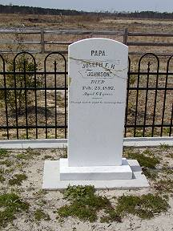
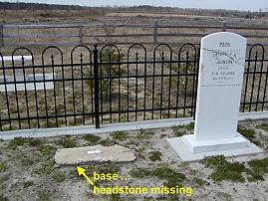 | 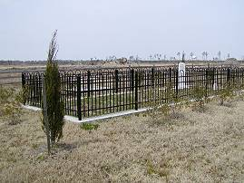
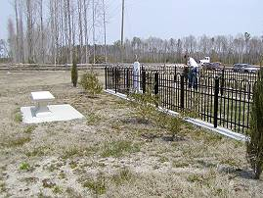 | 