Jones-Dashield ~Burwells Bay Rd~ Cemetery
Transcribed by members of the
Grave Site Survey Task Force (GSSTF)
Under the Auspices of
Isle of Wight County Historical Society (IWCHS)
Visited March 26, 2006

A selection of shaving foam, water, or talcum powder was used to improve the legibility of the inscriptions on the older tombstones. Afterwards, a clean water spray was used to remove any residue. GSSTF members were careful not to damage tombstones or artifacts during the transcription process.

Any text within the “[ ]” is a comment about the tombstone inscription, ex., [fs] indicates a footstone inscription. Throughout the transcribing process, an attempt was made to preserve the, ‘look and feel’ of the original inscriptions as regards word spacing, arrangement, and possible misspellings.

Please address your comments/corrections to: albert.b@charter.net or epowellsr@aol.com.

 | Inscription |  |  | Inscription
 | ABRAHAM JONES  March 28, 1839  April 28, 1897 |  |  | FISHER DASHIELD  SARAH DASHIELD  ELLA DASHIELD  MARGARET DASHIELD  FISHER Y DASHIELD  T. A. DASHIELD  ANNIE DASHIELD  JOSEPH BARLOW  HELEN BARLOW
BENJAMIN JONES
Born April 10, 1803
and died July 2nd 1856
Aged 53 years 2 months & 23 days
‘Twas thus he w[- - - - -]ay
Dissatisfied, no[- - - - -]wanted
A boso[ - ] where [- - - - -] lay
And hear the [ - - - - -]ie it granted

J.D. Couper,
Norfolk

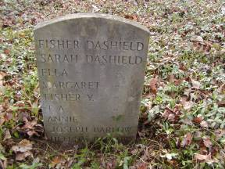 | 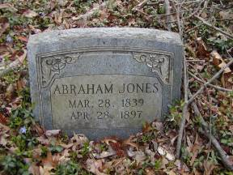
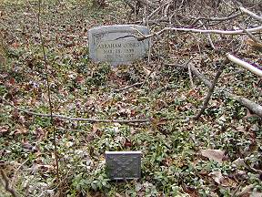 | 