Jones ~ Burwell’s Bay Rd ~ Cemetery
Transcribed by members of the
Grave Site Survey Task Force (GSSTF)
Under the Auspices of
Isle of Wight County Historical Society (IWCHS)
Visited March 26, 2006

A selection of shaving foam, water, or talcum powder was used to improve the legibility of the inscriptions on the older tombstones. Afterwards, a clean water spray was used to remove any residue. GSSTF members were careful not to damage tombstones or artifacts during the transcription process.

Any text within the “[ ]” is a comment about the tombstone inscription, ex., [fs] indicates a footstone inscription. Throughout the transcribing process, an attempt was made to preserve the, ‘look and feel’ of the original inscriptions as regards word spacing, arrangement, and possible misspellings.

Please address your comments/corrections to: albert.b@charter.net or epowellsr@aol.com.

 | Inscription |  |  | Inscription
 | ROBERT  CRAWFORD  JONES  Born  Dec. 23, 1851  Died  Dec. 21, 1890  R.C.J. [fs] |  |  | LUCY A.  BELL JONES  Wife of  ROBERT T. JONES  Born  April 27, 1817  Died Dec. 3, 1882  LABJ [fs]
Note (1) | ROBERT T.  JONES  Father of  R. E. – M. B. – L. A. C.  C. P. and R. C. JONES  Born Sept. 5, 1811  Died Feby’ 24, 1881  R.T.J. [fs]

Notes:
(1) According to Great-Great Grandson Roger Adkins, all 5 sons of Robert T. Jones fought for the C.S.A.

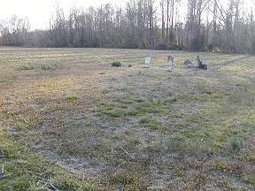 | 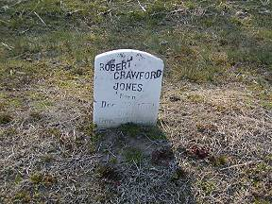
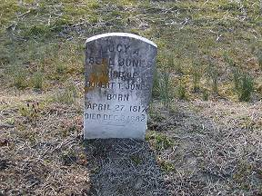 | 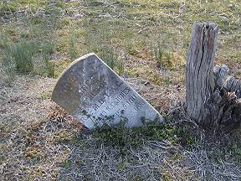
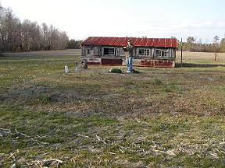 | 