Jones ~Emmanuel Church Rd~ Cemetery
Transcribed by members of the
Grave Site Survey Task Force (GSSTF)
Under the Auspices of
Isle of Wight County Historical Society (IWCHS)
Visited July 24, 2005

The cemetery is located in the woods down the lane leading to the old Wolftrap Plantation. From the size of the cemetery, there could be more graves although no visible markers were found other than the ones transcribed and listed herein.

A selection of shaving foam, water, or talcum powder was used to improve the legibility of the inscriptions on the older tombstones. Afterwards, a clean water spray was used to remove any residue. GSSTF members were careful not to damage tombstones or artifacts during the transcription process.

Any text within the “[ ]” is a comment about the tombstone inscription, ex., [fs] indicates a footstone inscription. Throughout the transcribing process, an attempt was made to preserve the, ‘look and feel’ of the original inscriptions as regards word spacing, arrangement, and possible misspellings.

Please address your comments/corrections to: albert.b@charter.net or epowellsr@aol.com.

 | Inscription |  |  | Inscription
 | ANNIE E.  wife of  BERBIN L.  JONES,  Born Sep. 28, 1863  Died Apr. 19, 1911  Gone but not  forgotten. |  |  | BERBIN L.  JONES  Born Sep. 28, 1865.  Died Feb. 22, 1912  Gone but not  forgotten.
 | SIMON ATKINSON  Born July 27, 1816  Died June 3, 1873 |  |  | [two unmarked brick & mortar vaults about 4” underneath the sod]
 | Mrs. SALLIE W. ATKINSON  Born Feb. 28, 1800  Died Mar. 14, 1872  Age 72 yrs. & 14 days  S.W.A. [fs] |  |  | Father Mother  JONES  ISAAC N. JONES MAY E. JONES  May 9, 1873 Aug. 8, 1878  Jan. 25, 1945 Oct. 23, 1922
 | 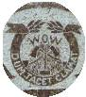  W. D. YOUNG JONES  Born Dec. 15, 1866  Died Oct. 15, 1908 |  |  | NANCY ELYDIA  Daughter of  W. Y. & N. B. JONES  Born  April 21, 1902  Died  April 28, 1902  N.E.J. [fs]
Note (1) | VIOLA DAVIS  Daughter of W. Y. & N. B. JONES  Born May 23, 1892  died Jany. 21, 1902  V.D. [fs] |  |  | CHERRY BETTIE JONES  Born Nov. 20, 1868  died Sept. 3, 1869
Note (2) | In Memorium  EMMA LEE JONES  Daughter of N. P. & LAURA LEE JONES  God took our dear little Emma away  one drear November night  “Oh mama” where the last words we heard her say  then her spirit took its flight  may we meet our dear child in Heaven  above when this troublesome life is over.  at the pearly gates may she meet us  with love.  May we meet to part no more.  Oh God didest thou take Emma away  to draw me nearer to thee I feel  so day by day.  As though an angel had revealed it too …  Dear Jesus send little Emma I pray  when death’s messenger shall come  to bear my spirit away.  To that beautiful Heaven my home  One sweet flower has drooped and faded  Dear little Emma’s voice has fled  our fair brow the grave has shaded.  Our dear school mate is now dead  Schoolmates  Little Emma has gone before us  but she turns & waves her hand  pointing to the glories o’er  in that happy spirit land.  Jodie |  |  | 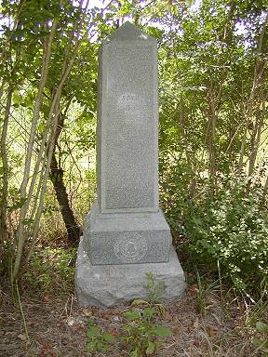

Notes:
(1) The month, “Jany” is actually engraved on the tombstone … not a typo.
(2) The word, “Memorium” is actually engraved on the tombstone and the phase, “Oh Mama where the last words” is on the stone … not a typo.

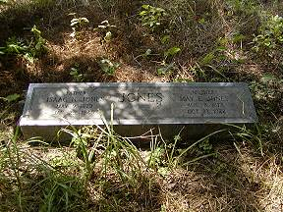 | 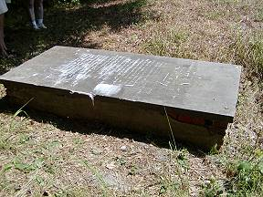
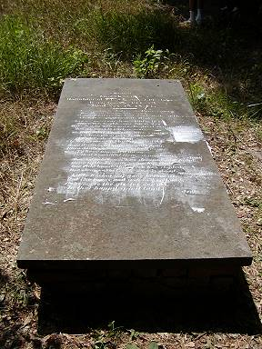 | 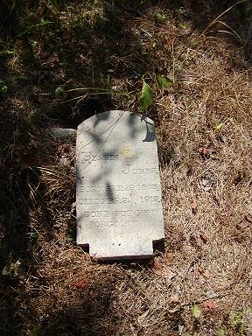
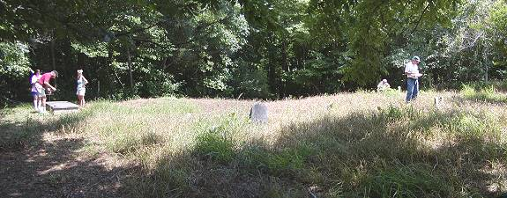
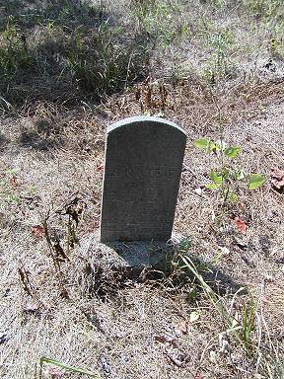 | 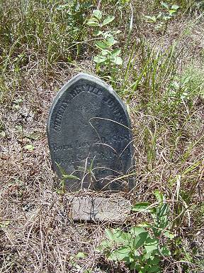
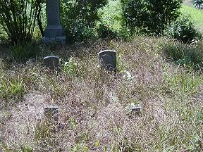
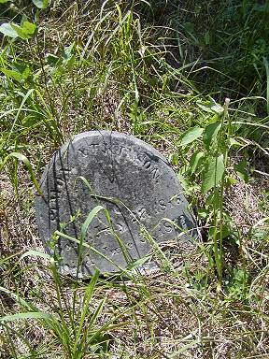 | 