Jones-Harris ~Rattlesnake Trail~ Cemetery
Transcribed by Members of
Grave Site Survey Task Force (GSSTF)
Under the Auspices of
Isle of Wight County Historical Society (IWCHS)
Visited Feb 27, 2005

A selection of shaving foam, water, or talcum powder was used to improve the legibility of the inscriptions on the older tombstones. Afterwards, a clean water spray was used to remove any residue. GSSTF members were careful not to damage tombstones or artifacts during the transcription process.

Any text within the “[ ]” is a comment about the tombstone inscription, ex., [fs] indicates a footstone inscription. Throughout the transcribing process, an attempt was made to preserve the, ‘look and feel’ of the original inscriptions as regards word spacing, arrangement, and possible misspellings.

Please address your comments/corrections to: albert.b@charter.net or epowellsr@aol.com.

 | Inscription |  |  | Inscription
 | LUCY DREWERY BUTLER  Jan. 26, 1890  Mar. 5, 1961 |  |  | EDITH J. BRYANT  1932 - 1934
 | JONES  MARY JOHN H.  Jan. 15, 1946 Dec. 30, 1936 |  |  | SARAH T. JONES  Nov. 17, 1900  Jan. 18, 1975  At Rest
 | ROBERT D. JONES  Born April 6, 1886  died Nov. 6, 1943  At Rest |  |  | MARY WELL  wife of  R. D. JONES  Born  Aug. 15, 1887  died  Oct. 15, 1918  Gone but not forgotten  JONES
 | Our Baby [JONES ?] |  |  | [grave with marker but no inscription]
 | GEORGE HARRIS  Mar. 13, 1902  May 12, 1973  In memory of our Father  GEORGE HARRIS  1902 – 1973  Colonial Funeral Home |  |  | MARIE STRINGFIELD HARRIS  Nov. 25, 1904  Jan. 17, 1937  In memory of our Mother
 | STEPHEN PAUL DICKERSON  May 28, 1978  Here lies our beloved son  JANICE H. and GARY F. DICKERSON |  |  | JERRY W. JONES  1910 – 1976 [fs]
 | H. S. RUBEN JONES JR  Feb 1 July 8  1908 1940 |  |  | MARTHA D. JONES  Mar 28 Apr 10  1913 1948
 | KETURAH JONES  Born  June 9, 1839  Died April 17, 1916  “Asleep but not forever  In the dark and only grave  Blessed be the one that  giveth Blessed be the one  that taketh” |  |  | RUBIN W. JONES  Mar. 29, 1867  Dec. 12, 1946
 | Mother  MATTIE T. JONES  Mar. 11, 1876  Mar. 8, 1945  M.T.J. [fs] |  |  | ELVIRA S. HARRIS  Born  Feb 15, 1865  died Nov 5, 1944  At Rest
 | HENRY L. JONES  Born  Jan. 5, 1840  died Aug 19, 1905  dead but not forgotten |  |  | WILLIE L. HARRIS  Born Nov. 8, 1883  died Sept. 1909  W.L.H. [fs]
 | [unmarked grave surrounded by stones] |  |  | [unmarked grave surrounded by granite]
 | [unmarked grave with flowers on grave]

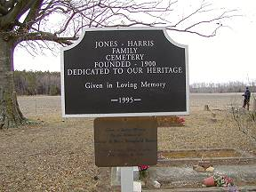 | 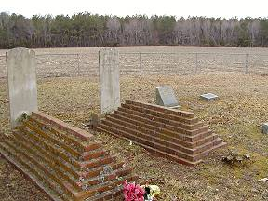
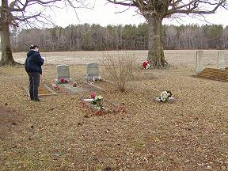 | 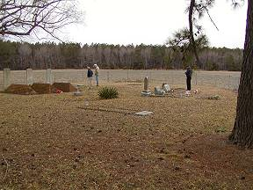
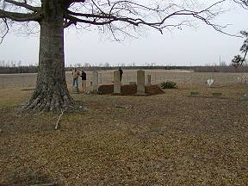 | 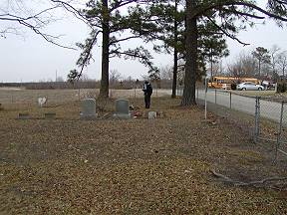
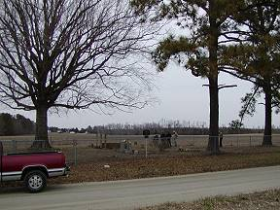 | 