Jordan ~Field of Dreams La~ Cemetery
Transcribed by members of the
Grave Site Survey Task Force (GSSTF)
Under the Auspices of
Isle of Wight County Historical Society (IWCHS)
Visited March 12, 2006

This single occupant cemetery is located about three miles west of Foursquare Rd (# 620) off of Courthouse Hwy (# 258) on a road that is not yet officially named … the property owner indicated that the proposed name, “Field of Dreams Lane” would probably be adopted.

GSSTF members were careful not to damage tombstones or artifacts during the transcription process.

Any text within the “[ ]” is a comment about the tombstone inscription, ex., [fs] indicates a footstone inscription. Throughout the transcribing process, an attempt was made to preserve the, ‘look and feel’ of the original inscriptions as regards word spacing, arrangement, and possible misspellings.

Please address your comments/corrections to: albert.b@charter.net or epowellsr@aol.com.

HARRISON JORDAN
Died
Oct. 16, 1926
To live in hearts we leave
behind is not to die.

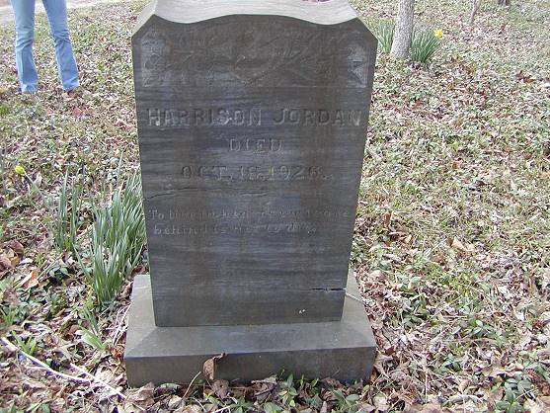
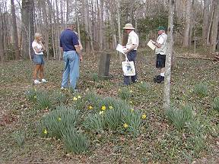 | 