Jordan ~Moonlight Rd~ Cemetery
Transcribed by members of the
Grave Site Survey Task Force (GSSTF)
Under the Auspices of
Isle of Wight County Historical Society (IWCHS)
Visited April 30, 2006

This cemetery is located in a farm field off of Moonlight Rd (# 627). It is very heavily overgrown with dense weeds, briars, and small trees and difficult to access the tombstones. Thanks to Mr. Raymond Edwards for working with GSSTF members to identify and locate this cemetery.

A selection of shaving foam, water, or talcum powder was used to improve the legibility of the inscriptions on the older tombstones. Afterwards, a clean water spray was used to remove any residue. GSSTF members were careful not to damage tombstones or artifacts during the transcription process.

Any text within the “[ ]” is a comment about the tombstone inscription, ex., [fs] indicates a footstone inscription. Throughout the transcribing process, an attempt was made to preserve the, ‘look and feel’ of the original inscriptions as regards word spacing, arrangement, and possible misspellings.

Please address your comments/corrections to: albert.b@charter.net or epowellsr@aol.com.

 | Inscription |  |  | Inscription
 | In Memory of  JOHN EDWARD  Son of  JOHN A. & K. G. JORDAN  Died Apr. 21 1854  In the 19th year of his age  ‘Tis done: The darling idol I resign  unfit to share a heart so justly thine. |  |  | To the  In Memory of  SELAH F. JORDAN  Relict of  THO. JORDAN ^{D}ec  Who died  May 20, 1812  Aged 75 years &  20 days
 | [indecipherable] J. JORDAN  departed this life  March 14th 1839  Aged 22 years, 1 month & 17 days  “Leaving a devoted husband  and four small children  to mourn the loss of a  fond and affectionate Mother” |  |  | Sacred to the memory of  NANNIE H. JORDAN,  who died Jan. 8, 1856  Aged 4 yrs. 7 mos.
 | Sacred  to the memory of  MERIT JORDAN  born in this county  July 2^{d} 1792,  died in Norfolk, VA  May 10 1872  Age 79 yr 10 mo 8 days  ----------  An affectionate and devoted husband  and father; a sincere friend.  -----------  MERIT JORDAN  “Tempora mutantur, et nos  mutamura in illis.” [fs] |  |  | In Memory of  POCAHONTAS  daughter of MERIT and PAULINA JORDAN  who died on the 4th day of December 1836  aged 5 yrs; 5 mos.; 10 days  She lived, the idol of her parents,  She died the Angel of her God.  P.J. [fs]
 | [poured concrete gravemarker .. unidentified] |  |  | Sacred to the memory of  JAMES C. JORDAN  who died Jan. 20, 1855  60 yrs. 9 mos.  A^{Eb} [fs]

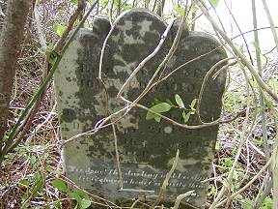 | 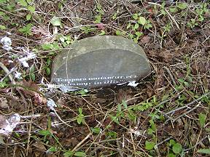
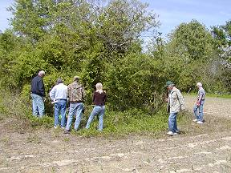 | 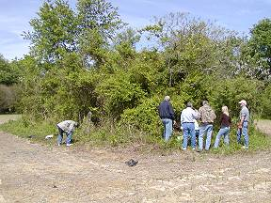
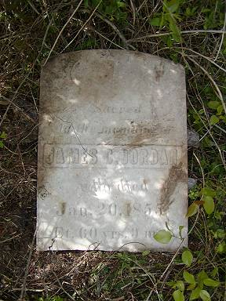 | 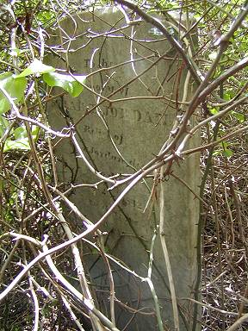
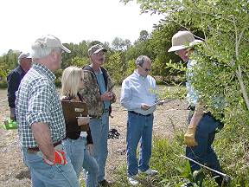
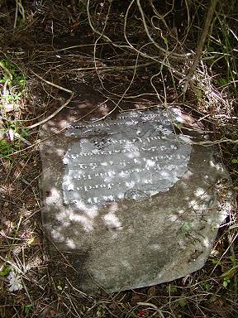 | 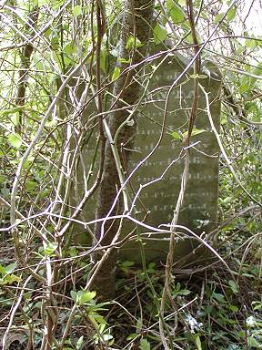

The document that follows is a transcription recorded in 1972 and is included here verbatim for reference only … IOWC GSSTF members do not verify the accuracy of past transcriptions.

JORDAN CEMETERY

LOCATED ON HIGHWAY 626, 4 MILES WEST OF SMITHFIELD. THEN HALF MILES NORTH ON
627.CEMETERY IS ON THE RIGHT ON THE IVAN GWALTNEY FARM. THE HORIZONTAL MARKER IF
I.JORDAN HAD BEEN REPAIRED AND A PART OF THE INSCRIPTION COVERED. OLD
RESIDENTS REPORT THAT IVAN GWALTNEY'S FATHER WAS BURIED HERE. THERE ARE NO
GWALTNEY STONES.

COPIED BY ELSIE H. COX. (04-22-1972)

"Sacred to the Memory of"
Thomas Jordan
of Smithfield, Virginia
who departed this life
[Born 08-18-1768]
June 12th 1818
Aged 49 years, 9 mos. & 14 days.

"To the Memory of"
Selah F. Jordan
Relict of
Thomas Jordan dec"
[Born April 30, 1737]
who died
May 20, 1812
Aged 75 years, 20 days

"Sacred to the Memory of"
James C. Jordan
[Born Apr. 20, 1794]
who died
Jan. 20, 1855
Aged 60 years, 9 mos.

Mamie R. Jordan
[Born May 21, 1852]
who died
Jan. 8, 1856
Aged 4 yrs. 7 mos. 18 days

----- I. Jordan
[Born Jan. 28, 1817]
departed this life
March 14th, 1839
Aged 22 years, 1 month & 17 days
"Leaving a devoted husband
and four small children
to mourn the loss of a
fond and affectionate mother."

"In Memory of"
John Edward [Jordan]
son of John A. & K.G. Jordan
[Born 1832]
Died April 21st, 1851
in the 19th year of his age.

"Sacred to the Memory of"
Merit Jordan
born in this county
July 2nd, 1792
Died in Norfolk, Va.
May 10, 1872
Aged 79 yrs.10 mos. & 8 days
"An addectionate and devoted husband
and father, a sincere friend."

"In Memory of"
Pocahontas
daughter of
Merit and Paulina Jordan
[Born June 25, 1831]
who died on the 4th day
of December 1836
Aged 5 years, 5mos. & 10 days
"She lived the idol of her parents
She died the angel of her God."

