Knight ~Carrsville Rd~ Cemetery
Transcribed by members of the
Grave Site Survey Task Force (GSSTF)
Under the Auspices of
Isle of Wight County Historical Society (IWCHS)
Visited August 28, 2005

This small cemetery is located in the front yard of a private residence across the street from the Pulaski Baptist Church on Carrsville Rd (Hwy # 58). It has been well maintained as evidenced by the pictures and the tombstone inscriptions are legible. GSSTF members were careful not to damage tombstones or artifacts during the transcription process.

Any text within the “[ ]” is a comment about the tombstone inscription, ex., [fs] indicates a footstone inscription. Throughout the transcribing process, an attempt was made to preserve the, ‘look and feel’ of the original inscriptions as regards word spacing, arrangement, and possible misspellings.

Please address your comments/corrections to: albert.b@charter.net or epowellsr@aol.com.

 | Inscription |  |  | Inscription
 | JOHN ROBERT GRANT SR  Feb. 24, 1933 – Jan. 28, 2005  Peebles Funeral Home |  |  | MOSES CROSS  June 3, 1925  Oct. 28, 2002
 | AMIE E. GRANT  Aug. 26, 1910 – Jan. 13, 2001  Wm. M. Johnson & Son Funeral Home |  | Note (1) | GRANT  EVELYN K. WILLE P.  Nov. 23, 1906 Mar. 25, 1905  Jan. 19, 1994 Feb. 7, 1983  EVELYN K. GRANT WILLIE P. GRANT  Nov. 23, 1906 March 25, 1903  Jan. 19, 1994 Feb. 7, 1988
 | KNIGHT  Rev. JOHN L BERTHA M.  1914 – 1976 1922  Our trust is in God  Rev JOHN  Jan 10, 1914  Dec 6 1976 |  |  | JANICE B. KNIGHT  March 27 1940  Feb 26 1992
 | KNIGHT  ESTHER LEE BUNYON  May 12, 1920 Jan 27, 1916  June 7, 1989 Sept 12, 1990  ESTHER L. G. KNIGHT BUNYON KNIGHT  May 12, 1920 Jan 27, 1916  June 7, 1989 Sept 12, 1990 |  |  | JAMES E  KNIGHT  US Navy  World War II  Nov 27 1914  Jun 15 1995  JAMES E KNIGHT  Nov 27, 1914  June 15, 1995
 | NONIE GRANT  Dec 25, 1911  Nov 24, 1995 |  |  | EASTER J. BARNES  Jan 3, 1905  March 19, 1989
 | ALMEDIN COSTON  Nov 5, 1912  Jan 20, 1981 |  |  | CAROLIN M. HOLMES  Aug 11, 1916  April 2, 1996
 | JAMES F. JONES  Dec. 25, 1903  Oct. 28, 1979 |  |  | WAVERLY  TURNER  Pvt  US Army  Korea  May 10 1929  Jul 30 1987
 | Rev WAVERLY TURNER  May 10, 1929  July 30, 1987 |  |  | WILLIE KEYS  July 19, 1922  May 10, 1987
BLANCHE BOONE BAKER
Nov 7, 1931
Nov 8, 1998

BLANCHE V. BAKER
Nov. 7 1931 – Nov. 8, 1998

Crocker Funeral Home

Notes:
(1) The disparity in dates on Willie P. Grant is actually what is engraved on the tombstone and the concrete vault.

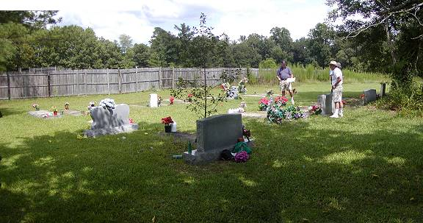

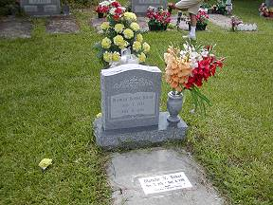 | 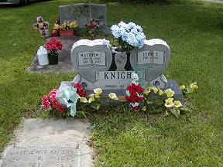
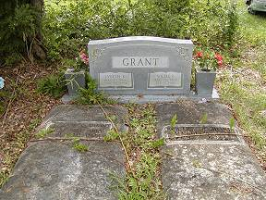 | 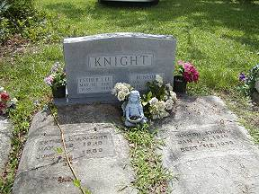
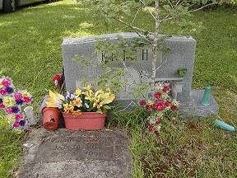
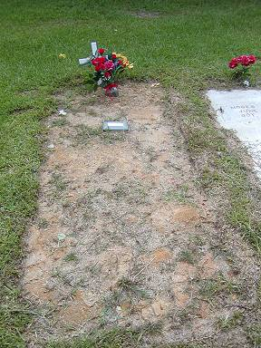 | 