Macedonia Church Cemetery
Visited by Members & Volunteers of
Isle of Wight County Historical Society (IWCHS)
Grave Site Survey Task Force (GSSTF)

February 11, September 26, 2004

This small cemetery is located behind the church on Smith’s Neck Road near Rescue.

 | Inscription |  |  | Inscription
Note (1) | [~~~] ON BAILEY |  | Note (2) | PALMER
 | JULIA E. JONES  March 17, 1901  Dec. 28, 1996 |  |  | JONES  Apr 12, 1928  Jan 7, 2001
 | JONES  JAMES B. MARY E.  1928 – 2001 1927  “In my Father’s house are many mansions” |  | Note (3) | FERGUSON  CHARLES ETHEL PALMER  Aug. 6, 1900 Feb. 7, 1907  June 12, 1983 Mar. 23, 1986  “In loving memory”
Note (4) | CHARLES L. FERGUSON  Aug. 6 1900  June 12 1983 |  | Note (4) | ETHEL M. FERGUSON  Feb 7, 1907  March 23, 1986
 | NORMA C. RANDELL  Oct. 7, 1940  Sept. 13, 1978 |  | Note (5) | JAMES M. LEE  PFC US Army  World War II  Sep 17 1910 May 30 1984
Note (4) | JAMES M. LEE  Sept 17 1910  May 30, 1984 |  | Note (4) | JOSEPHINE C. LEE  Sept. 1, 1914  April 15, 1995
Note (4) | THEODOSIA B. WARREN  June 28, 1906  June 30, 1985 |  | Note (3) | KING  RICHARD A. DORIS P.  Nov. 15, 1894 Sept. 21, 1903  April 15, 1972 Sept. 14, 1983
Note (4) | RICHARD A. KING  Nov 15, 1894  April 15, 1972 |  | Note (4) | DORIS P. KING  Sept. 21, 1903  Sept. 14, 1983
 | DONETRIAN H. WHITE  Jan 1989  Pretlow Chapman Funeral Home |  | Note (5) | FREDERICK M. WHITE  - 1948  Pretlow Chapman Funeral Home
Note (4) | TEOLAR H. PACE  Feb. 4, 1935  Nov. 15, 1989 |  | Note (4) | LORETTA BAILEY  Jan. 16, 1948  March 2, 1995
 | RUFUS BELL  Died June 16, 1951 |  |  | WILLIS B. LANGHORNE  May 7, 1919  Aug. 23, 1966
 | ANNIE LANGHORNE  July 27, 1894  June 13, 1968 |  |  | WILLARD C. HUNT  Nov. 3, 1904  April 22, 1972
 | OLIVIA L. HUNT  Oct. 29, 1910  Nov. 11, 1993 |  |  | VENA HUNT  Feb. 12, 1954  Feb. 5, 1998
 | GARY LEE HUNT  Nov. 20, 1953 - Sept. 15, 2000  Cooke Bros. – Shivers Funeral Chapel  [ - - - - - - - - - - - - - - -]  GARY LEE HUNT  US Army  Nov 20 1953 Sep 15 2000 |  |  | ELIZABETH HERRING  October 10, 1875  October 15, 1961
Note (4)

Note (5)
 | Mrs. KATHERYN HATCHER  Jan. 20, 1904  Aug. 15, 1962 |  |  | FRANCES L. CHANCY  Sept. 18, 1917  Dec. 7, 1974
 | WASHINGTON HERRING  June 20, 1904  Dec. 12, 1974 |  |  | ELNOR H. SMITH  Nov. 27, 1900  May 20, 1978
 | ARMETEAN E. SMITH  Oct. 29, 1931  May 20, 1978 |  |  | WILLIE L. HERRING  April 27, 1893  April 8, 1979
 | JAMES C. HERRING  Aug. 7, 1912  Mar. 26, 1985 |  |  | ALVERTIS LANGHORNE  Jan. 10, 1892  Oct. 25, 1957
 | MARY LANGHORNE  July 28, 1895  Nov. 17, 1968 |  |  | FRANCES L. STUBBS  May 23, 1924  Feb. 20, 1986
 | DENSON  JESSIE D. KATE O.  June 29, 1912 MAR. 26, 1918  Apr. 8, 1988 May 23, 1998 |  |  | JESSIE D. DENSON  June 29, 1912  April 8, 1988  Pretlow-Chapman Funeral Home
 | KATE O. DENSON  March 26, 1918 – May 23, 1998  Pretlow-Chapman Funeral Home |  |  | JUNIOUS R. LEE  Dec. 30, 1912  July 17, 1991
 | EUNICE L. LEE  April 4, 1913  May 27, 1993 |  |  | RAYMOND R.  LANGHORNE  June 13, 1928  July 11, 2002
 | JAMES B. TYNES  Died July 17, 1962 |  |  | WILLIE S.  LONGHORNE  S1  US Navy  World War II  Sep. 18, 1914  Aug. 25, 1977
Note (6) | WILLIE S. LANGHORN  Sept. 18, 1914  Aug. 25, 1977 |  |  | HENRY  FORD JR  June 12, 1933  May 14, 1999  Pretlow Chapman Funeral Home
 | SARAH E. JOHNSON  Nov. 17, 1915  March 7, 1980 |  |  | ROBERT T. JOHNSON  March 4, 1913  July 30, 1966
 | ELDER JOBBIE  JOHNSON  May 30, 1902  Jan. 30, 1992 |  |  | CONROY  JOHNSON  North Carolina  S SGT  US Army  World War II  March 4, 1913  July 5, 1967
 | CONROY JOHNSON  Mar. 4, 1913  July 5, 1967 |  |  | JOSEPH RAWLS  Dec. 28, 1902  June 12, 1968
 | MAUDE H. RAWLS  Aug. 9, 1906  May 20, 1988  Pretlow Chapman Funeral Home |  |  | JOHNNY S. JOHNSON  June 10, 1961  Jan. 7, 1981
 | “In God’s Care”  ELSIE  PALMER  HICKS  May 11, 1913  July 10, 1994  [concrete crypt]  ELSIE P. HICKS  May 11, 1913  July 10, 1994 |  |  | MRS SARAH BAKER  Died June 10, 1947  Age 57
 | JOHN BAKER  Died Sept. 17, 1955 |  |  | AMOS BAKER  Died Feb 28, 1962  Tynes Service
 | STEPHEN ASHTON  PALMER  1867 – 1929 |  |  | MARTHA ANNA  TURNER PALMER  1869 – 1932
 | FRED PALMER  Born: 1847 |  |  | ALTO TURNER  Died: 1931
 | LUCY HAZEL  PALMER  Born: 1907 |  |  | GEORGIA W. PALMER  April 21, 1911  Sept 16, 1930
 | BURREL A. PALMER  Aug. 2, 1938  June 6, 1982 |  |  | In Loving  Memory of  My Mother  MILDRED PALMER  VAUGHN  June 21, 1909  Dec. 22 1987  MILDRED P. VAUGHN  June 21, 1909  Dec 22, 1987  Cooke Brothers
 | WILLIE R. E. LEE  Nov. 12, 1919  Oct. 25, 1984 |  |  | MARIE M. RAINEY  Born June 6 1906  Died Jan 24 1955
 | SARAH V. LEE  Born June 1, 1888  Died Aug. 4, 1956 |  |  | SAMUEL J. LEE  Born 1882  Died Mar. 30, 1950
 | GLAYS DENSON  Aug, 12, 1908  June 16, 1963 |  |  | CHRISTOPHER C. DAY  Nov 5, 1947  June 24, 1968
 | LEE  SAMUEL J. SARAH V.  1882 – 1950 1888 – 1956  “At Rest”  From Mother and Children |  |  | PRISCILLA BAILEY  Dec. 12, 1907  Feb. 27, 1986
 | WALTER F. BAILEY  Died Feb 17 1962 |  |  | EDDIE L. WHITE SR  June 12, 1908  June 15, 1968
 | EDDIE LEE WHITE JR.  May 20, 1936  Sept 30, 1968 |  |  | JULIA A. BAILEY  Dec. 6, 1909  June 9, 1993
 | LILLIE L. WHITE  Aug. 11, 1925  Nov. 12, 1997 |  |  | IRENE M  BROWN  Feb 8 1941  May 10 1999  Pretlow Chapman
 | BILLIE MERECER  June 26, 1918  May 6, 1987 |  |  | IDA R. CHANNEL  March 13, 1919  May 1, 1986
 | RICHARD CHANNEL  Oct. 10, 1912  July 15, 1975 |  |  | ELMO SMITH  Oct 3, 1892  Aug 12, 1966  ELMA  SMITH  Virginia  PVT  US Army  World War I  October 3 1892  August 12 1966
 | MARTHA  PALMER  1907 – 1979  MARTHA J. PALMER  SEPT. 25, 1979 [cs] |  |  | STEPHEN A  PALMER  PVT  US Army  World War I  Mar 8 1895  Apr 2 1975  STEPHEN PALMER  March 8, 1895  April 2, 1975
 | TINA RUFFIN BELL |  |  | In Loving Memory  SMITH – LEE
 |  |  |  | Mother  PECOLA DIGGS SMITH  Oct. 2, 1900  June 18, 1979 | Wife  [blank] | Husband  STEPHEN N. LEE  Dec. 14, 1914  Jan. 13, 1999
 | TEDLAR H. PACE  Feb. 4, 1935  Nov 15, 1989 |  |  | LORRETTA BAILEY  Jan. 16, 1948  March 2, 1995
 | FREDERICK M. WHITE  1947 – 1948 |  |  | DOMETRIA N. WHITE  Jan 1999
 | JAMES D. WHITE  Apr. 23, 1923  Dec 27, 1994 |  |  | NANNIE B. BATTEN  Jul 2, 1931  Dec. 19, 2000  “She is just away but  her memory is still here”  Beloved Wife, Mother,  Friend, Grandmother & Gi-Gi
 | Stormy  RUTH B. EDWARDS  Feb. 19, 1933  Aug. 8, 1991 |  |  | EDWARD GENE PALMER  SP3 US Army  Korea  Sept 16 1932 Oct 4 1995
 | JAMES E. PALMER  Nov. 11, 1904  July 28, 1974 |  |  | MARY E. WILSON  Jun 1, 1921  Nov 24, 1980  O. H. Smith and Son
 | WOODLEY HICKS  Died Sept. 10, 1966 |  |  | FLETCHER M. HICKS  July 1896  March 23, 1976
 | ELVEN HICKS  July 1, 1901  Aug. 25, 1985 |  |  | CLARENCE HICKS  Died April 5, 1960
 | EUGENE B. CARTER  Jan. 26, 1928  Aug. 7, 1984 |  |  | EUNICE B. RIDLEY  Jan. 25, 1928  Feb. 7, 1990  Pretlow-Chapman
 | JEANNETTE H. HUNT  Oct. 17, 1929  Apr. 4, 2004  Pretlow-Chapman |  |  | MARK S. THOMAS SR.  US Army  Aug 24 1950 Mar 3 2004
 | CLIFTON LANGHORNE  Sep 10, 1967  Jan 16, 2002  Pretlow-Chapman |  |  | WARDELL R. WILLIAMS  Oct 20, 1962 – March 3, 2002  Cooke Bros. – Shivers
 | TESSIE MAE SYKES  (Mom SYKES)  Sept 9, 1910  Jan 8, 2002  Loving Memories Family |  |  | RUFUS BELL  Died June 16, 1951
Notes:
- Inscription is on metal tag stuck in ground, part of the name is obliterated.
- Within a brick surround – no inscription.
- This inscription is on an upright headstone
- This inscription is on a horizontal concrete crypt stone.
- Inscribed on a vertical metal plaque.
- The name, “LANGHORN” is not a misspelling .. it is inscribed with the, “E” missing.

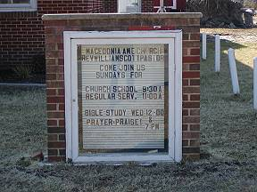 | 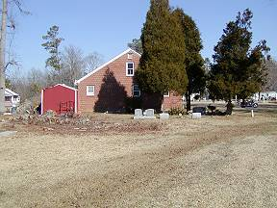
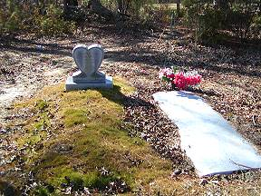 | 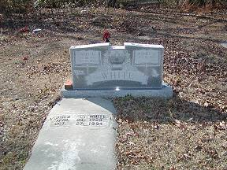
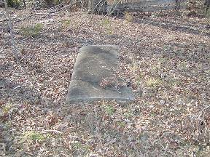 | 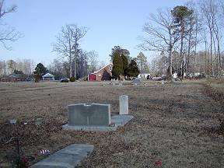
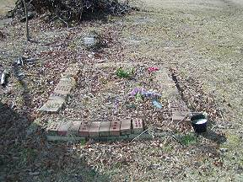 | 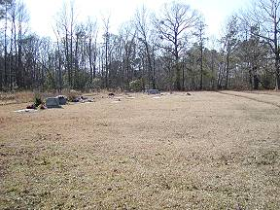
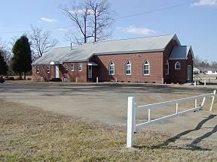 | 