Morningstar Baptist Church ~Blackwater Rd~ Cemetery
Transcribed by members of the
Grave Site Survey Task Force (GSSTF)
Under the Auspices of
Isle of Wight County Historical Society (IWCHS)
Visited March 13, 2005

A selection of shaving foam, water, or talcum powder was used to improve the legibility of the inscriptions on the older tombstones. Afterwards, a clean water spray was used to remove any residue. GSSTF members were careful not to damage tombstones or artifacts during the transcription process.

Any text within the “[ ]” is a comment about the tombstone inscription, ex., [fs] indicates a footstone inscription. Throughout the transcribing process, an attempt was made to preserve the, ‘look and feel’ of the original inscriptions as regards word spacing, arrangement, and possible misspellings.

Please address your comments/corrections to: albert.b@charter.net or epowellsr@aol.com.

 | Inscription |  |  | Inscription
 | FRANCES J  WRIGHT  Dec 17 1930  July 8 2002  Crocker |  |  | Ms. VIRGINIA A. WRIGHT  Feb. 25, 1912 – Sept. 30, 2000  Crocker Funeral Home
 | ANNIE B. WRIGHT  May 18, 1895  Aug, 1, 1982 |  |  | GRACIE L. COATS  April 12, 1928  March 1, 1989
 | MARIE GOODMAN  Born Sept 17, 1928  Died Sept1, 1953 |  |  | MARIE MOORE  April 24, 1986
 | GERADINE W  GHOLSON  July 25 1921  July 6 1992 |  |  | RUTH JACKSON  Died Dec – 9 – 1959  Tynes –  Services
 | HENRY – MOORE  Born – 1882  Died – 1958 |  |  | RANDOLPH  VINES  Feb 12, 1944  Oct 10, 1997
 | KALIM S  WASHINGTON  Jan 4, 1981 |  |  | FRANCES ELEY  Oct. 31, 1915  Nov. 8, 1972
 | DIANE ELEY  June 21, 1950  Dec. 28, 1969 |  |  | ESTELLE J. MOORE  March 11, 1926  Nov, 18, 1991
 | ROBERT MOORE  AUG, 21, 1982 |  |  | BRYANT COPELAND  Oct – 1940  July – 19 – 1959
 | LUTHER H. ELDER  Died Dec. 24, 1964 |  |  | JAMES ELDER  Dec 6 1901  Apr. 22 1975  WATTS
 | LILLIE M, ELDER  Mar. 13, 1943  Aug. 28, 1997 |  |  | [concrete slab but name plate missing]
 | HORACE E. HOLMES  Oct. 31 1933  July 2, 1990 |  |  | SINCLAIR HOLMES  July 16 1946  Oct. 15, 1973
 | ALTON EUGENE KNIGHT  1974 1975 |  |  | RAYFIELD HOLMES  Oct 3 1947  Dec 8 1977
 | Rev. R. B. PAGE  Died April 1937 |  |  | EMORY JOHNSON  Died Aug. 18, 1957
 | EVA FREEMAN  July 3, 1962 |  |  | PHILIP O. FREEMAN  Died Sept. 2, 1939
 | CHARLES FREEMAN  Died Apr. 22, 1952 |  |  | MARIE J. ELLIOTT  July 6, 1903  Nov. 21. 1969
 | LENA B. JOHNSON  July 6, 1912  Dec. 24, 1964 |  |  | LEMUEL B. CHAPMAN  Sept. 20, 1952  July 4, 1973
 | JOSEPHINE CHAPMAN  May 15, 1892  Jan. 15, 1989 |  |  | [Unmarked Slab]
 | MARTHA FREEMAN  Died June 4, 1954 |  |  | KATE FREEMAN  Died April 9, 1927
 | WILLIAM L. FREEMAN  Oct. 19, 1911  Jan. 12, 1987 |  |  | WILLIE FREEMAN  Died Aug. 3, 1952
 | [unmarked slab] |  |  | MARY BAILEY  Died Feb. 8, 1953
 | [unmarked collapsed vault] |  |  | SAM CHAPMAN  1882 – 1947  S.C. [fs]
 | [unmarked grave – no slab] |  |  | AARON CHAPMAN SR.  Born 1885  Dec. 29, 1943
 | LOUISE JONES ELEY  1932 |  |  | GLADYS W. CHAPMAN  Aug. 7, 1922
 | JESSE L. CHAPMAN  Aug. 5, 1909  April 15, 1984 |  |  | ALICE CHAPMAN  July 7, 1914  Jan. 1943
 | SOLOMON EVANS  1923 – 1934 |  |  | AARON CHAPMAN, JR.  Dec. 29, 1919
 | LEANNA J. CHAPMAN WHITE  July 4, 1885  March 12, 1971 |  |  | WILLIE M. DIGGS  June 22, 1911  Feb. 27, 2000
 | MCKENLEY DIGGS  Died June 12, 1950 |  |  | JOHN YATES  Died May 16, 1955
 | [unmarked slab] |  |  | DANIEL DIGGS  PFC  US Army  World War II  May 7, 1931  Aug 16 1977
 | CAROLINE LAWRENCE  Died July 1940 |  |  | CHAPMAN  LELAND A. CINDELLA C.  Jan, 21, 1925 June 29, 1929  July 31, 1994 June 22, 1985  U.S. Navy Carpenter’s Mate 2nd Class
 | EMMETT B. REID  Aug 12, 1936  May 3 1983 |  |  | MILDRED BRYANT  Aug 11 1921  June 17 1983
 | EMMA F. MOORE  “Mousy”  Feb. 7, July 30,  1922 1991 |  |  | PERCELL MOORE SR  PVT  US Army  World War II  Jul. 19 1920  Jun 28 1990
Note (1) | JOESPH ARTIS  Nov 1 1939  Apr 31 1980 |  |  | WYATT  CATHERINE RILEY  Mar – 1927  June – 1974
 | ANNIE M. COPELAND  Born Oct. 10, 1901  Died July 1, 1965 |  |  | JOSEPH P. JOHNSON  Dec. 16 1931  Aug 9 2002  CROCKER
 | LAWRENCE N. PATTERSON  April 30, 1937  Dec. 18, 1991 |  |  | JAMES M. BOYKINS, JR.  Aug. 29, 1969  Dec. 14, 1996  Beloved Son, Brother  Daddy, Fiancé & Friend
 | STRINGFIELD  WILLIE A. ELNORA A.  Nov. 13, 1913 Dec. 25, 1912  Mar. 2, 1997 Sept. 29, 2001 |  |  | GRACIE MAE HOLMES  Sept. 15, 1939  Jan. 3, 1986
 | MANLEY  JESSE A. MALLE C.  Dec. 24, 1923 Feb. 11, 1928  MALLE C. MANLEY  Feb. 11, 1928 – Aug. 8, 1998  Cooke Bros. Funeral  Chapel |  |  | BENJAMIN H. BOWERS  Virginia  Pvt. 51 Co 13 BN  153 Depot Brig  World War I  Sept 3 1888  Aug 2 1966
 | ANNIE MAY BOWERS  Born Jan 1898  died Nov 1, 1949 |  |  | MARTHA BOWERS TYSON  Born Dec. 25, 1924  died Sept 22, 1965
 | MARY S. EVANS  died Dec. 3, 1959 |  |  | ELMIRA J. WASHINGTON  Oct. 7, 1893  Jan. 27, 1976
 | ELMA LEWIS  July 10, 1918  June 3, 1966 |  |  | WILLIAM E. WASHINGTON  Virginia  Pvt  US Army  World War II  October 22 1922  May 9, 1955
 | LUCY C. CRUTE  died July 25, 1955 |  |  | HENRY MOORE  Born – 1882  died – 1958
 | MARIE MOORE  April 24, 1986 |  |  | SIMON L. MOORE SR  July 14, 1926  March 12, 1993
 | [unmarked grave] |  |  | PATTIE M. DREW  July 28, 1914  Oct. 27, 2001
 | JOHN M. DREW  Feb. 14, 1902  July 6, 1981 |  |  | CARRIE L. BAILEY  Dec. 22, 1900  Oct. 16, 1990
 | JAMES C VINES JR  Sept. 3, 1941 |  |  | THOMAS HENRY ARTIS  July 10, 1946  Jan. 10, 2000  T. H. [fs]
 | ROSA L FLOYD E.  Dec. 26, 1939 May 1, 1936  Sept. 23, 2003  BAILEY |  |  | CLARA ARTIS VINES  Nov. 9, 1942
 | MARCELLAR FAUCK  PVT US Army  World War II  Jan 6 1924 Sept 15 1998 |  |  | In God’s Care  NAOMI JOHNSON  ELEY  Jan. 10, 1957  Aug. 6, 2000
 | [unmarked slab] |  |  | [flowers marking grave, no visible inscription]
 | _EARSON LORENZO  1921 – 1990  Wyatt Funeral Home |  |  | SEBRON  WILLIE E. MARY E M  Jan. 31, 1912  Sept 26, 1996
 | PORTER JAMES  1954 Wyatt 1990  Funeral Home  Together Forever Married 58 years |  |  | JAMES T. LEWIS  1918 Pretlow 1990  Chapman
 | VIRTLEY MIRTEEN  WASHINGTON LAWRENCE  Nov. 13, 1928  June 26, 1999  We Love You |  |  | DANIEL BLOW  June 29 1925  June 8 1986  WYATT
 | VINCENT ELEY  Aug 16, 1960  Jan 8, 1968 |  |  | JOSHUA C. WASHINGTON  Feb. 8, 1894  Dec 12, 1989
 | FRONIA B BROADWAY  May 25 1928  Sept 7 1997 |  |  | LEROY ELEY  Dec 26, 1930  Nov 27, 1979
 | HARVEY GOODMAN  died May 13, 1956 |  |  | AARON GOODMAN  died May 13, 1956
 | WILLIAM H GOODMAN  Died May 11, 1970 |  |  | OPHELIA WALTON  Oct 8, 1900  June 18, 1964
 | MELVIN LIVEREMAN  June 12 1949  Oct 8 1991 |  |  | ANNIE T GOODMAN  Sept 23 1915  Oct 12 1993
 | ECARIOUS WALTON  Born Oct 3 1896  Died May 16 1965 |  |  | DONALD E LIVERMAN  June 15 1850  Oct 16 1882
 | ERNEST WALTON  March 13, 1925  Sept 30, 1994 |  |  | MARTHA A WHITAKER  Dec. 10, 1919  Nov 21, 1979
ROBERT WHITAKER
Jan 6, 1912
Aug 26, 1980

NOTES: (1) The name “JOESPH” is actually on the tombstone

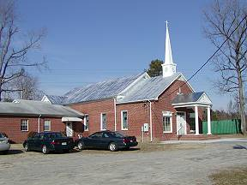 | 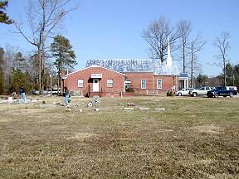
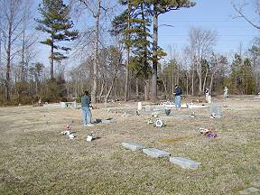 | 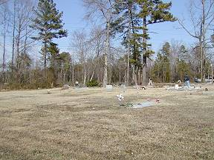
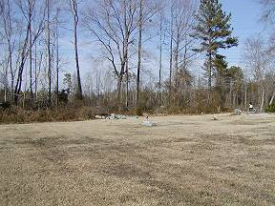 | 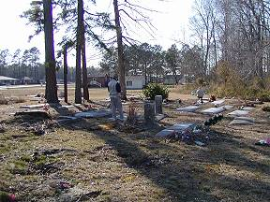
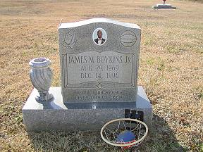 | 