Mountjoy ~Marina Dr~ Cemetery
Visited by Members of
Grave Site Survey Task Force (GSSTF)
Under the Auspices of
Isle of Wight County Historical Society (IWCHS)
June 9, 2004

This small cemetery is located off of Marina Drive in the town of Rescue, near Smithfield.

GSSTF members were careful not to disturb tombstones or artifacts during the transcription process.

Any text within the “[ ]” is a comment about the tombstone inscription, ex., [fs] indicates a footstone inscription. Throughout the transcribing process, an attempt was made to preserve the, ‘look and feel’ of the original inscriptions as regards word spacing, arrangement, and possible misspellings.

Please address your comments/corrections to: albert.b@charter.net or epowellsr@aol.com.

 | Inscription |  |  | Inscription
 | MILDRED  MOUNTJOY  Jan 27 1843  June 29, 1909  “At Rest”  Mother  M.M. [fs] |  |  | JAMES T.  MOUNTJOY  June 13, 1876  March 1, 1904  “At Rest”  Son  J.T.M. [fs]

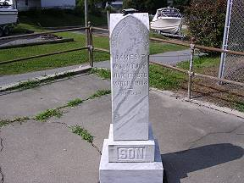 | 