Mt Tabor ~Waterworks Rd~ Cemetery
Transcribed by members of the
Grave Site Survey Task Force (GSSTF)
Under the Auspices of
Isle of Wight County Historical Society (IWCHS)
Visited July 13, 2005

A selection of shaving foam, water, or talcum powder was used to improve the legibility of the inscriptions on the older tombstones. Afterwards, a clean water spray was used to remove any residue. GSSTF members were careful not to damage tombstones or artifacts during the transcription process.

Any text within the “[ ]” is a comment about the tombstone inscription, ex., [fs] indicates a footstone inscription. Throughout the transcribing process, an attempt was made to preserve the, ‘look and feel’ of the original inscriptions as regards word spacing, arrangement, and possible misspellings.

Please address your comments/corrections to: albert.b@charter.net or epowellsr@aol.com.

 | Inscription |  |  | Inscription
 | KEVIN D. MAJOR  Nov 25, 1967  Jan 28, 2002  Beloved Son |  |  | RODRICK  WARREN  Dec. 9, 1967  June 19, 1999  Pretlow  Chapman
 | ARTHUR CORNICK JR  Dec. 27, 1945  Nov. 22, 1991 |  |  | DARLENE O. WARREN  March 12, 1966  August 16, 1983
 | ELNORA T. CORNICK  Aug 27, 1916  June 4, 1982 |  |  | VIRGINIA ARCHER  Jan. 22, 1920  Jan. 27, 1985
 | REBECCA F. JONES  Nov. 25, 1900  April 14, 1990 |  |  | RONNIE T.  TYNES  4 12 1964  5 28 1973
 | JOHN F. TYNES JR.  May 23, 1930  June 18, 1990 |  |  | OTTO WIALKER  Died April 6, 1973
 | JOSEPH C. THOMAS  AUG. 26, 1937  Oct. 24, 1997 |  |  | ARTHUR I. THOMAS  Virginia  Cpl US Marine Corps  Vietnam PH  Jan 21, 1945 Nov. 1, 1967
 | HOWARD L. THOMAS  Feb. 28, 1941  April 24, 1990 |  |  | THOMAS  ALMA N. JOSEPH C. SR.  Jan. 28, 1917 May 25, 1913  Aug 31, 2000 July 17, 1980
 | ANDREW L. THOMAS  Jan. 30, 1943  Aug. 14, 1996 |  |  | Son  KEVIN LIGGINS  Aug. 9, 1997  July 20, 1983
 | Baby LIGGINS  May 1990 |  |  | PLUMMIE TYNES  Virginia  Tec 5 US Army  World War II  Jan 15, 1921 April 26, 1970
 | RUTH T. JORDAN  Oct. 2, 1924  Aug. 4, 1988 |  |  | RICHARD JORDAN, JR.  Died Sept. 26, 1965
 | WALTER WILKINSON  Died Jan 12 – 1960 |  |  | VIOLET V. WILSON  March 29, 1918  Oct. 20, 1974
 | WILLIAM BOWMAN  Born July 28, 1875  Died March 29, 1959 |  |  | SARAH J. BOWMAN  Oct. 5, 1895  Feb 23, 1974
 | Our Baby Girl  COURTNEY LENISE  RALPH  January 18, 1993 |  |  | ADDISON  Elder  SHURLEY L. SR.  July 17, 1938  Feb. 18, 2002
 | JAMES R. WILSON  June 16, 1924  Jan. 24, 1978 |  |  | JAMES ROBERT WILSON  CK3  US Navy  World War II  1924  1978
 | MAJOR  SHERMAN, JR. GLADYS H.  Aug 17, 1926 Sept. 27, 1930  July 7, 2000 |  |  | SHERMAN MAJOR JR  Pvt US Army  World War II  Aug 17 1926 July 7 2000
 | THEODORE A. GREEN, SR.  Feb. 11, 1913  Nov. 20, 1978 |  |  | EL. ALBERT J. MAJOR  Nov. [note (1)] 1898  July 13, 1967
 | LEROY GREENE JR  SP4  US Army  Vietnam  Feb 3 1952  Oct 24 1975 |  |  | DIGGS  Mother Daughter  ALISIA L. B. AZIHA Z.  Sept. 19, 1971 Nov. 19, 1997  Dec. 15, 1999 Dec. 13, 1997
 | LITTLE S. MAJOR  Feb. 17, 1944  Jan. 21, 1952 |  |  | JOYNER  JAMES A. BEATRICE W.  June 21, 1925 May 12, 1929  Feb. 16, 1991 Mar. 3, 1991
 | AGNES W. HOLLOWAY  Dec. 8, 1907  June 29, 1979 |  |  | JOHN E. RUFFIN  June 10 1909  Feb 27 1978
 | Miss LAURA RUFFIN  1962 |  |  | JESSIE LEE JOYNER  Jan 1881 Dec 1956
 | JAMES A JOYNER  S Sgt US Army  World War II  June 21 1924 Feb 16 1991 |  |  | OSBORNE  RICHARD R. SYNTHIA M.  May 7, 1935 Mar. 31, 1937  Sept. 5, 2002
 | MAJOR  SAMUEL ADLENA  May 2, 1900 Mar. 5, 1914  Jan 20, 1989 April 9, 2001 |  |  | [hs]  FREDRIC SEAN  JOHNSON  Mar. 24, 1966  Jan. 19, 1986  [slab]  FREDRIC S. JOHNSON  Mar. 24, 1966  Jan. 19, 1986
 | GEORGE JUDKINS  Died Mar. 12, 1964 |  |  | MARY C. BLIZZARD  Jun. 25, 1915  July 28, 1979
 | GERTRUDE BOWSER  Sept 11, 1917  Nov 14, 1961 |  |  | FRANK T. BOWSER  Died Feb. 8, 1972
 | [military marker]  ROBERT LEROY BOWSER  SP5  US Army  Vietnam  1939  1981  [slab]  ROBERT L. BOWSER  Dec. 11, 1939  Jan. 29, 1981 |  |  | NINNER E. BOWSER  Oct. 27, 1972
 | CAROLYN O. WELLS  Died July 31, 1962 |  |  | NAOMI T. WELLS  April 28, 1932  June 23, 1984
 | EMMA W. BURRELL  July 3, 1922  Apr 21 1999 |  |  | JOSEPHUS BURRELL  Feb. 25, 1929  Dec. 31, 1969
 | HARRY L. TYNES  March 23, 1935  Feb. 24, 1974 |  |  | LILLIAN W. TYNES  Jan 9, 1912  April 24, 1979
 | JOHN E. TYNES, SR.  July 22, 1907  July 3, 1988  Pretlow-Chapman |  |  | SAMMIE B. WILLIS  July 11, 1928
 | LENA SPRATLEY  died Feb. 1958 |  |  | [military marker]  CHARLES H. MAJOR JR.  CW2  US Army  July 22 1942  Mar 5 1986  [slab]  CHARLES H. MAJOR JR  July 22, 1942  March 5, 1986
 | CHARLES MAJOR SR  Dec. 18, 1896  Dec. 20, 1987 |  |  | IDA K. MAJOR  Aug. 22, 1919  March 20, 1993
 | Husband  and  Father  GEORGE R. MAJOR  Feb. 1, 1952  May 10, 2003  At Rest  We loved him a lot  but God loved him more |  |  | WILLIAM BOWMAN  Born July 28, 1875  Died March 29, 1959
 | MCKINLEY UZZLE SR  May 3, 1928  Jan. 16, 1997 |  |  | HALL  EDNA FRANCIS PAUL MELVIN  Feb. 19, 1915 Dec. 2, 1914  Feb. 28, 1974 Sept. 1, 1969  Our Father which art in Heaven
 | EDNA F. HALL PAUL M. HALL  Feb. 19, 1915 Dec. 2, 1914  Feb. 24, 1974 Sept. 1, 1969 |  |  | ELIZABETH G. COFER  Dec. 5, 1923  Nov. 6, 1994
 | LLOYD M. COFER  Oct. 1, 1916  Oct. 2, 1982 |  |  | WILLIE S. MAJOR  Jan. 6, 1908  May 23, 1979
 | JOHN C. WELLS  April 28, 1949  April 23, 1989 |  |  | JUNIOUS W. WELLS  Aug 2, 1883  May 11, 1967
 | NETTIE  M. [indecipherable] |  |  | VIRGINIA L. BROWN  July 1920  Nov 1973
 | NEVOLIA T. MALLORY  Dec. 27 1919  Aug. 25, 1986 |  |  | [indecipherable characters on slab]
 | ROBERT WILKERSON  VIRGINIA  Pvt. 545 Service BN  Engr Corps  World War I  September 15 1890  June 7, 1954 |  |  | JOHN W. TALIAFERRO  April 25, 1934  Jan. 15, 1979
 | MARY W. TALIAFERRO  July 15, 1896  March 24, 1979 |  |  | ISIAH TALIAFERRO  Born May 30, 1891  Died June 17, 1930
 | Mother  MYRTEEN DINKINS  June 24, 1875  April 19, 1947 |  |  | [unmarked concrete slab]
 | WALKER  MARY E. Together Forever BENJAMIN D.  May 13, 1912 Married 40 years Aug 31, 1906  Feb. 25, 1979 Mar 26, 1981 |  |  | PHILLIP TALIAFERRO  April 12, 1890  June 6, 1969
 | JAMES A. ELLIS  March 1, 1897  June 1, 1965 |  |  | ANNIE L. B. ELLIS  March 4, 1914  Jan 24, 1894
 | [two unmarked concrete slabs] |  |  | WILLIAM K. GREENE  Feb. 5, 1939  May 27, 1971
 | MAGGIE J. MAJOR  Oct. 16, 1936  Oct. 26, 1992 |  |  | LENA M. GOODRICH  March 15, 1902  March 24, 1971
 | [unmarked concrete slab] |  |  | LONNIE M. BURRELL  Oct. 16, 1959  Dec. 16, 1998
 | GEORGE W. BAILEY  Dec. 10, 1920  Nov. 3, 1981 |  |  | MOZELL J. GEORGE W. ELLIS  ELLIS Together US Navy  Forever  Beloved wife and Mother World War II  Jan. 17, 1925 [blank] May 8 1926 May 28 1999
 | JAZMYN R. JUDKINS  Nov. 21, 1997  May 27, 1999 |  |  | “Manpie”  ROBERT WINGO, JR.K  June 16, 1969  Sept. 18, 1992
 | OLMA J. PURDIE  April 15, 1907  March 17, 1994 |  |  | GLADYS JOHNSON WILLIS  Sept. 8, 1923  July 30, 1999
 | JOSEPH EMILY W.  May 8, 1924  May 20, 2002  MAJOR |  |  | DOROTHY E. SMITH  1926 2003
 | [no names visible]  If tears could build a  stairway, and Memories  a lane, I’d walk right up  to Heaven and bring  you home again. |  |  | JACQUELINE W.  JOHNSON  Mar 21 1953  June 27 1999  Tynes –  Edwards
 | ALMA R. WELLS  June 19, 1908  March 10, 1993 |  |  | STACIE C. GRAHAM  Oct 21 1918  Oct 5 1994  Cooke Brothers  Funeral Home
 | MARIAN W. CARL W., JR.  June 6, 1947 Oct. 7, 1946  Jan. 26, 2004  MAJOR |  |  | TYNES  JUNIUS [blank]  Sept. 28, 1927  Dec. 8, 2000
 | IDA F. HOLLOWAY  Oct. 20 1934  Jan. 20 1984 |  |  | NOLLIE E. HOLLOWAY  July 18, 1932  Aug. 18, 1991
 | WESLEY D  WILKERSON  Aug 27 1960  July 20 1996  Poole |  |  | ROBERT E. WILKERSON SR  Aug 22, 1944  Aug 28, 1991
 | GARDNER DELK  April 8, 1942  June 26, 1990 |  |  | ASHLEY T. JONES  Nov. 21, 1989  July 24, 1990
 | VALERIE D.  JUDKINS  Nov. 29, 1964  Dec. 15, 1999  Shivers  Cooke Bros |  |  | DAVID R.  EDWARDS  Nov. 29, 1982  July 19, 2000
 | VIRT D. WILKERSON  Dec 16, 1935  Jan 28, 1981 |  |  | AARON WHITE SR  June 17, 1917  Sept. 27, 1980
 | AARON WHITE, JR.  May 31, 1939  Aug. 23, 1990 |  |  | AMY LEE WHITE  Jan 8 1919  Feb 10 1989  Pretlow Chapman
 | MARTHA A. GREEN  July 6, 1898  Feb 25 1988 |  |  | GREENE  ROGER LILLIE L.  Jan. 5, 1918 Apr. 23, 1920  March 25, 1994 Jan. 8, 1992
 | In Memory of  MICHAEL D. LANKFORD, SR.  Nov. 2, 1958  Dec. 3, 2000  Beloved Husband & Father |  |  | [blank] MARY E.  Feb. 28, 1938  Oct. 1, 2000  THOMAS
 | ANGELA MAJOR  9 77 1 02  Mt Tabor CGC |  |  | We Love You  EDWINNA V.  THOMAS  Mar. 23, 1968  Oct. 22, 2002

Notes:
(1) The ‘day’ has been removed, either accidentally or purposely.

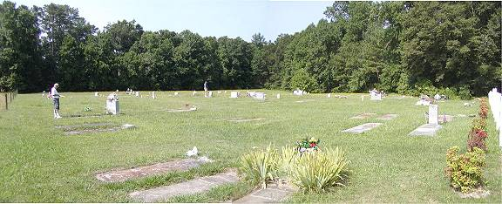
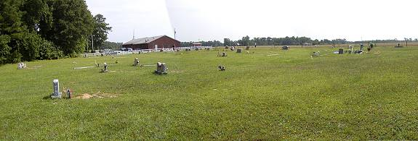
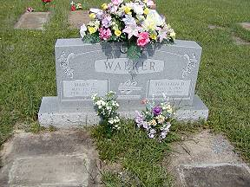 | 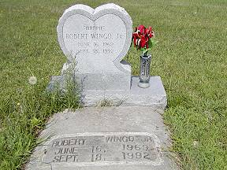
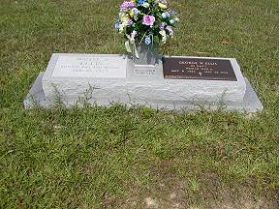 | 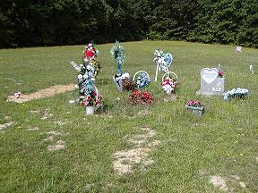
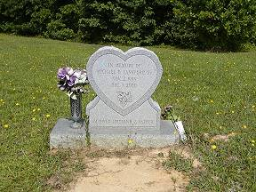 | 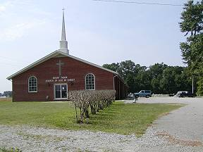
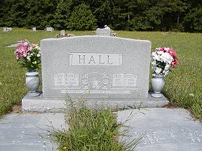 | 