MUMFORD ~Ecella Rd~ Cemetery
Visited by Members of
Grave Site Survey Task Force (GSSTF)
Under the Auspices of
Isle of Wight County Historical Society (IWCHS)
April 7, 2004

This single occupant cemetery is located in a field adjacent to the Mumford home. Land erosion has caused the adjacent farmland to be about three feet lower than the cemetery.

Throughout the transcribing process, an attempt was made to preserve the, ‘look and feel’ of the original inscriptions as regards word spacing, arrangement, and possible misspellings.

Please address your comments/corrections to: albert.b@charter.net or epowellsr@aol.com.

CARR MUMFORD
Born Oct. 1864
Died Dec. 16, 1928

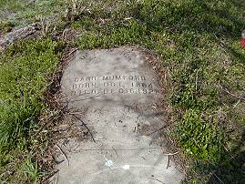 | 