Munford ~Central Hill Rd~ Cemetery
Transcribed by Members of
Grave Site Survey Task Force (GSSTF)
Under the Auspices of
Isle of Wight County Historical Society (IWCHS)
Visited Feb 27, 2005

There appears to be only one grave with just a fragment of a tombstone at this small cemetery, yet this cemetery has somewhat of a history. Team members talked to a resident living next to the cemetery to get permission to record the cemetery. The lady who answered the door said that her husband’s family was buried there (that would be Matthew Munford). She would speak to a relative who was in a nursing home in Smithfield to find out who else might be buried there and what the dates would be.

Reference to one of the team member’s records revealed the following information (the following is quoted from her records):

“From two different descendants of Wells Munford I was always told that two brothers (Matthew & Wells) were buried in this cemetery.

Matthew Munford
born abt 1845
died 8 May 1892
Matthew was a member of the 68th NC Co K
[stone at site was white marble with letter "M." visible, stone is similar to those placed for CSA Veterans]

Wells E Munford
born Oct 1855 [date from census]
died 5 May 1907 [date from family records]

****
other misc info regarding these two brothers

Matthew was married twice

1) unk had issue: John Franklin Munford (his descendants own house & cemetery I think)

2) Mary Emily Britt (1858 - 4 Apr 1926) buried at Central Hill small cemetery, dau of William Robert Britt (abt 1826 - 22 June 1862) and Elizabeth Johnson (born abt 1830 - died aft 1880) Matthew & Emily were married on 21 Feb 1878 by Samuel H Holmes

Wells was married to Sarah Elizabeth Britt (29 May 1856 - 1 July 1930) buried at Antioch, dau of William Robert Britt & Elizabeth Johnson, sister to Mary Emily Britt, Wells & Sarah were married on 17 June 1879 by Samuel H Holmes

Sarah & Emily had a third sister: Caroline Virginia Britt (6 Oct 1854 - 7 July 1931) buried at Central Hill who married George Robert Lewis Pulley (30 Oct 1844 - 11 July 1920) buried at Central Hill, married on 16 Feb 1875 by Samuel H Holmes

Interesting side note is that Samuel H Holmes also married the girls parents William Robert Britt & Elizabeth Johnson on 27 Nov 1851.”

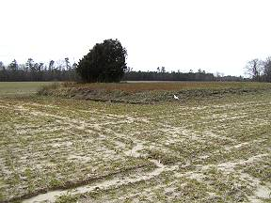 | 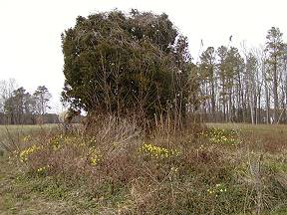
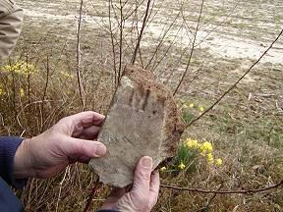 | 