NELMS ~Windsor Blvd~ Cemetery
Visited by Members of
Grave Site Survey Task Force (GSSTF)
Under the Auspices of
Isle of Wight County Historical Society (IWCHS)
May 7, 2004

This small cemetery is located in a forested area behind the Henry Saunders Place off of hwy # 460 about 2.2 miles east of Windsor. A deteriorated metal fence surrounds it and the entire area is heavily overgrown with dense vegetation and trees. One of the tombstones had fallen from its foundation and was erected to an upright position by team members.

Due to tombstone deterioration caused by weathering where the inscriptions were not legible, shaving cream foam was used to highlight the inscriptions and make them legible. Photographs # 2 and # 4 show the results of this process.

Any text within the “[ ]” is a comment about the tombstone inscription, ex., [fs] indicates a footstone inscription. Throughout the transcribing process, an attempt was made to preserve the, ‘look and feel’ of the original inscriptions as regards word spacing, arrangement, and possible misspellings.

Please address your comments/corrections to: albert.b@charter.net or epowellsr@aol.com.

Photo # | Inscription |  | Photo # | Inscription
1 | JOSEPH LAFAYETTE  NELMS  Aug. 15, 1882  Nov. 24, 1934  J.L.N. [fs] |  | 2 | JUDITH ANN  Wife of  W. J. NELMS  Died  Jan. 7, 1916  Age 77 years  “Our darling one has gone before  to greet us on the blissful shore”  J.H.N. [fs]
3 | J. R. L. NELMS  Born  Aug. 23, 1866  Died  Aug. 1, 1895  “Not lost to love, not lost to memory  But gone to our Heavenly home above”  J.R.L.N. [fs] |  | 4 | W. J. NELMS  Nov. 30, 1846  Nov. 13, 1918  “Peace Sweet Peace”

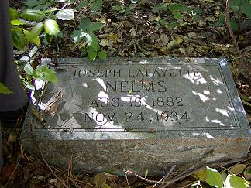 | 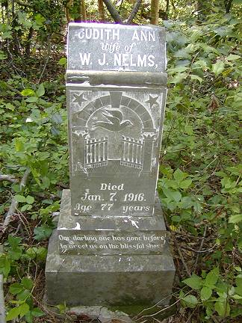
Photo # 1 | Photo # 2
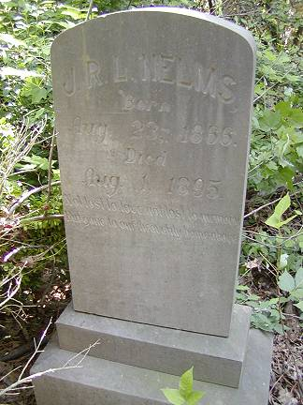 | 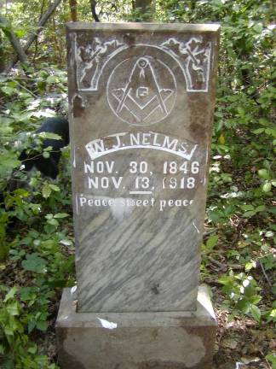
Photo # 3 | Photo # 4

