Nelms ~Trump Town Rd~ Cemetery
Transcribed by members of the
Grave Site Survey Task Force (GSSTF)
Under the Auspices of
Isle of Wight County Historical Society (IWCHS)
Visited November 16, 2005

This single-family cemetery is located just off the driveway to a private residence on Trump Town Road.

Throughout the transcribing process, an attempt was made to preserve the, ‘look and feel’ of the original inscriptions as regards word spacing, arrangement, and possible misspellings. GSSTF members were careful not to damage tombstones or artifacts during the transcription process.

Please address your comments/corrections to: albert.b@charter.net or epowellsr@aol.com.

Mother  ANN ATKINS  Wife  B. F. NELMS  Jan. 5, 1846  July 22, 1903  ------- | Father  B. F. NELMS  Sept. 22, 1839  Jan. 14, 1921  -------------
Thou God of love beneath thy
sheltering wing, we leave
our dead to sweetly rest.

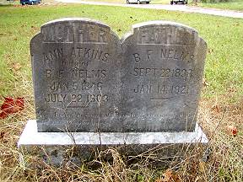 | 