New Bethany United Church of Christ ~Benns Church Blvd~ Cemetery
Transcribed by members of the
Grave Site Survey Task Force (GSSTF)
Under the Auspices of
Isle of Wight County Historical Society (IWCHS)
Visited June 4, 2005

This small cemetery is located adjacent to the Church and has been well maintained. All tombstone inscriptions are visible and were easy to decipher and record.

GSSTF members were careful not to damage tombstones or artifacts during the transcription process.

Any text within the “[ ]” is a comment about the tombstone inscription, ex., [fs] indicates a footstone inscription. Throughout the transcribing process, an attempt was made to preserve the, ‘look and feel’ of the original inscriptions as regards word spacing, arrangement, and possible misspellings.

Please address your comments/corrections to: albert.b@charter.net or epowellsr@aol.com.

 | Inscription |  |  | Inscription
 | R. ALTHENIA DEA. JAMES L.  Nov. 4, 1931 Mar 8, 1926  July 12, 2001 Aug. 4, 1999  JORDAN |  |  | MILES D. ROBINSON  10 – 3 - 31  2 – 16 - 2000
 | PERNELL BYRD  1917 -- 2000 |  |  | FRANCIS W. TRAVIS  June 10, 1915  Sept. 20, 2000  The Lord is my shepherd  I shall not want
 | NORA L. B. WHEELER  Apr. 4, 1919  Feb. 7, 2001 |  |  | In Loving Memory  RUTH E. JORDAN BLACKMON  Dec. 9, 1932  Sept. 20, 2003
JORDAN
RACHEL NICOLE
Apr. 4, 1985
Nov. 1, 2003

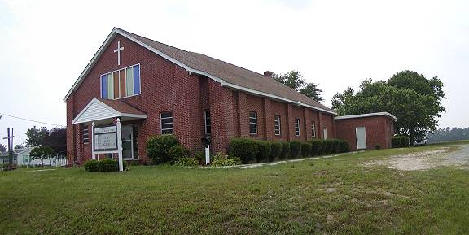

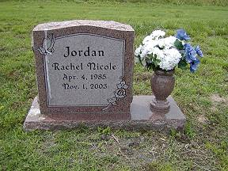 | 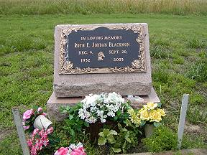
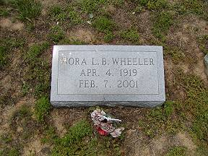 | 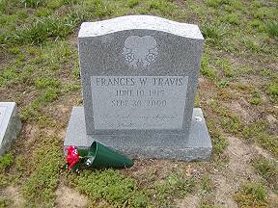
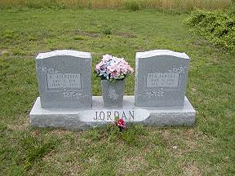 | 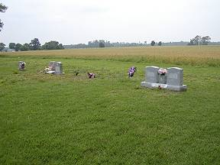
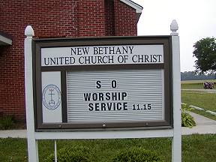 | 