New Gravel Hill_Old Stage Rd_Cemetery
Transcribed by members of the
Grave Site Survey Task Force (GSSTF)
Under the Auspices of
Isle of Wight County Historical Society (IWCHS)
Visited May 11, 2005

A selection of shaving foam, water, or talcum powder was used to improve the legibility of the inscriptions on the older tombstones. Afterwards, a clean water spray was used to remove any residue. GSSTF members were careful not to damage tombstones or artifacts during the transcription process.

Any text within the “[ ]” is a comment about the tombstone inscription, ex., [fs] indicates a footstone inscription. Throughout the transcribing process, an attempt was made to preserve the, ‘look and feel’ of the original inscriptions as regards word spacing, arrangement, and possible misspellings.

Please address your comments/corrections to: albert.b@charter.net or epowellsr@aol.com.

 | Inscription |  |  | Inscription
 | ROBERT L  BOWSER SR  US Navy  Korea  Apr 19 1929  Jun 14 1995 |  |  | SHIRLEY ANN  THOMPSON  Mar. 14, 1939  Dec. 18, 1995  Rest in Peace
 | Mother  P. CLARICE HARDY KEY  Oct. 2, 1938 -- June 15, 1996  WVESLM |  |  | STEVEN T  JONES  US Navy  Vietnam  May 26 1948  Jul 7 1998
 | Beloved Mother  ANNIE K. MILES  Mar. 31, 1933  Sept. 21, 2004 |  |  | WALTER  MILES  SP3  US Army  May 20 1937  Jul 29 1995
 | Husband/Son  BOBBY DARNELL KEY  Oct. 23, 1962 – June 14, 1996  11. WVESLM |  |  | Beloved Son & Brother  DR. MARC A. McCAIN  July 20, 1954  August 12,1996  In God We Trust
 | Beloved  Son Brother  Grandson nephew  Cousin Friend  Poet  MICHAEL R. YOUNG, JR.  July 1, 1977  April 2, 1999 |  |  | ARTHUR R. GLORIA J.  Mar. 20, 1927 Aug. 12, 1927  _________ __________  YOUNG
 | WILLIAM R. MATTIE KR.  Aug, 4, 1928 Aug. 14, 1928  __________ April 30, 1999  Beloved Wife  HOLMES |  |  | MELVIN MASON  6 1 25 2 2 05  Pooles Funeral Home
 | LOUVENIA L.  NASH  April 2, 1918  Feb. 23, 1990  In Loving Memory of Our Mother |  |  | MELVIN JEAN HARDY, SR.  Nov. 28, k1938  Dec. 25, 2000  WVVJ
 | MARY J.  May 15, 1921  Nov. 28, 1988  Beloved Wife |  |  | ANNA B. PERKINS  Aug. 25, 2905  May 18, 2000
 | Daughter  SANDRA N. BRADBY  Feb. 21 Nov. 20  1948 1971 |  |  | HAZEL M.  HERRING  April 13, 1925  Aug. 19, 1993  Beloved Wife, Mother & Grandmother
 | Mother / Daughter  VIOLA MARITHA KEY  Jan. 1, 1957 – Oct 26, 1997  ETD WESLM |  |  | EARNEST W HARRIS  1 17 28 1 10 01  Pooles  Funeral Home
 | WILLIE R.  Aug. 7, 1920  June 17, 1992  Beloved Husband |  |  | LITTLE  RUSSELL LEVOLIA M.  Jan. 8, 1925 June 23, 1914  Sept. 26, 1989 June 28, 1988
 | JANITA R, GOODWIN  June 29, 1963  Aug, 29, 1986 |  |  | WELLS  WILLIAM A. ARLENA J.  June 9, 1924 Apr. 39, 1927  _________ Feb. 25, 1999
 | [unmarked grave .. small wooden board in the ground] |  |  | JOHN T. MARTHA A.  Sept. 27, 1914 June 22, 1920  Feb. 16, 2002 May 4, 1997  Beloved Father Beloved Mother  & Grandfather ARMENTRIA & Grandmother  JOHNSON
 | ANNIE B. JONES  Nov. 23 1969  Aug 29 1986 |  |  | ARMENTRIA MAKRIS  11 . 22 . 1922 – 8 . 8 . 1986  Beloved Mother  Always in Our Hearts
[cs]  [hs] | JAMES O. WELLS  Feb. 13, 1921  Feb. 2, 1985  JAMES O WELLS  B2 US ;Navy  World War II  Feb 21 1921 Feb 2, 1985 |  |  | DAVID JANICE  WHITAKER WHITAKER  April 24, 1932 Jan. 9, 1929  ________ Jan. 28, 2002  Beloved Wife & Mother
 | ELMER HOWARD SARAH A.  June 4, 1926  May 17, 1998  Devoted Husband  & Father  JONES |  |  | JAMES A. SPRATLEY  Sept 12, 1909  July 1, 1968
 | Sister  NAOMI SPRATLEY  STEWARTJ  Nov. 18, 1904  Oct. 26, 1971  NAOMI S. STEWART  Nov, 18, 1904  Oct, 26, 1971 |  |  | GEORGE L. CONNOLLY  October 18, 1894  April 7, 1979
 | SPRATLEY  BENNIE CORENE R.  June 29, 1918 Feb. 10, 1921  April 8, 1975 July 15, 2001 |  |  | TROY E. BAILEY  Nov. 4, 1965  July 11, 1993  Beloved Father & Son
 | GEORGE A. CATHERINE E.  April 19, 1948 Nov. 25, 1948  ______________ Sept. 20, 1984  BRADBY |  |  | WILLIE ROBERTS  DORSEY  Feb. 22, 1915  Sept. 26, 2000  Devoted Mother & Friend
 | WILLIE E. BAILEY  April 23, 1962  Nov. 18, 1994  Beloved Father & Son |  |  | HENRY  SPRATLEY  Jan. 12, 1897  Nov. 30, 1975  In Loving Memory  At Rest
 | TRESSIE MOORE  1901 1986  Pretlow Chapman |  |  | VIRGINIA C. MARTIN  April 29, 1900  July 31, 1986  In Loving Memory
 | PEARL GWALTNEY  April 11, 1886  April 18, 1968 |  |  | WARNER H. WILSON JR  Nov 8, 1952  July 20, 1968  Bradby Service
 | JANE C, SCOTT  Aug, 30, 1908  May 20, 1980 |  |  | WILLIAM T.TYNES  Died nov, 1 1964
 | THOMAS ROBERTSON JR  July 28 1918  July 24 1984 |  |  | FRANK  BOWENS  1904 --- 1991  An Inspiration To  All Who Knew Him
 | CHARLES C  TYLER JR  PVT  US Army  World War II  Oct 3 1919  May 23 1979 |  |  | WARNER H  WILSON SR  PVT  US Army  World War II  Jan 27 1921  May 19 1999
 | JACK K. GWALTNEY, SR.  Mar. 10, 1924  Feb. 10, 1993 |  |  | SAM O PRESS  July 2, 1892  Jan 23, 1974
 | JAMES WALTER SMITH  June 10, 1924  Dec. 27, 1996 |  |  | JONES  Peace in the Valley  PEYTON RUTH  Aug. 22, 1902 Feb. 19, 1902  June 17, 1978 Aug. 25, 1980
 | ENGLISH  CECIL N MARY L.  Aug. 2, 1929 Jan. 5, 1932  Jan. 19, 1984 Jar. 27, 2001  CECIL N ENGLISH  Aug 2 1929  Jan 19 1984 |  |  | JOHNNIE TYNES  8 20 47 6 22 04  Pooles
 | DECATOR JEFFERSON  PVT US Army  World War II  1925 1982  DECATOR  JEFFERSON  Jul 20 1925  Jul 22 1982 |  |  | HERMAN R JONES  PVT US Army  1938 1989
 | TERRISSIA J, PERRIN  Jan 7 1946  Aug 4 1982 |  | [hs]  [cs] | C N ENGLISH  PFC US Army  World War II  1929 1984  CECIL N ENGLISH  Aug 2 1929  Jan 19 1984
 | MARGARET WYNN  12 2 23 5 31 04  Pooles |  |  | MARTHA BAILEY  Nov, 26, 1981
 | [illegible] L. TURNER  Jly[sic] 4, 1912  Mar. 28, 1985 |  |  | ELMER TURNER  Oct 15 1909  Nov 26 1981
 | ARLETHIA V HARRIS  June 26, 1938  Feb. 3, 1985 |  |  | LELAND J. HARRIS  Jan. 4, 1967  July 89, 1976
 | [unmarked grave] |  |  | [unmarked grave]
 | ADDIE LEE WELLS  HARRIS  May 13, 1894  Oct. 7, 1978  In Loving Memory  Of Our Mother |  |  | MARY E. SPRATLEY  Born April 5, 1896  Died May 5, 1965
 | F. D. SPRATLEY SR  Dec. 4, 1897  Mar. 14, 1981 |  |  | AMANDA S. DRUMGOOLE  Born July 26, 1900  Died June 17, 1958
 | JOHN SHELTON  Died Mar. 19, 1951 |  | [slab] | [illegible)
 | MINNIE PEARSON  Jun. 24, 1889  Jan, 19, 1978 |  |  | JANNIE MOODY  Apr 17, 1877  Sept 21, 1933
 | ROBERT MOODY  Nov. 6, 1830  Aug. 13, 1900 |  |  | MANDY MOODY  May 6, 1839  Jan, 12, 1908
 | MANDY [illegible … hand carved]  1919 |  |  | [illegible]
 | [illegible] |  |  | GLADYS A. MINGS  Feb. 6, 1910  April 13 1995
 | NOSES MINGS  Feb 8 1894  Aug 26, 1979 |  |  | ADOLDHUS DRUMGOODE  Jan 9 1902  July 15 1969
 | ROBERT MINGS  Virginia  PVT CO L 370 Infantry  World War I  Sept 21 1891 June 2 1961 |  |  | HARRIET E. WILSON  Aug 20, 1923  Jan. 26, 2000  Not My Will but Thine be Done
 | MARY W WELLS  Dec. 21, 1935  Mar, 25, 1996  All that we needed God provided  Rest in Peace |  |  | RALPH S. BROWN JR  Sept. 15 1955 April 16 1994  We loved you, but God loved you more
 | Father  JOSEPH A. BAILEY  Jan. 11, 1910  June 5, 1989 |  |  | Mother  OCTAVIA D. HOLLOMAN  April 9, 1884  December 5, 1976
 | ALEX E. CRAWLEY  Aug 28, 1910  Oct. 1, 1974  In Loving Memory |  |  | THELMA B. WELLS  Aug 11, 1912  July 18, 1996  Rest in Peace
 | ROBERT B. WELLS  June 15, 1902  Nov. 20, 1982 |  |  | ETHEL WELLS  B. Sept. 21 1908  D. Sept 25 1977
 | Our Beloved Mother  JOSEPHINE J. BOWSEA  Mar. 8, 1907  20, 1937  Thy Rod and thy staff  They comfort me |  |  | JAMES HOLLOMAN  Oct. 28 1908  Nov, 3 1976
 | Our Beloved Father  REV. EDWARD F. BOWSER  May 4, 1905  Sept. 28, 1975 |  |  | THEODORE A BAILEY  PFC  US Army  JUL 17 1927  Sep 30 1991
 | [new grave … no markings] |  |  | CORA C JOHNSON  Mar 3, 1939  Sept 15, 1992
 | JOHNSON  PERCY L. GIRLIE H  1900 – 1925 1907 -- 1996 |  |  | Beloved Mother Grandmother  And Great Grandmother  MASURIA GRIFFIN  Feb 17, 1928 Apr. 25, 1995
 | ADDIE J. HILL  Born July 26, 1902  Died June 9, 1983 |  |  | REBECCA ROBERTSON  Nov. 27, 1899  1972
 | JANIE E JACKSON  Mar. 2 1925  Apr 11 1984 |  |  | MAMIE H. HARRIS  Aug 16, 1889  Nov 10, 1979
 | SAMUEL A HOLMES  Dec. 22, 1901  Feb 27, 1984 |  |  | EMMA J. HOLMES  Mar. 23, 1909  Dec 1, 1974
 | ARTHUR S. JEFFERSON, JR.  May 28, 1952  July 26, 1944 |  |  | STANLEY J. JOHNSON  April 29, 1935  Oct. 1, 1966
 | HARDY  WALLACE L. SR. GRACE LEE J.  Jan 18, 1919 Aug. 4, 1921  Oct. 21, 2001 May 4, 2001  WW! |  |  | MAXIE HARDY  Born Mar. 10, 1921  Died Dec. 29, 1963
 | MAXIE HARDY  Virginia  CPL Engineers  World War II  March 10 1921 Dec 29 1963 |  |  | CARRIE A. THOMPSON  B. 4 15 1903  D 10 26 1976  Rushmere VA
 | THOMPSON  CARRIE B. JAMES L.  Apr 15, 1903 Feb. 6, 1897  OCT. 26, 1976 Jan. 7, 1963 |  |  | JAMES L THOMPSON  Virginia  PVT US Army  World War I  Feb 6 1897 Jan 7 1963
 | OSCAR R THOMPSON SR  Us Army  World War II  Sep 19 1925 May 14 1981 |  | [hs]  [slab] | Mother  IRENE ROWLETT  LOCKETT  Feb. 10, 1921  June 1, 1972  In Loving Memory  IRENE R. LOCKETT  Feb. 10, 1921  June 1, 1972
 | BIRDIE A ROWLETT  Jan 31 1918  April 19 1971 |  |  | OCIR A. ROWLETT  Jan. 25, 1888  Feb. 17, 1966
 | MAUDE ROWLETT  Born Feb. 13, 1897  Died Dec. 29, 1962 |  |  | OTHELL OSLIN  ROWLETT  May 24, 1928  June 15, 1996
 | Mother  VOHN DELA MASON  Oct. 29, 1899  Feb. 16, 1965 |  |  | EDWARD L. JONES  Dec. 8, 1882  Jan.10, 1964
 | ALVIN JONES  Virginia  PVT  US Army  World War I  September 18 1893  April 21 1970 |  |  | Mother  ELIZABETH JONES  Sept. 23, 1908  July 27, 1981
 | JOHNNIE MASON  1901 – 1964 |  |  | BAILEY  LADY ROOSEVELT THEODORE  Nov. 6, 1900 Aug, 13, 1902  Nov. 27, 1987 May 20, 1973
 | ARICHARD WILSON  1893 -- 1964 |  |  | GLORIA G. FLEMMING  1942 – 1965
 | CORA W. FLEMMING  Apr. 16, 1922  Mar. 29, 1987  Mother and  Grandmother |  |  | ARDELL V. MINGS  March 2, 1917  April 14, 1973
 | ROWLETT  STANDLEY O. BESSIE E.  Dec. 29, 1925 May 4, 1931  Aug. 24, 1991 Dec. 14, 1979 |  |  | JOE WILLIAMS  Sept 9 1969
 | DINAH WILLIAMS  Aug. 10, 1875  March 9, 1968 |  |  | ROXIE GILES  Sept. 21, 1901  Feb. 27, 1967
 | OWENS  JAMES A. CALTHIA B.  APR. 13, 1902 Feb. 4, 1908  Sept. 16, 1990 Apr 14, 1966 |  |  | JAMES EDWIN WELLS  SSGT US Army  World War II  Aug 8 1920 Dec 27 1978
 | MIKE JOHNSON  Jan – 15 – 1874  May – 11 – 1961  Pooles Service |  |  | ELLA B. JOHNSON  Aug. 16, 1881  Oct. 8, 1967
 | WILLIAM SMITH JR.  July 15, 1938  April 6, 1961 |  |  | BRADBY  HENRY H. VIRTLEY T.  November 26,1923 July 2, 1926  ----------- December 1, 1994  Father Mother
 | WILLIAM SMITH  S1 US Navy  World War II  Mar 15 1913 Oct 1 1990 |  |  | ALPHA B SMITH  June 6 1918 January 31 2008  “Loving wife mother  And Grandmother”
[hs]  [slab] | DOROTHY E. THOMAS  Jan. 17, 1916  Oct 5, 1995  Our Beloved Sister  DOROTHY BRADBY THOMAS  Jan 17 1916  Oct 5 1995 |  |  | Mother  FLORENCE E. BRADBY  May 26, 1897  Jan. 18, 1969
 | ALMA E. BURRELL  Dec. 11, 1936  Jan. 15, 1978 |  |  | EMMA J. HOLMES  Mar. 23, 1909  Dec. 1, 1974
 | SAMUEL A. HJOLMES  Dec. 22, 1901  Feb. 27, 1984 |  |  | JOHNSON  STERLING, SR. GLADYS M.  May 5, 1926 Mar. 2, 1928
 | ROBERTSON  MARY TENA THOMAS, SR.  Sept. 17, 1888 Jan 21, 1890  Oct. 19, 1991 Dec. 14, 1980 |  |  | MAJOR PIERCE JR  PVT US Army  Apr 8 1934 Feb 19 1977
 | ANNE J. JOHNSON  Oct. 22, 1903  Jan. 29, 1972 |  |  | LOTTIE W. LITTLE  Jan. 30, 1909  April 30, 1990
 | L. PERRY LITTLE  Nov. 26, 1906  Jan. 31, 1974 |  |  | YVONNIE S. JAMES  1937 – 1985  Beloved Wife  And Mother
 | THOMAS T WELLS  SGT US Navy [sic]  World War II  May 20 1918 Jul 8 1983 |  |  | HAROLD M. HOLMES  July 21 1939  Jan 11 1985
 | CHARLES A. REESE  June 26, 1938  Nov. 26, 1971 |  |  | MAC A. BANKS  May 18, 1942  May 15, 1971
 | LITTLE  JAMES JR JEWEL R.  July 26, 1937 July 5, 1942  _______ Dec. 3, 1990 |  |  | (Mr) EDWARD Z. ELLIOT  Born June 6, 1929  Died June 20, 1998
 | THOMAS J. REESE  11 26 65 6 6 02  Pooles Fu |  |  | JONES  ROYCE L. JEAN B.  Feb 12, 1938 July 26, 1939  Sept. 6, 2004
 | WILLIAM M EDWARDS  5 24 41 12 26 00  Pooles Funeral Home |  |  | CLEO GWALTNEY FLOOD  1921---- 2001  The smartest girl in  Isle of Wight County
 | CRPL . RAEICH  SMITH , JR.  U.S. Army  Nov. 1926  Feb. 01 |  |  | ALICE H. HILL  January 6, 1928  April 28, 2001  Gone but not  Forgotten
 | ALVIN T HUDGINS  1994 2002  Pretlow & Chapman |  |  | ERNEST P. DIGGS, JR.  1955 – 2001  In loving memory
 | HOLMES  STANLEY N. SR. MAJORIE F.  May 25, 1930 Nov. 26, 1933  Dec. 5, 2001 Oct. 3, 2001  Proud Parents of Stanley J. Carol,  Andre, Vivian, Sonya, and  Kenneth. |  |  | ISABELLE E  ROBERTSON  POOLES
 | DOROTHY M. THOMPSON  Jan. 14, 1920  May 2, 2002 |  |  | “My Ma”  MARTHA V. SCOTT  Feb. 14, 1917  July 19, 2003
 | SPRATLEY  GENE RAY, JR FELEAN GIBBS  Dec. 29, 1956 Sept. 8, 1961  Oct. 11, 2003 Oct. 11, 2003  BRITTANY GENETTE TREY JAMAL  Sept. 10, 1986 July 20, 1990  Oct. 11, 2003 Oct. 11, 2003 |  |  | OSBORNE  WARREN WILLIAM  Jan. 8, 1941  Nov. 25, 2003  VERMONT WILSON  Feb. 2, 19[illegible]
 | LUKE ROBERTSON  3 18 22 4 10 04  Pooles |  |  | HUBERT ROBERTSON  Mar. 30, 1943  Dec. 30, 1962
 | CHARLIE ROBERTSON  Died  July 19, 1963 |  |  | LUCY J. ROBERTSON  Nov. 125, 1923  Apr. 13. 1973
 | FANNIE W. RIBERTSON  Aug. 10, 1892  Oct. 23. 1976 |  |  | MOLLIE TYNES  Died July 19, 1964
 | EDDIE TYNES  Died April 30 1964 |  |  | MARGARET J HILL  April 8 1867  June 10 1965
 | RUSSELL JOHNSON, SR.  April 8, 1908  May 24, 1988  Beloved Husband |  |  | SARAH JOHNSON  4 2 10 3 7 04  Pooles
 | ROSANNA J SMITH  Sept 29, 1893  Aug. 1, 1974 |  |  | RALEIGH SMITH  Sept 15, 1991  Nov. 12, 1966
 | EVELYN D. JOHNSON  Aug. 6, 1941  Aug. 17, 1995  Eternal Rest  Mom, Dad & Family |  |  | TAMULA DIANNE JONES  Dec. 8, 1961  Oct. 11, 1972
 | DORIS J HICKS  May 9. 1923  Jan 20, 1968 |  |  | JAMES ALLEN JONES  Virginia  AN US Navy  MARCH 14 1936 Dec. 21, 1968
 | SARAH R. HARRIS  May 30, 1919  July 1, 1971 |  |  | JAMES R. HARRIS  March 13, 1917  June 26, 1972
 | LURETTA W. JOHNSON  Dec. 4, 1891  July 21, 1971 |  |  | WILLIAM I JOHNSON  Feb. 11, 1903  Jan. 21, 1983  Pooles
 | JOHNSON  ISAAC SR. EMILY E.  1909 – 1985 1912 |  |  | JONES  ALLAN D.  Feb. 21, 1932  Feb. 16, 1987
 | RUTH A.  June 16, 1936  May He rest in peace forever,  May his music live on forever  Through us. |  |  | JAMES BUDDY BAKER  Aug. 6, 1931  June 15, 1987
 | ELIZABETH R. JOHNSON  December 12, 1916  December 7, 1987 |  |  | RIDDICK JOHNSON SR  January 1, 1912  October 16, 1994
TYNES
CHRISTINE P. EDWARD
1926 – 1990 1919 -

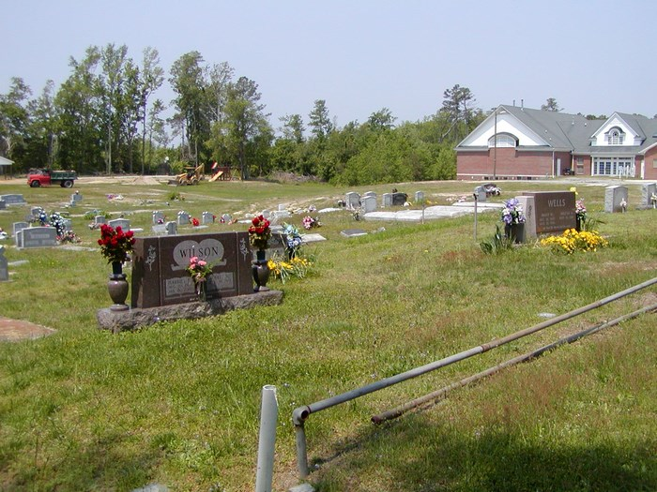 | 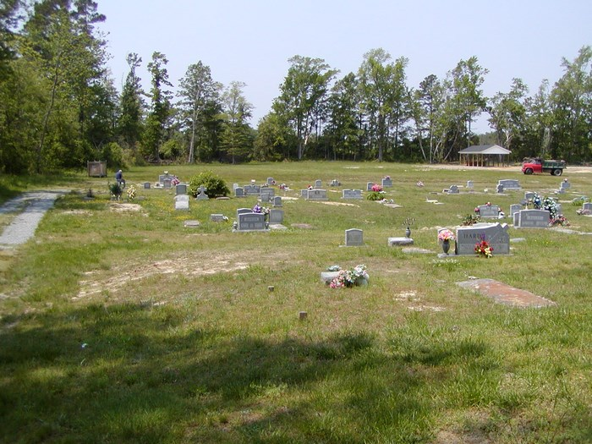
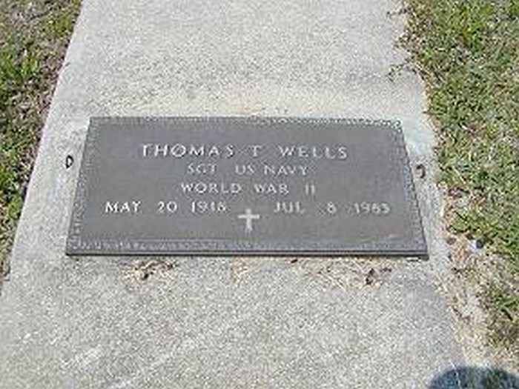 | 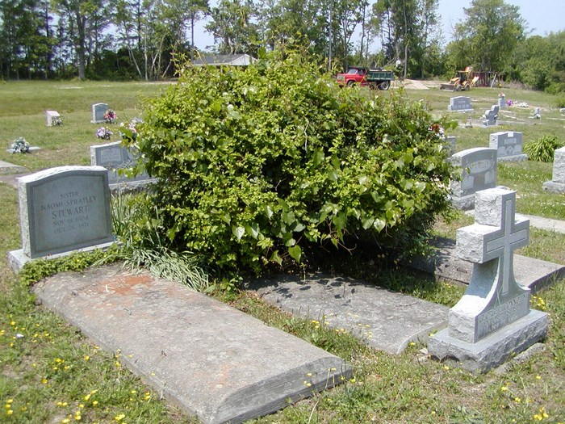
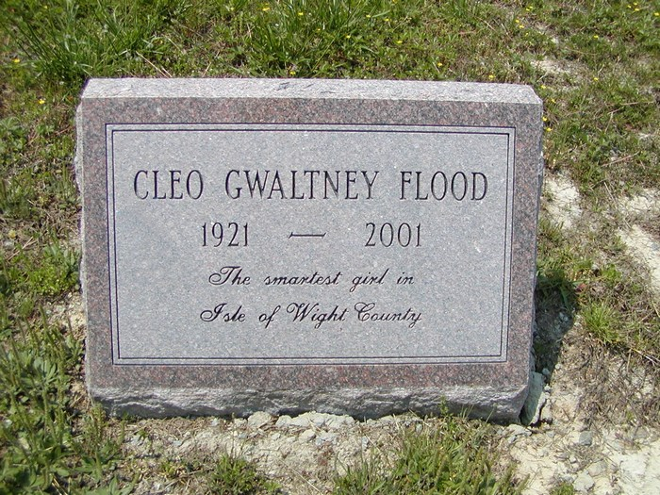 | 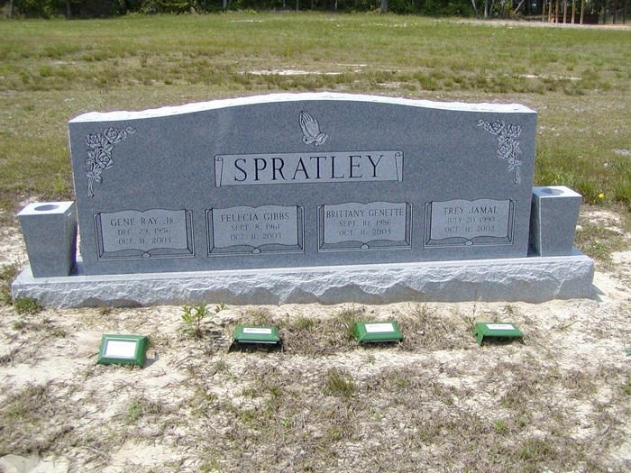
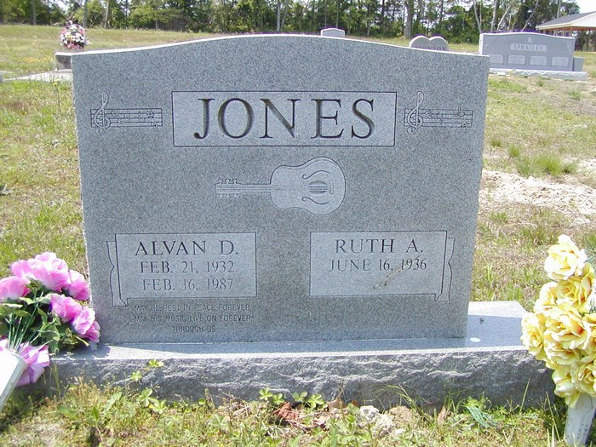 | 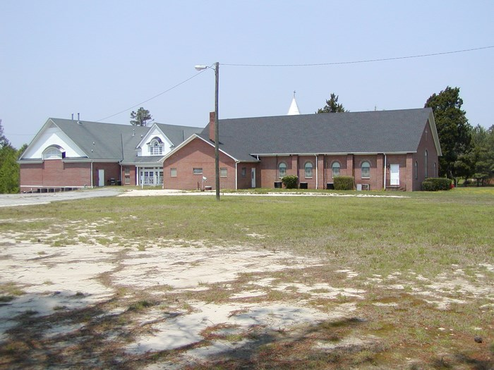
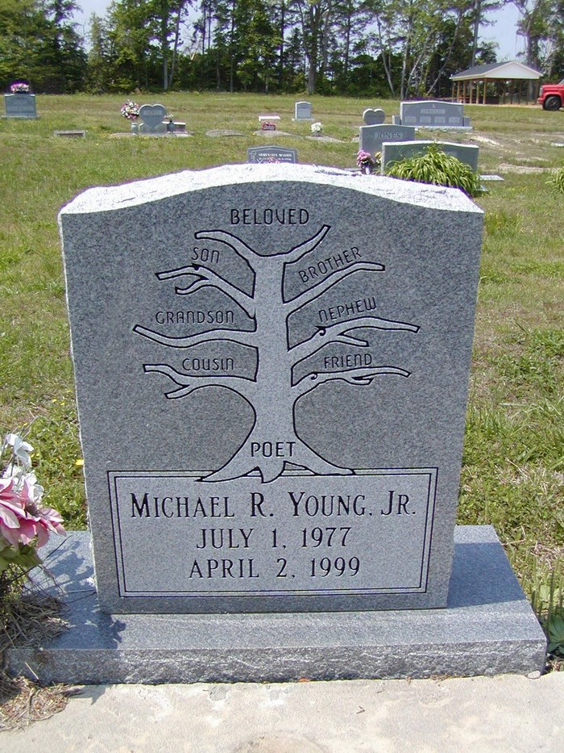 | 