New Jones Grove ~Woodland Drive ~ Cemetery
Transcribed by members of the
Grave Site Survey Task Force (GSSTF)
Under the Auspices of
Isle of Wight County Historical Society (IWCHS)
Visited May 4, 2005

A selection of shaving foam, water, or talcum powder was used to improve the legibility of the inscriptions on the older tombstones. Afterwards, a clean water spray was used to remove any residue. GSSTF members were careful not to damage tombstones or artifacts during the transcription process.

Any text within the “[ ]” is a comment about the tombstone inscription, ex., [fs] indicates a footstone inscription. Throughout the transcribing process, an attempt was made to preserve the, ‘look and feel’ of the original inscriptions as regards word spacing, arrangement, and possible misspellings.

Please address your comments/corrections to: albert.b@charter.net or epowellsr@aol.com.

 | Inscription |  |  | Inscription
 | PORTER  ARLEAN C. WEBSTER D.  May 4, 1896 June 8, 1897  Sept. 20, 1989 Aug. 3, 1937  Devoted Mother Together Forever Loving Father |  |  | GLADYS R. ELEY  Sept. 21, 1922  Aug 29, 1981
 | WAVERLY PORTER  Feb. 18, 1920  Dec. 22, 1955 |  |  | D. W. (marker with hand carved initials)
 | GRACE P. LONGHORNE  May 2, 1983 |  |  | father mother  MERVIN L. ANNA MARIE  Aug. 28, 1912 Aug. 28, 1913  Nov. 20, 1958 Feb. 8, 1971  WILSON
 | NOEL J. EDITH W.  Apr. 23, 1908 Mar. 24, 1910  Aug. 21, 1972 Dec. 9, 1967  I will lift up mine eyes unto  the hills from whence cometh my help.  Psalms 124  JORDAN |  |  | (3 pointed markers, 2 unmarked graves, 1 hand-carved stone with the initials, E. D.)
Note (1) | MRS. CLAUDIA ELEY  1921 – 1930 |  | Note (2) | MRS. LIZZIE ELEY  Born Dec ______  Sept. 8, 1949
 | REV. JESSIE M.  ELEY  May 4, 1920  May 24, 2002 |  |  | DAN ELEY  June 9, 1896  Jan. 5, 1975
 | GLEENWOOD BAKER  1875  Dec. 24, 1968 |  | Note (3) | _ _ _ CLESION ELEY  1922 1984
 | JONES  HENDERSON PLUMMIE  Dec. 9, 1865 Dec. 19 1875  Feb 4, 1957 Feb 13 1950 |  |  | ALTON P. JONES  Oct. 28, 1917  July 31, 1972
 | COWLING  JAMES T. ESSIE J.  1897 – 1953 1900 - 1972 |  |  | JOSEPH E. JONES  Sept. 15, 1915  May 2, 1968
 | ALICE M. JONES  March 1, 1917  July 5, 1992 |  |  | WILLIAM W. HOLLAND  May 6, 1915  Jan. 2, 2002
 | SAMUEL E. JONES  father of  JUNIOUS T. JONES  And Husband of  NANNIE F. JONES  Sept. 22, 1897  May 24, 1924  Oh, death where is thy sting  Oh, grave where is thy victory  Triumphant is Christ. |  |  | WALDEN  RICHARD H. ALVERTA P.  Dec. 29, 1903 Mar. 15, 1905  Nov. 15, 1945 Dec. 7, 1992
 | PORTER  WILLIAM E. NOVELLA B.  1880 – 1951 1888 – Sept. 15, 1961 |  |  | MARTHA A. JONES  1903 – 1919
 | CORRINE PORTER  June 14, 1921  Oct. 16, 1964 |  |  | (non legible marker)
 | MRS. ETHEL A. DIXON  Dec. 25, 1900  Oct. 17, 1952 |  |  | TONEY E. ALLMOND  Born Oct. 16, 1879  Died April 4, 1907  Beloved one, farewell  Peace Perfect Peace  T.E.A. (fs)
 | Our Dear Mother  BELLE D. ALLMOND  Born Oct. 14, 1860  Died Oct. 3, 1933  Our Faithful Mother |  |  | Peace Perfect Peace  Our Dear Father  TONIE ALLMOND  Born May 15, 1853  Died Oct. 10, 1917  His last words: “If I tell you I see Jesus  You all would not believe me”  We loved him but the Lord loved him best
 | ALLMOND  LILLIE M. CLAIBORNE B. S. MARY N  Born Mar 11, 1891 Born July 10, 1878 Born Aug 14, 1895  Died Oct. 21, 1972 Died Dec 12, 1951 died Aug 9,1916  Baby WAVERLY  rest with her |  |  | THOMAS H. ALLMOND  Nov. 5, 1905  Dec. 27, 1996
 | (broken marker .. unable to read) |  |  | JORDAN THOMAS  Virginia  Pvt. Co I 370 Infantry  World War I  Feb. 13, 1894 Jan 8 1965
 | Mother  IVORY L. TYNES  Aug 10, 1913  Jan 20, 1973 |  |  | HENRY HOWARD ALLMOND SR  Sgt  U.S. Army  World War II  Jan 3 1923  Aug 18 1984  Eternal Love
 | TIMOTHY ERNEST ALLMOND SR.  July 20, 1927  Dec. 17, 1990 |  |  | GWALTNEY  ROBERT L. MARY A.  Mar 12, 1905 July 30, 1920  Jan 23, 1999 July 1, 2002  Our Father which art in Heaven
Note (4) | MRS LANER |  |  | EDDIE EDWARDS  Aug. 31, 1979
 | SAMUEL ARTIS SR  Sept. 16 1922  Mar 3 1998 |  |  | EVELYN ARTIS  April 10, 1922  Dec. 11, 1998
 | STANLEY M. WIGGINS  May 15 1945  April 8 1989 |  |  | OLLIE ANDRE MANUEL  June 27 1955  Jan 8 2001
 | ANITA MANUEL  June 15 1958  Jan 2 2004 |  |  | JOHN COOPER  April 18, 1918  Aug. 3, 1993
 | JAMES J. DELOATCH  DOB Aug 21, 1918  DOD March 6, 2004 |  |  | ROMONA MARNA SEABORN  Sept. 17, 1957  Feb. 19, 2001  Beloved Mother
 | ROBERT LANG HORNE  TN US Navy  World War II  1920 1979 |  |  | EARLENE P. LANGHORNE  Feb. 2, 1927  June 8, 1993
 | GALVIN P. ALLMOND  Feb. 21, 1978 |  |  | MR. JOSEPH TYNES  1958
 | Mrs. BESSIE EDWARDS  1854 - 1954 |  |  | WILLIAM H. TYNES  Born 1911 – Died 1953
 | LINWOOD E. TAYLOR  March 8, 1950  Jan. 22, 1994 |  |  | RACHEL M. ARTIS  1922 – 1971
 | LUVENIA WILLIAMS  1914 – 1969 |  |  | CORIN B. ARTIS  1894 – 1966
 | EDWARD L. COFER SR  Sept. 6, 1915  April 9, 1988 |  |  | BERNIE SEABORN  1914 – 1988
 | JOHN L. SEABORN  Born March 8, 1883  Died June 23, 1958 |  |  | MARY L. SEABORNE  died Aug 18, 1970
 | CATHERINE ELEY  died July 30, 1962 |  |  | ALLIE ELEY  Virginia  PFC  US Army  World War I  December 25, 1895  September 29, 1962
 | HENRY H. GATLING  June 2, 1904  Feb. 14, 1973 |  |  | JESSIE GHOLSTON  Nov. 16, 1937  Aug. 24, 1976
 | JONATHAN L. ANDERSON  July 26, 1986  March 10, 1988 |  |  | CURTIS L. GOSTON  Dec. 8, 1927  April 1, 1991
 | JOHNNIE GHOLSTON JR  Aug 30, 1929  Feb. 20, 1997 |  |  | ALLEN GHOSTON  Born Dec. 2, 1921  Died Sept 13, 1942
 | JOHNNIE GOSTON  Sept. 10, 1900  Oct. 27, 1970 |  |  | RISSIE B. GHOSSTON  Sept. 28, 1903  June 6, 1993
 | VIRGINIA G. HOLLOMAN  Sept. 7, 1933  Aug. 20, 1993 |  |  | MRS. NETTIE SCOTT  Aug. 14, 1912  July 10, 1951
 | MARY JORDAN  1915 – 1964 |  |  | J. W.
 | JAMES H. WARREN  March 25, 1902  Nov. 20, 1965 |  |  | JOSEPHINE WARREN  Dec. 7, 1903  Jan. 16, 1977
 | (6 unmarked graves) |  |  | ALLMOND  ROBERT I. ALLMOND  June 27, 1885  Nov. 14, 1963
Note (5) | ROBERT O. ALLMOND  June 27, 1885  Nov. 14, 1968 |  |  | REV JOSEPH C. ALLMOND  June 25, 1896  June 1, 1969
 | JOHN W. ALLMOND  Aug. 27, 1889  Aug. 5, 1956 |  | Note (6)  Note (7) | JOHN W. ALLMOND  Born Aug, 27, 1889  Aug. 5, 1956  JOHN W. ALLMOND  Born Aug, 28, 1889  Died Aug. 5, 1956
 | (unmarked grave) |  |  | (unmarked grave)
 | BESSIE E. JAMES H.  Apr. 4, 1907 June 25, 1900  July 22, 1989 Oct. 23, 1972  ALLMOND |  |  | WAVERLY WHITE  Jan. 16, 1922  Nov, 15, 1997
 | JOHN L. WHITE  Died May 28 1964 |  |  | QUEENIE M WHITE  Dec 24 1904  June 29 1988
 | GRACIE HALL  Born July 1925  Died Oct. 9, 1957 |  |  | TYNES  JOSEPH NETTIE A.  Nov. 10, 1862 Jan. 16, 1882  Oct. 15, 1940 (blank)
 | JOSEPH TYNES  Oct 15, 1940 |  |  | NETTIE ANN TYNES  Dec, 11, 1972
 | WALTER P. TYNES  1909 - 1937 |  |  | EMILINE DAUGHTERY  1857 – 1941
 | HENRY E. TYNES  1916 – 1962 |  |  | (unmarked grave)
 | SOLOMON E. TYNES  Dec. 12, 1912  Dec. 18, 1964 |  |  | SOLOMON E. TYNES  Died Dec 18, 1964
 | BUTLER  MARY L. JOHN J.  Nov. 5, Feb 8 Sept. 15 May 5.  1879 – 1923 1873 1922 |  |  | SELENA B SAUNDERS  Oct 1 1904  June 8 1984
 | (10 unmarked graves) |  |  | LILLIE INEZ TUCKER  1967 1967  Tynes Cook Funeral Home, Inc.
Note (8)  Note (9) | JAMES M  WIGHT  Virginia  PFC  US Army  World War I  November 25 1892  April 6, 1969  JAMES M WHITE  Nov. 25, 1892  April 6, 1969 |  |  | TODD  JERRY ROSA ANNA  Mar. 1858 Apr. 1859  Feb. 1948 Nov. 1937
 | ANITA  MANUEL  June 15 1958  Jan 2 2004  CROCKER |  |  | RICHARD LILLIAN D.  1875 1952 1901 1949  ELEY  RICHARD ELEY (slab inscription)
 | LILLIAN D ELEY  Born 1901  Died 1949 |  |  | HESTER D PORTER  Born – 1888  Died – 1948
Note (10) | JOEL POETER  Aug 27 1915  Sept 11 1965 |  |  | JACK WILLIAMS JR.  Dec. 23, 1974
 | CLARENCE W. SEABORN  Died July 12, 1964 |  |  | (4 unmarked, small graves)
 | TYNES  IDA E – GEORGE W |  |  | ALICE C TYNES  Feb 15 1911  Sept 22 1987
 | (unmarked adult grave) |  |  | CHARLES BAILEY  D - - D July 5 1939  TYNES
 | LAURA HOLLOWAY  Mar 1967  Pretlow Chapman |  |  | (unmarked – steel rebar covering)
 | JAMES BAILEY  Died Mar 1 1949  TYNES |  | Note (11) | JOSEPHINE BAILY  Died Feb 1 1942  TYNES
 | MAMIE W. ALLMOND  1925 1972 |  |  | ROY N  ALLMOND  Virginia  Cpl Sq F  2109 Base Unit AAF  World War II  March 11 1919  June 8 1962
 | MARY L. ALLMOND  Sept 6 1894  Dec 3 1959 |  |  | CLINTON  Father Mother  DENNIS L., SR. SADIE B.  Apr. 19, 1910 Sept. 15, 1915  Jan. 7, 1972 July 25, 1984
 | GEORGIA H. WARREN  June 20 1927  July 9 1994 |  |  | DENNIS L. CLINTON, SR.  April 19, 1910  Jan 7, 1972
 | SADIE B CLINTON  Sept. 15, 1915  July 26, 1984 |  |  | DENNIS L. CLINTON, JR.  April 25, 1945  Sept. 17, 1989
 | GEORGE H WARREN  Oct 18, 1925  Oct 25, 1996 |  |  | WILBERT E. PORTER  Nov. 25, 1982
 | ERNEST L. WELLONS  Jan. 27, 1935  Sept. 25, 1989 |  | Note (12) | BAKER H. ALLMOND  Oct. 13, 1925  Sept. 17, 1991  BAKER H ALLMOND  STM1 US Navy  World War II
 | Wife  LAURA A. MADDREY  Dec. 31, 1925  Apr. 16, 1992 |  |  | EUGENE WARD  Jan 26, 1968
 | GEORGE M. PORTER, JR.  May 28, 1957  Oct. 5, 1990 |  |  | REB. DOROTHY E. PORTER  Nov 11 1930  Sept 5 2004
 | GEORGE M. PORTER  Feb 8, 1927  Dec 2, 1990 |  |  | RUTH M. PORTER  Aug. 2, 1928  Sept. 15, 1998
 | WESTLEY J. PORTER  Jan. 12, 1922  April 8, 1993 |  |  | SUSIE P. ALLMOND  March 17, 1899  Aug 28, 1976
 | JOEL B. PORTER  Died May 19, 1964 |  |  | PORTER  NORA J. DAVID V.  July 10, 1920 Jan. 23, 1918  (blank) Nov. 8, 1961  Gone but not forgotten
 | MICHEAL NEWBY  April 10, 1961  Jan 3, 1981 |  | Note (13) | ELIYEBATH NEWBY  Sept 9, 1900  Apr 13, 1978
 | THOMAS L. NEWBY  Born Mar. 2, 1910  Died Aug. 7, 1936 |  |  | JOSEPH M. NEWBY  Born Feb. 21, 1880  Died Dec. 16, 1932
 | WILLIAM D. ALLMOND  Mar. 1, 1924  May 7, 1987 |  |  | ALLMOND  MOSES K. MARY B.  Apr. 19, 1893 Apr. 20, 1901  Feb. 18, 1959 June 2, 1985
 | PEARL J. A. FENTRESS  Mar. 14, 1941  May 9, 1996 |  |  | MOSES K ALLMOND  Virginia  PFC  US Army  World War I  April 19 1893  February 18 1959
 | PEARL B BAILEY  July 7, 1905  Sept. 29, 1929 |  |  | CLINTON  EARNEST O. LAWNELLE E.  Feb. 13, 1913 Sept. 18, 1918  June 24 2000
 | DAVID H. ALLMOND  April 14 1891  Dec. 28 1971 |  |  | ORA E. ALLMOND  Oct. 24, 1899  June 1, 1965
Note (14) | HERBERT L. ALLMAN  Born May 29, 1924  Died March 24, 1955 |  | Note (15) | WILLIE CLANTON  1889 - 1961
 | JAMES WHITEHEAD  Sept. 25, 1937  Aug. 14, 1968 |  |  | JASPER L. JONES  Aug. 21, Mar. 27,  1933 2002
 | ARTHUR M. JONES  July 3, 1936  Mar. 29, 1982 |  |  | BETTIE L. JONES  Born Sept. 1, 1914  Died Oct. 4, 1960
 | VIRGINIA I. JONES  May 29, 1907 - Dec. 16, 2000  ~~~~~~~  Tynes-Edwards and Turner Funeral Home |  |  | Mrs. VIRGINIA J. BUTLER  Born 8-16-1961 Died 5-12-2004  Age 42  Shivers Funeral Chapel  12749 Courthouse Hwy  Smithfield, VA.
 | HERMAN FENTRESS JR.  Oct. 19, 1963  June 10, 1976 |  |  | LARRY H. LEWIS, JR.  Jan 28, 1963  Feb. 13, 1963
 | INFANT SON OF  Mr. & Mrs. BAKER  ALLMOND  Aug. 13, 1958 |  |  | SAMUEL BAKER  Jan 15, 1931  Age 64
 | MINNIE L. BAKER  Dec. 17, 1884  Nov. 19, 1967 |  |  | CORNELIONS B  ALLMOND  PFC  US Army  June 17 1943  Sep 20 1989
 | CYNTHIA MAJOR  Dec 29 1959  Jan 10 1999 |  |  | MARY P. JOHNSON  May 30 1895  March 19 1972
 | WALTER C. JOHNSON  July 4, 1888  Aug. 22, 1975 |  |  | GIRLIE B. COLLINS  Oct. 8, 1907  June 20, 1998  From Children & Grandchildren
 | JOSEPH C. COLLINS  Feb. 15, 1929  Feb. 28, 1993 |  |  | ELLIS J. COLLINS  Born May 10, 1938  Died Feb. 26, 1961
 | JOHNNIE COLLINS  Sept. 5, 1905  Feb. 12, 1964 |  |  | CALVIN C VAUGHAN  8/10/78  11/7/78
 | JIMMIE C. JORDAN SR.  1911 - 1979 |  |  | GOLDIE B. DIGGS  Oct. 11, 1904  May 2, 1994
 | ZELDA MAIRA BLACK  Mar. 10, 1933  Aug. 8, 1934  Little Flower |  |  | BLACK  NANNIE T. ROGERS W.  July 6, 1905 Jan. 23, 1905  Oct. 2, 1988 Oct. 5, 1965
 | ROGERS WILLIAM BLACK  Jan. 23, 1905  Oct. 5, 1965  The grass withereth  The flowers fadeth but  The word of our God  Shall stand forever |  |  | MARY L. BLACK  Sept. 30, 1936  Oct. 31, 1993
 | ROGERS A BLACK  Virginia  PFC Co D 4 Infantry Regt  Feb 23 1936 May 12 1957 |  |  | BLACK  MAURICE L. MARY L.  July 9, 1938 Sept. 30, 1936  Oct. 31, 1993
 | WILLIAM H. WELLONS  1915  March 16, 1949 |  |  | CLARIS M. ALLMOND  Sept. 18, 1924  Oct. 2, 1981
 | JOHN M. ALLMOND  June 7 1922  Mar 20 1989  Pretlow-Chapman |  |  | MARY C. WHITFIELD  Sept. 12, 1899  Dec, 4, 1972
 | (unmarked grave – dirt mound) |  |  | THOMAS H GOLDEN  Baby  Aug 6 2000  Pretlow-Chapman
 | TONNIE E. WERRELL  Born  Feb. 20, 1908  Died  July 7, 1926  He died full faith  T.E.W. (fs) |  |  | WILLIAM H. ASKINS  Nov. 1 1915  Oct. 4 1969
 | (small unmarked concrete slab) |  |  | GILBERT T. FULGHAM  Oct. 9, 1898  June 25, 1978
 | VA J, COPELAND  1879 – 1957 |  |  | WILBERT L.  RICKS  PVT  US Army  World War II  Jan 7 1909  Jun 29 1987
 | (unmarked dirt mound) |  |  | BETTIE L. ALLMOND  March 27 1897  Dec. 11, 1978
 | VIOLA W. ALLMOND  March 15, 1925  Sept, 21, 1991 |  |  | JOHN H, FULGHAM  Died Jan, 28, 1965
 | (unmarked concrete slab) |  |  | LOUVENIA DARDEN  Jan 2, 1914  Dec 20 1992
 | CARRIE FULGHAM  Born 1892  Died 1952 |  | Note (16) | JAMES L. FLUGHAM  Nov. 22, 1894  Jan. 26, 1972
 | Mrs. BEATRICE V. HOLLAND  Born June 18, 1918 Died November 08 2003  Age 85 |  |  | Mr. PERNELL STRINGFIELD  Born 9-01-41 Died 4-10-04  Age 62
 | LEON S WARREN SR  SWF3 US Navy  Dec 10 1943 Jul 27 2000  LEON S. WARREN SR.  Dec. 10, 19423 – July 27, 2000  Cooke Bros. – Shivers Funeral Chapel |  |  | EVA G. ENSLEY  May 19, 1927  June 26, 1994
 | ELIZA K, MITCHELL  Feb. 4, 1982 |  |  | Mrs. DOROTHY HOLLAND HORTON  Born Oct. 17, 1940 Died March 01, 2005  Age 64
 | (unmarked dirt mound) |  |  | LILLIE V. WARREN  Oct. 16, 1910  Oct. 26, 2004  Shivers Funeral Home
 | MATHEW WARREN  Sept 25, 1907  June 1, 1967 |  |  | HOBERT L, GRAVES  Nov, 20, 1904  Oct, 8, 1968
 | MARGARET P. GRAVES  Sept. 16, 1911  Aug. 7, 1982 |  |  | LARRY JORDAN  April 26 1958  Dec 2 1987
 | SHEMETRA M, RICKS  Oct, 25, 1979  April 14, 1987 |  |  | JOSEPH C. JORDAN SR.  February 20, 1927  April 14, 2004  Crocker Funeral Home, Inc.  900 E. Washington St.  Suffolk, VA 23434
 | WILLIAM E  PORTER  Jan 5 1955  July 16 2001  EDWARDS |  |  | SHELLEY WILSON  Sept, 16, 1927  Feb, 22, 1970
 | WILLIAM N  BUCK  Dec 23 1944  July 30 2001  Crocker |  |  | FLOYD COLLINS  Sept, 29, 1949  May 3, 1968
 | HOBERT E. GRAVES  Aug, 26, 1983  April 14, 1987 |  |  | KELVIN L. VAUGHAN  May 29, 1964  Dec, 23, 1968
 | FEBBIE B. GRAY  Aug 7, 1905  March 12, 1997 |  |  | JOHN R. PORTER  Jan 9, 1973
 | MILDRED V  WILSON  Dec 12 1931  Nov 29 1999  Crocker |  |  | ASAIAH EPPS  Dec. 21, 1904  Oct. 28, 1970
 | EFFIE P. WHITE  March 29, 1886  Feb. 12, 1971 |  |  | RANDOLPH CHOLSTON  Dec, 25, 1931  April 26, 1994
 | THOMAS L, CHOLSTON  Sept, 8, 1965  May 12, 1996 |  |  | (unmarked grave – caved in)
 | JOHN J. THOMAS  Sept. 8, 1933  Oct. 4, 1975 |  |  | JAMES W HICKS  March 1 1919  May 20 1997  O H Smith Son
 | ZACKARIAH HORTON  Nov, 25 1900  Oct, 30 1970 |  |  | JAMES E. HICKS JR  Sept 2, 1953  April 26, 1972
 | HELEN L. CHOLSTON  Dec. 20, 1930  March 4, 1980 |  |  | LLOYD HOLLOMAN  Nov 12 1928  Sept 10 1977
 | BERTHA L, THOMAS  Feb, 17 1935  June 1 1995 |  |  | PERLIE THOMAS  Pvt US Army  World War II  Oct 25 1925 Dec 23 1975  PEARLEY THOMAS  Oct, 12, 1925  Dec, 23, 1975
 | LUETREEL S HICKS  July 1 1935  Oct 17 2004  O H Smith & Son |  |  | HOWARD L PORTER  June 5 1925  Feb 6 1975
 | FLOSSIE A. HORTON  Feb 10 1903  Aug 18 1989  Pretlow Chapman |  |  | MALIND A.  PORTER  Oct 14 1919  July 16 2000  Pretlow-Chapman
 | ROSA TODD SHERMAN  Aug. 29, 1889 Jan. 8, 1888  Aug. 12, 1974 Jun. 23, 1974  HOLLAND |  |  | LAURA C. H. MITCHELL
 | PATRICK  R. PORTER  1 – 28 – 82  3 – 30 – 82 |  |  | FRANK A. ALLMOND  May 27, 1937  Nov, 17, 1986
 | WILLIAM S.  ALLMOND  Mar 23, 1920  Jan 31, 1999 |  |  | MARY HOLLAND  Apr. 24, 1919  Oct. 2, 1938
 | ROSA T. HOLLAND  Aug. 29, 1889  Aug. 12, 1974 |  |  | SHERMAN HOLLAND SR  Jan. 8, 1888  June 23, 1974
 | Infants ALMOND  LIZZIE  Jan. 31, 1948 --- June 15, 1948  RAY JR.  Nov. 19, 1958 --- Nov. 19, 1958 |  |  | JOSEPH H. ALLMOND  Nov. 17, 1888  Aug. 15, 1937
 | WILLIAM C DARDEN  March 3, 1963 |  |  | DARDEN  WILLIAM C. ZELDA L.  Jan. 30, 1892 May 29,  Mar. 3, 1963 July 28, 1980
 | WALTER F. DARDEN  Sept. 30, 1930  May 27, 1967 |  |  | NOSSIA G, NEWBT  Aug, 1, 1925  March 17, 1964
 | (unmarked infant grave) |  |  | ANNA R, ALLMOND  Sept, 26, 1888  Feb, 6, 1968
 | TYNES  Mother Father  CORA L. JUNIOUS T.  Jan. 30, 1868 Dec. 21, 1860  Dec. 7, 1930 Sept. 3, 1934 |  |  | ZELDA DARDEN  July 28, 1980
 | RODERICK J. NEWBY  Dec, 28, 1976  Jan, 14, 1996 |  |  | WILLIE T. NEWBY  June 16, 1922  Nov. 21, 1979
 | CHARLIE  GHOLSTON, SR.  Sept. 7, 1935  Sept. 25, 2002  Beloved Husband, Father, & Grandfather |  |  | Mother  ELIZABETH “MOOK” WARREN  Oct. 6, May 3,  1941 2000  You are gone but not forgotten  May your soul have eternal life

Notes:
- metal marker
- The inscription is on a metal marker … the month & year of birth is missing
- Metal plate … part of the plate is missing, or letters on the plate are missing
- Carved by hand marker … no other info visible
- The middle initial is almost illegible … it could be a “D” vice the “O” shown
- This inscription is on the headstone … notice the discrepancy between the date-of-birth on the slab inscription
- This inscription is on the concrete slab … notice the discrepancy between the birth dates
- Metal Military Marker: The last name spelling is different between this and the concrete slab inscription
- Concrete slab: The last name, “WHITE” is spelled differently than “WIGHT” on the military marker
- The misspelled name, “POETER” is actually engraved on the tombstone, vice the assumed correct, “PORTER”
(11) The name, “BAILY” is actually engraved on the tombstone
- Military marker engraving
- The name, “ELIYEBATH” is actually engraved on the tombstone
- The name, “ALLMAN” is actually engraved on the tombstone vice the supposedly correct, “ALLMOND”
- The name, “CLANTON” is actually engraved on the tombstone vice the supposedly correct, “CLINTON”
- The name, “FLUGHAM” is actually engraved on the tombstone vice the supposedly correct, “FULGHAM”

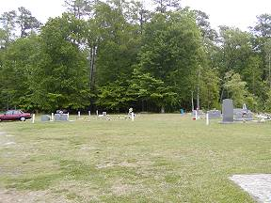 | 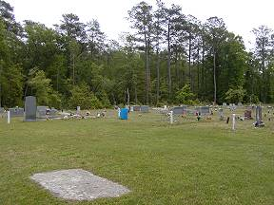
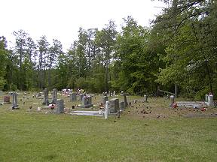 | 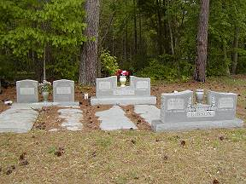
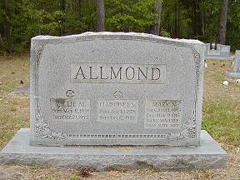 | 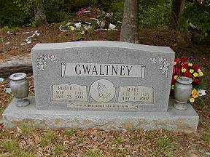
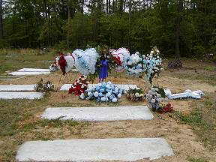 | 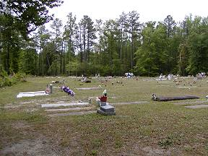
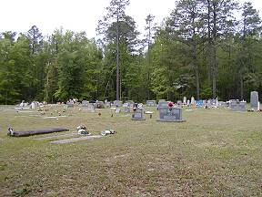 | 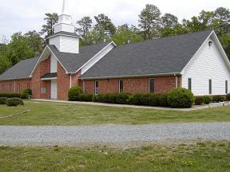
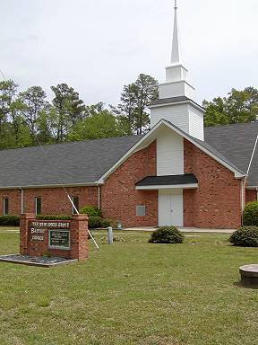 | 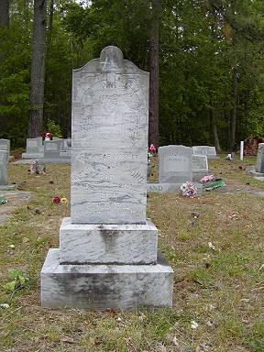
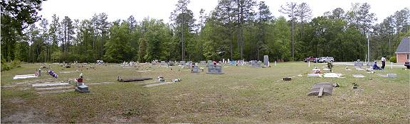
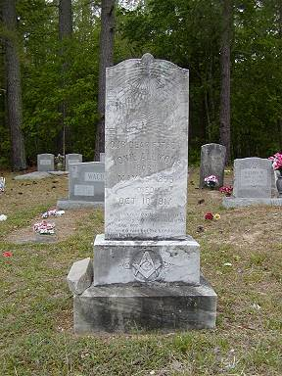 | 