Parker ~Days Point Rd~ Cemetery
Transcribed by members of the
Grave Site Survey Task Force (GSSTF)
Under the Auspices of
Isle of Wight County Historical Society (IWCHS)
Visited April 12, 2006

This hard-to-find gravesite was located only after intensive searching and questioning of workmen in the vicinity of the reported location. It is located off of Old Stage Road near Blounts Corner Road in the woods adjacent to a farm field … the wooded area had been used as a cow pasture as was obvious by the evidence of their having been there. The single tombstone found was in pieces and very difficult to decipher as some of the breaks obscured the letters inscribed on the stone. Many thanks to Mr. Maynard Gwaltney for his able assistance in locating the cemetery.

Note: The word, “Text” is actually engraved on the tombstone … it may possibly have been on a handwritten note from Copeland Parker to the engraver to indicate where the epitaph was to start. Also, there is additional information on this cemetery from a transcription by Ms. Elsie Cox in 1972. This is included verbatim at the end of this report. It is sad to see that an additional grave with its tombstone is missing … possibly due to animals (cows) knocking it over or being damaged by falling trees during hurricane Isabel and subsequently buried under the ample forest debris. Probing by GSSTF team members did not locate any additional tombstones.

A selection of shaving foam, water, or talcum powder was used to improve the legibility of the inscriptions. Afterwards, a clean water spray was used to remove any residue. GSSTF members were careful not to cause any further damage to the tombstones or artifacts during the transcription process.

Any text within the “[ ]” is a comment about the tombstone inscription, ex., [fs] indicates a footstone inscription. Throughout the transcribing process, an attempt was made to preserve the, ‘look and feel’ of the original inscriptions as regards word spacing, arrangement, and possible misspellings.

Please address your comments/corrections to: albert.b@charter.net or epowellsr@aol.com.

He will never leave us or forsake us

Text
Here rests from labour and pain
the body of Elizabeth Parker
consort of Copeland Parker
who departed this life
on the 16th Febr;^{y} 1807 aged 27
years 3 moº. and 5 days
This monument was erected
by her husband
Tis His last sad duty paid:
And will point to future ages
the spot where she was laid.

E.P.
1807 [fs]

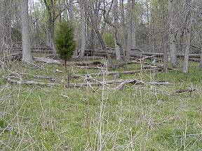 | 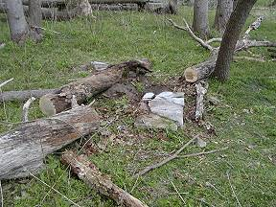
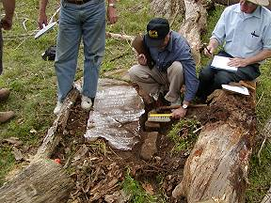 | 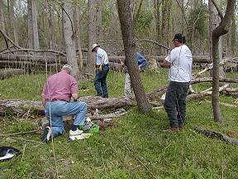
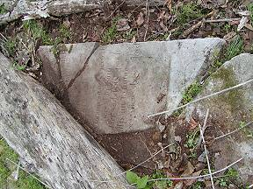 | 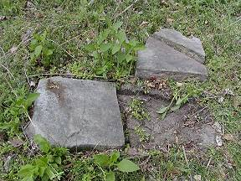
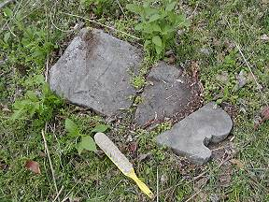 | 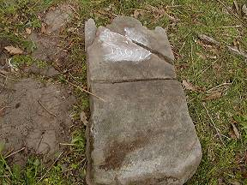
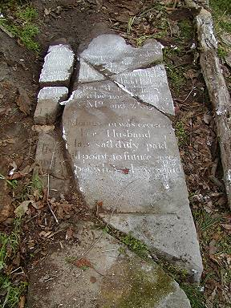 | 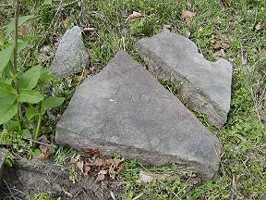

Transcription from the Roots Web … Isle of Wight County Cemeteries by Ms. Elsie Cox (1972)

IW-61

SINCLAIR CEMETERY
LOCATED ON THE SYKES FARM IN ISLE OF WIGHT CO., VA.

Ann Elizabeth Wilson [Sinclair]
Buried by her Mother
d/o George and Judith Wilson
First wife of
Capt. John Sinclair

Elizabeth Sinclair Parker
and Infant Parker
First wife of Copeland Parker
Died in Norfolk, Va.
February 28, 1807

