PARKER ~Macclesfield Rd~ Cemetery

Visited on November 9 and November 16, 2003
By Members and Volunteers of
Isle of Wight County Historical Society

Observations
The Parker cemetery is located on the old Macclesfield Farm off of Scot’s Neck Road about 3 miles east of Smithfield. It is very heavily overgrown and covered with dense brush and debris. It also shows damage from hurricane Isabel. Only a few grave markers are visible although it has been reported that approximately 13 persons are buried in the cemetery. A report obtained from the Internet, date unknown, lists the following:

PARKER CEMETERY
LOCATED AT "MACCLESFIELD", CARROLLTON, VA.

Ann S. Parker
Only daughter of Copeland
and Elizabeth Parker
Rest here
She died 16th July 1800
1 year, 8 months, 24 days

Here rests from pain
The body of Copeland S. Parker
Son of E. Parker
Who departed this life
on the 9th Sept. 1803
Age 1 year - 9 mos. - 27 days

Here rests from labor and pain
the remains of
Nichols Parker
Died 1789

*Buried in this cemetery without visible stone.
Colonel Josiah Parker
Born "Macclesfield"
May 11, 1751
Died "Macclesfield"
March 18, 1810
h/o Mary Pierce Bridger Parker
Only child: Anne Pierce Parker Cowper

The only tombstones found during the November 2003 visits are shown in the tables below. Evidently, due to time and possible vandalism, some tombstones appear to have been removed. Volunteers were careful not to disturb artifacts or cause further damage to the few tombstones found. A combination of shaving cream and a water spray was used in conjunction with a soft brush to clean, highlight, and make legible the inscriptions on the tombstones. At completion, water was used to wash away any shaving cream residue.

Efforts were made to preserve the ‘look and feel’ of the original tombstone inscriptions insofar as regards spelling, punctuation, and letter/word arrangement. The numbers in the leftmost column are identified in the photographs. Text within the “[“ and “]” are author’s comments and are not inscripted on the stone.

Please address your comments/corrections to: albert.b@charter.net or epowellsr@aol.com.

Photo I.D. | Inscription
#1 | After sixty seven years  Through many busy and changing  Scenes of life including  Fifteen years of great affliction  Here rest from labor and pain  The remains of  NICHOLAS PARKER  “Reader suspend thy opinion of  Me until the day of judgment”  Chapter ~~~~~~~~~ [illegible -- stone cracked]  Written By Himself  OB 1789

#2 | ERECTED TO THE GRAVE  OF CAPT. T. FREDERICK  P. P. COWPER, ALSO IN  MEMORY OF COL.  JOSIAH PARKER  LEOPOLD C. P. P. COWPER  MARY ANN KEITH PARKER  ANN P. P. COWPER [note 1.]
#3 | [See note (2)]
#4 | [See note (3)]

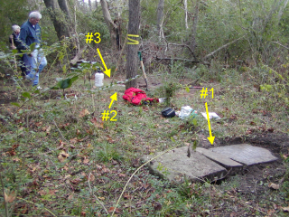

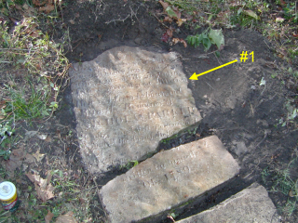
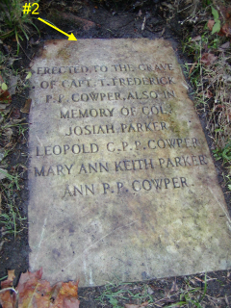

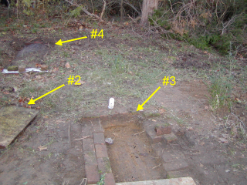

NOTES:
- This stone was not upright and did not seem to be a headstone. A gravesite was not found in the vicinity of the stone.
- A small (52-inches long) grave containing a metal coffin surrounded by a brick enclosure was discovered here.
- This grave was not marked by a stone of any kind … it was of brick construction and measured about 96-inches long.

