PERSON ~Sunset Dr~ Cemetery
Visited by Members of
Grave Site Survey Task Force (GSSTF)
Under the Auspices of
Isle of Wight County Historical Society (IWCHS)
April 7, 2004

Thanks to Mr. W. B. Copeland of Windsor for leading the team members to this graveyard that he remembered from childhood. It is located in the woods behind a house (no longer there) in which he used to live. Cemeteries like this one would possibly not be located without the assistance of older persons who can pinpoint the location from memories past.

There was only a single stone, which had been dislocated from its foundation by a fallen tree. Remnants of a metal fence are still evident and the surrounding area is dense with vegetation.

Throughout the transcribing process, an attempt was made to preserve the, ‘look and feel’ of the original inscriptions as regards word spacing, arrangement, and possible misspellings.

Please address your comments/corrections to: albert.b@charter.net or epowellsr@aol.com.

 | Inscription |  |  | Inscription
 | DR. ANTHONY  PERSON  Jan. 4, 1799  Feb. 17, 1882 |  |  | MARTHA S.  PERSON  His Wife  Dec. 14, 1809  Age 33 years
KEZIA PERSON
His Wife
Feb. 4, 1818
Feb. 20, 1898

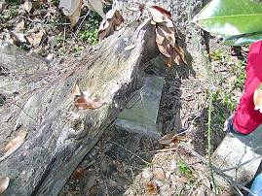 | 