Phillips_Bowling Green Rd_Cemetery
Transcribed by Members of
Grave Site Survey Task Force (GSSTF)
Under the Auspices of
Isle of Wight County Historical Society (IWCHS)
Visited May 1, 2005 and May 3, 2015

Thanks to Tommie & “DeDe” Darden for their able assistance in identifying and locating this cemetery. The cemetery is located in a field behind the residence at 14061 Bowling Green Road.

A selection of shaving foam, water, or talcum powder was used to improve the legibility of the inscriptions on the older tombstones. Afterwards, a clean water spray was used to remove any residue. GSSTF members were careful not to damage tombstones or artifacts during the transcription process.

Any text within the “[ ]” is a comment about the tombstone inscription, ex., [fs] indicates a footstone inscription. Throughout the transcribing process, an attempt was made to preserve the, ‘look and feel’ of the original inscriptions as regards word spacing, arrangement, and possible misspellings.

Addendum: The first 4 pictures were taken on May 1, 2005 during the initial visit. The dense underbrush prevented the transcribing of all of the tombstones. The second visit was made on May 3, 2015 and the remainder of the tombstones was recorded as shown in the rest of the pictures.

Please address your comments/corrections to: albert.b@charter.net or epowellsr@aol.com.

 | Inscription |  |  | Inscription
 | Sacred  to the memory of  MARY PHILLIPS,  Who died Aug. 13, 1846,  Aged 75 years, 10 months &  28 days |  |  | Sacred to the Memory  of  JOHN F. PHILLIPS  Who departed this life  Oct. 29, 1854  Aged 27 years.  “Tho he slay me, yet will I trust in him.”
 | Sacred to the Memory  Of  MRS. ALMEDIA O. PHILLIPS  Who departed this life  August 19, 1844  Aged 36 years & 6 months,  Jesus said unto her,  I am the resurrection, and the life,  He that believeth in me, though  He were dead, yet shall he live. |  |  | Sacred to the memory  of  JOHN PHILLIPS  Who died Nov. 13, 1853  Aged 80 years, 8 months & 29 days.

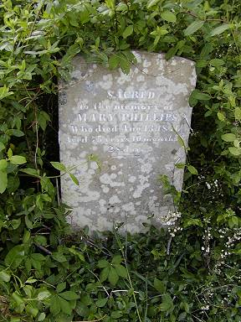 | 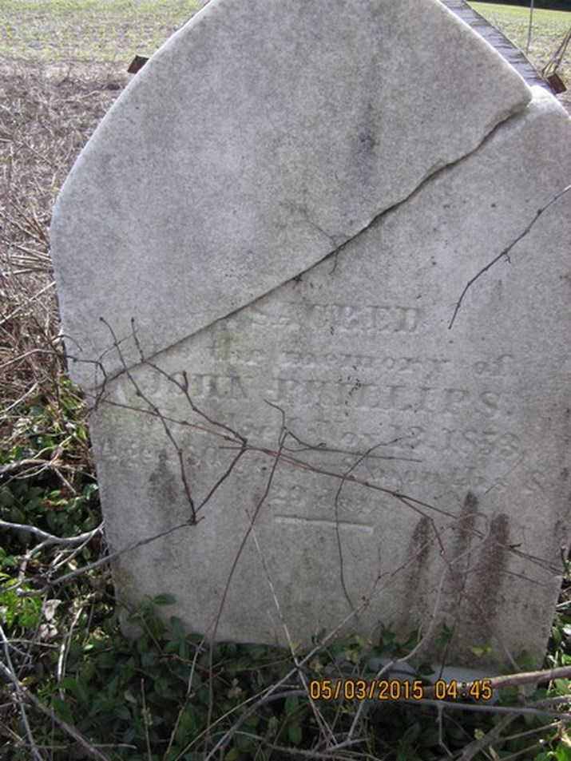
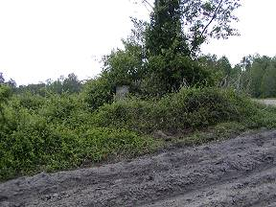 | 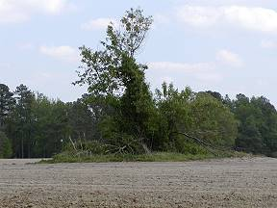
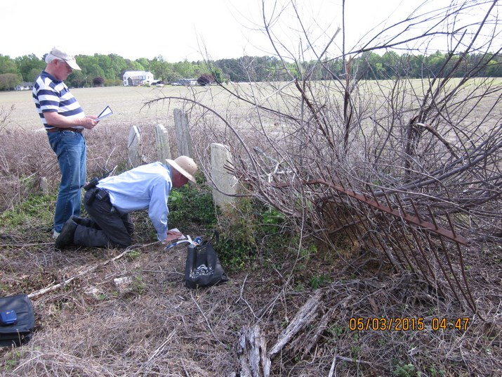 | 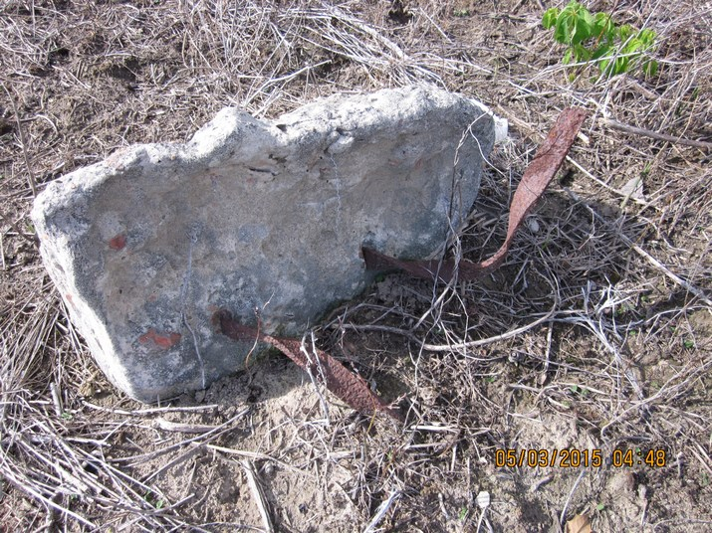
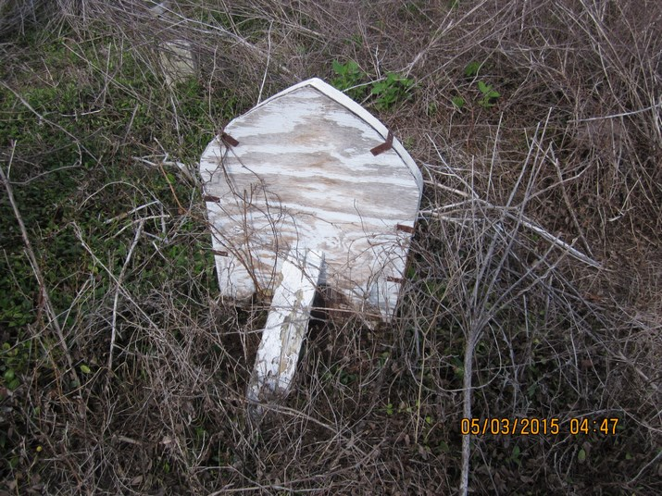 | 