Picott ~Holly Run Dr~ Cemetery
Transcribed by members of the
Grave Site Survey Task Force (GSSTF)
Under the Auspices of
Isle of Wight County Historical Society (IWCHS)
Visited August 24, 2005

A selection of shaving foam, water, or talcum powder was used to improve the legibility of the inscriptions on the older tombstones. Afterwards, a clean water spray was used to remove any residue. GSSTF members were careful not to damage tombstones or artifacts during the transcription process.

Any text within the “[ ]” is a comment about the tombstone inscription, ex., [fs] indicates a footstone inscription. Throughout the transcribing process, an attempt was made to preserve the, ‘look and feel’ of the original inscriptions as regards word spacing, arrangement, and possible misspellings.

Please address your comments/corrections to: albert.b@charter.net or epowellsr@aol.com.

 | Inscription |  |  | Inscription
 | EDWARD S. CLARK  Sept. 22, 1924  Aug. 2, 2000 |  |  | BEULAH M. BOONE  May 16 1900  Mar 25 1980
 | [blank] LESSIE  Mar. 6, 1928  Nov. 22, 1996  BOONE |  |  | JAMES BOONE SR  Born Nov 26  Age 65 years  Died March 30, 1962
 | Rev.  ALDESTER HILL  Born Nov. 20 1844  Died June 3 1959  Age 65 years |  |  | THOMAS F  DAUGHTREY  Aug 10 1936  Aug 3 2002
 | GLORIA L RAWLINGS  Feb 19 1952  Feb 9 1993 |  |  | A LINCOLN RAWLING  June 1921  Dec 10 1990
 | LILLIE C BANKS  Dec 26 1898  Oct 12 1971 |  |  | MARGARET BANKS  DAUGHTREY  April 20 1945  July 25 1995
 | [unmarked stone] |  |  | [unmarked stone]
 | [unmarked stone] |  |  | MAGGIE RAWLINGS  June 6 1928  Nov 19 1981
 | HATTIE M BANKS  Feb 22 1918  March 10 1991 |  |  | WILLIE J  BANKS  Nov 22 1942  May 13 1994
 | WILLIE J BANKS  Sept 2 1921  Oct 2 1971 |  |  | In Loving Memory  EDITH ELIZABETH BLOUNT  Feb 11 Jan 21  1932  2003  A loving Mother,  Grandmother and  Faithful Wife    Children: Alice, Divia, Wesley,  Robert, Barbara, Dorene, Alvin  Debbie, Crystal and Trina
 | WILBERT L MADDREY  Born May 5 1943  Died March 15 1953 |  |  | EDWARD RICKS  Sept. 11, 1914  Dec. 27, 1976
 | THERESA RICKS  July 11, 1921  Jan. 21, 1971 |  |  | JAMES W. MATTHEWS  June 18, 1929 – May 2, 2000
 | EUNICE S. MATTHEWS  Feb. 14, 1908  March 4, 1988 |  |  | JEROME MATTHEW  Virginia  PVT  U.S. Army  World War I  August 15, 1901  May 13, 1973
 | CLARENCE LAWRENCE  Born Jan. 8, 1906  Died May 20, 1962 |  |  | ENGLAND L. LEWIS  1901 - 1976
 | GOLD LAWRENCE  April 12, 1905  Nov. 25, 1980 |  |  | HENRY L. LEWIS  June 3, 1919  Feb 18, 1982
 | WILLIAM T. SPRATLEY  Jan. 25, 1925  Sept. 30, 1971 |  |  | JESTON EURE  Sept 1, 1904  Sept 16, 1994
 | MADREY EURE NEWSOME  Oct. 25, 1923  Nov. 30, 1999 |  |  | ELDER SETH E. MITCHELL  Feb. 6, 1932  Aug 19, 1997  He died as he lived – a Christian soldier
 | BUSTER L. JOHNSON SR  June 19, 1935  Jan. 20, 1990 |  |  | BUSTER L. JOHNSON  Born Apr. 10, 1912  Jan. 20, 1990
 | CLARENCE TURNER  Sept. 9, 1909  Oct. 9, 1975 |  |  | ETHEL L. PICOTT  Sept 6, 1922  April 24 1988
 | Dr ALBERT L HILL  July 7, 1920  May 14, 1985 |  |  | JAMES W BOONE JR  Nov 26 1917  Mar 31 1974
 | BENJAMIN F  LONG  July 4 1894  Oct 1 1984 |  |  | THOMAS JUNIUS  SPRATLEY  Born May 30 1957  Died Aug 16 1965
 | WILBERT MADDREY  Jan 26, 1921 – April 3, 2003  Elvin Vaughan Funeral Home |  |  | JOHN O. HILL  May 13, 1917  Oct 28, 1976  JOHN O  HILL  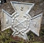  SGT  US Army  1917 1976
 | OLLIE HILL  Jul 4 1893  Dec 28 1981 |  |  | [unmarked stone]
 | [unmarked stone] |  |  | BUSTER L JOHNSON  Born Apr 10 1912  Died Apr 20 1958
 | LINA LAWRENCE  April 16 1918  Nov 24 1984 |  |  | MINNIE S SYKES  April 16 1923  April 10 1993
 | MARGARET V SPRATLEY  Dec 19, 1929  April 12, 1989 |  |  | LEROY SYKES  July 30 1949  Sept 8 1975  LEROY DYKES  SGT US Army  Jul 30 1949 Sept 8 1975
 | JACK SPRATLEY  Aug 25 1920  Aug 29 1996 |  |  | CARRIE JOHNSON  Sept 24 1912  Jan 16 1972
 | NEAMON TURNER  March 21, 1908  Jan 7, 1969 |  |  | ANNIE BATTLE  Nov 18, 1893  Dec. 9, 1969
 | CLAUDE J. KNIGHT  Born Sept. 1, 1919  Died Nov. 29, 1961 |  |  | SGT. E8 FRANK N. COPELAND  July 28, 1936 – Aug. 7, 1998  Peebles Funeral Home
 | JESSIE HOLLAND  July 18, 1900  Oct 18, 1973 |  |  | INEZ HOLLAND  June 4, 1903  July 31, 1966
 | GIOCIE O. JOHNSON  1885 – 1964 |  |  | ROSA E. JOHNSON  Dec 25 1889  June 21 1989
 | ADAM A. DAUGHTREY  Nov. 11, 1934  Dec. 7, 1981 |  |  | JAMES M. DAUGHTREY  Oct. 18, 1927  Sept. 16, 1972
 | NETTIE E. ELKERSON  May 7, 1911  Feb. 9, 1990 |  |  | RANDELL LEE BOONE  Dec. 13, 1930 – Oct. 03, 2001  Wm. M. Johnson & Son F.H.
 | LELIA MAE BOONE  May 6, 1929 – Sept. 17, 2000  Wm M. Johnson & Son Funeral Home |  |  | ERNEST HILL  Aug. 28, 1885  Aug. 10, 1973  Engram Service
 | CHRISTINE D. WARD  March 20, 1937  Dec. 7, 1981 |  |  | PATTIE E. DAUGHTREY  Jan. 8, 1907  July 12, 1978
Note (1) | CLARENCE DAUGLTREY  July 5, 1900  Dec. 10, 1969  CLARENCE McKINLEY  DAUGHTREY VIRGINIA  PFC COC 369 Infantry  World War 1 July 5 1900 Dec 10, 1969 |  |  | HEARTHIA A EATON  North Carolina  PFC US Army  World War II  August 18 1909  November 2 1960
 | ELMO PICOTT JR  PVT US Army  World War II  May 20 1913 Aug 22 1989  ELMO PICOTT JR  May 20, 1913  Aug. 22, 1989 |  |  | FRANK GOODMAN JR  June 15, 1900  May 1, 1968
 | ELMO C. PICOTT III  Aug. 23, 1943 – June 7, 2000  Cooke Bros. – Shiver Funeral Chapel |  |  | HUGH  BENTON SR  July 11 1944  Jan 27, 2005  Crocker
 | JERRY L. PICOTT, SR.  Nov. 5, 1947  Aug. 6, 1989 |  |  | WILLIS H. BROWN, JR  Jan. 19, 1934  July 29, 1983
 | WILLIAM T. PICOTT, JR.  Jan. 11, 1923  Aug. 23, 1988  Beloved Husband & Father |  |  | MAGGIE E. PICOT  Sept 22, 1903  May 22, 1985
 | ROY PICOT SR  PVT US Army  World War I  July 29 1896  Sep 14 1983 |  |  | EVLYN PICOT  Born June 8, 1924  Died Dec. 8, 1954
 | DAN PICOT  PVT US Army  World War I  1895 1976 |  |  | WILLIAM B. PICOTT  Feb. 28, 1871  Feb. 21, 1969
 | SARAH W. EATON  FEB. 6, 1902  Nov. 4, 1970 |  |  | CORINE EURE  Born -- 1876  Died -- 1960
 | BERTHA L. BUNN  Feb. 6, 1913  Dec 18, 1983 |  |  | [unmarked grave]
 | LIZZIE G BENTON  Jan. 14 1934  Dec 14, 1974 |  |  | CHARLIE H.  DAUGHTER  Nov. 26, 1927  July 5, 1977
 | GEORGE W. BENTON  April 3, 1901  May 15, 1978 |  |  | MELVIN L. RUSSELL  Aug. 22, 1924 – April 1, 2004  Elvin Vaughan Funeral Home
 | ANNIE E. GOODMAN  April 10, 1898  Oct. 5, 1974 |  |  | BETTY L. BARNES  Oct. 25, 1925  Aug 16, 1988
 | GEORGE W. BARNES, JR.  June 11, 1923 – Sept. 27, 2000  Wm. M. Johnson & Son Funeral Home |  |  | GREGORY W.  RUSSELL  New York  PVT  US Army  Vietnam  March 18, 1953  June 7, 1973
 | RICHARD JONES  1900 – 1949 |  |  | JEROME  MATTHEW  Virginia  Pvt  US Army  World War I  August 15 1901  May 13 1973
 | EVELYN D  SPRATLEY  Sept 17 1923  June 29 2004  Community |  |  | WILLIAM T. PICOT  Aug 10 1901  Aug 25 1992
 | EDWARD  ROY  SPRATLEY  Virginia  S 1C USNR  World War II  October 22 1923  April 27 1947 |  |  | SILAS BARNES  Feb 2 1917  Aug 30 1971
 | JEROME  MATTHEWS  Aug 15 1901  May 13 1973 |  |  | [unmarked grave]
 | Baby Boy JAYDEN FRINK  September 22, 2003  October 1, 2003  Final arrangement entrusted to:  Crocker Funeral Home, Inc.  900 E. Washington Street  Suffolk, VA 23434  (757) 539-7443 |  |  | ANNA M PICOT  Sept 28 1896  Dec 19 1989  Pretlow Chapman
 | [unmarked grave] |  |  | ALICE B. H. JONES  Feb 6 1908  May 2 1988
 | JACKIE D. KEYS  Sept 5 1967  July 10 1973 |  |  | [unmarked grave]
 | ANNIE J  HOWELL  Oct 25 1920  Dec 1 1983  Wm. Johnson |  |  | NAT SHEARRIN  JR  June 17 1918  Jan 24 1973
 | DORIS C. SHEARRIN  May 21, 1924 – Apr. 24, 2005  Wm M. Johnson & Sons – Funeral Home |  |  | LUCY A. GRANT  July 27, 1937 – June 12, 2003  Wm. M. Johnson& Son Funeral Home
HS  Note (2)  CS | BRODIE  WINDORNE  HOWELL  Virginia  Pvt 868 Co  Trans Corps  World War I  August 15 1897  February 15 1973  DRODI W  HOWELL  Aug 15 1897  Feb 15 1973 |  |  | JAMES R, DARDEN  May 15, 1949  April 27, 1969
 | EFFIE E. DARDEN  Feb 12 1917  July 6, 1990  Wm Johnson |  |  | HELEN L  TIMMONS  Jan 10 1937  Nov 13 1993
 | PENDLETON CROSS  Aug 20 1919  Sept 7 1975 |  |  | JOHNNIE L BATON  Feb, 25 1944  March 13 1993
 | ANNIE DARDEN  Dec, 18, 1921  Dec, 20, 1976 |  |  | ISRAEL CROSS  March 15, 1925  Jan. 22, 1974
 | WILSON HOLLAND  Sept. 20, 1929  Feb. 27, 1985 |  |  | CLARENCE BATON JR  April 28, 1953  Nov 30, 1996
 | JOHN BATON JR  May 20, 1914  Dec 19, 1991 |  |  | OLA B. BEATON  Dec, 26, 1921  Jan, 16, 1973
 | MACARTHUR BATON  June 21, 1952  Feb, 5, 1973 |  |  | JAMES E, GRANT  Nov, 22, 1900  June 1, 1974
 | AUBREY EATON  Oct, 1, 1935  Dec, 14, 1964 |  |  | LEORA EATON  Feb, 5, 1917  Dec, 25, 1984
 | HENRY SPRUILL  Feb, 6, 1908  Sept, 22, 1969 |  |  | JAMES E. BOONE  June 17, 1930 – April 12, 2003  Wm. M. Johnson & Sons Funeral Home
 | JOHN T, GRANT  Feb, 2, 1897  March 13, 1975  JOHN T.  GRANT  PVT  US Army  Feb 2 1897  Mar 13 1975 |  |  | HENRY SPRUILL JR  Feb 14, 1923  April 1, 1995
LUCILL GRANT
Jan 8, 1929
Nov 4, 1994

Notes:
- The spelling of “DAUGLTREY” is not a typo, it is actually engraved on the tombstone.
- The abbreviation, “HS” is “Head Stone” and, “CS” is “Crypt Stone” … the spelling and dates differ between the two but those are actually engraved on the stones.

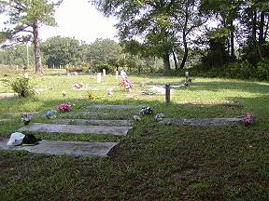 | 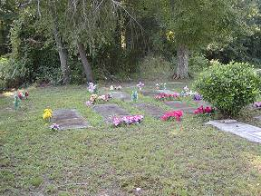
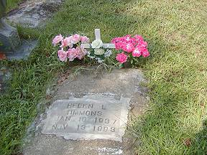 | 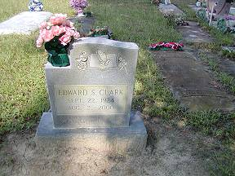
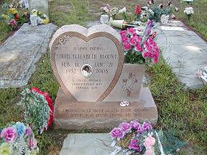 | 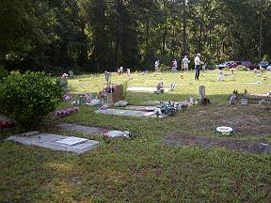
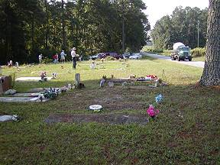 | 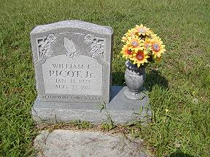
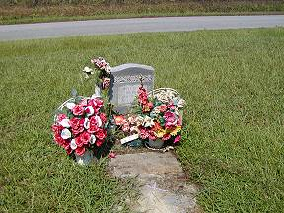 | 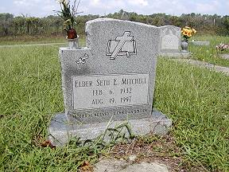
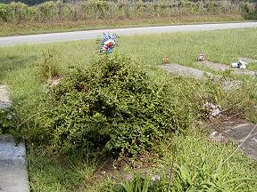 | 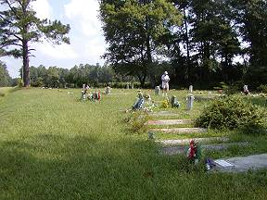
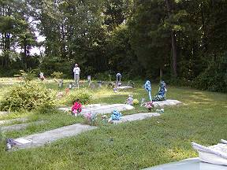 | 