Pittman ~Longview Dr~ Cemetery
Transcribed by members of the
Grave Site Survey Task Force (GSSTF)
Under the Auspices of
Isle of Wight County Historical Society (IWCHS)
Visited March 6, 2005

This small, well maintained cemetery is located alongside Longview Drive about 1/8 mile from the Christian Home Cemetery. A selection of shaving foam, water, or talcum powder was used to improve the legibility of the inscriptions on the older tombstones. Afterwards, a clean water spray was used to remove any residue. GSSTF members were careful not to damage tombstones or artifacts during the transcription process.

Any text within the “[ ]” is a comment about the tombstone inscription, ex., [fs] indicates a footstone inscription. Throughout the transcribing process, an attempt was made to preserve the, ‘look and feel’ of the original inscriptions as regards word spacing, arrangement, and possible misspellings.

Please address your comments/corrections to: albert.b@charter.net or epowellsr@aol.com.

 | Inscription |  |  | Inscription
 | NETTIE JORDAN  Feb. 2, 1977 |  |  | GUS JORDAN  Virginia  Pvt 101  338 Labor BN  April 2, 1892  April 4, 1946
 | JAMES GRANDEISON  1920 – 1940 |  |  | MOGNDRIA GRANDEISON  Died May 26, 1958
 | ONYXX O. WADE  June 2, 1994 |  |  | MISSOURIA P. LANG  Feb. 14, 1912  Jan. 5, 1993
 | AJANA PITTMAN  March 22, 1977 |  |  | ADA PITTMAN  Died April 23, 1965
 | CHARLIE PITTMAN  Died Feb. 4, 1940 |  |  | ELLA MAE BRINKLEY  Oct. 24, 1924  Aug. 9, 1996
FRED GRANDISON JR.
Maryland
Pvt
US Army
World War II
January 13, 1921
March 2, 1971

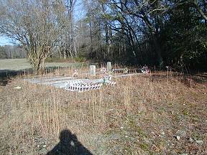 | 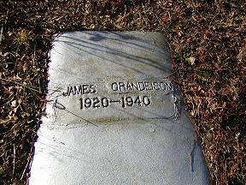
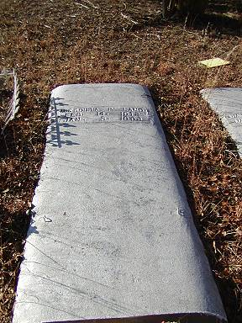 | 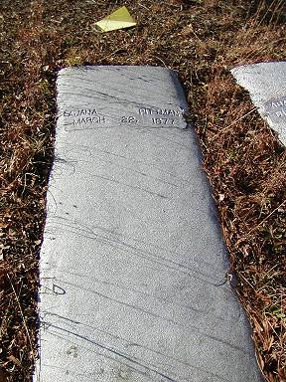
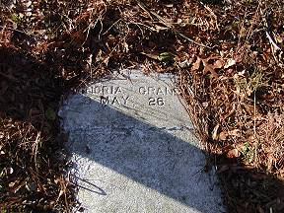 | 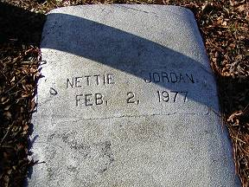
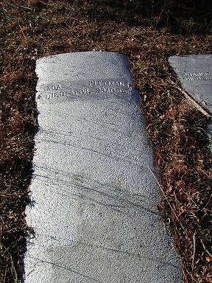 | 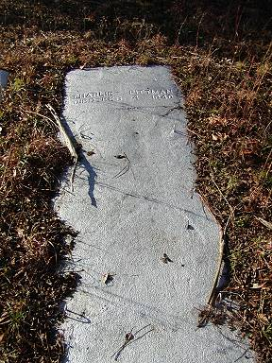
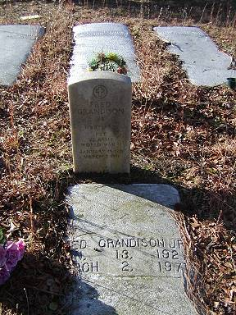 | 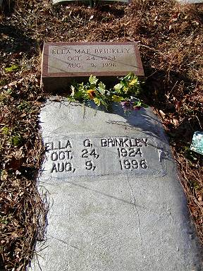
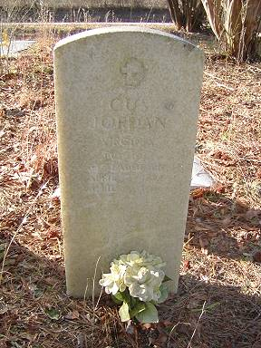 | 