Powell ~Zuni Circle~ Cemetery
Transcribed by members of the
Grave Site Survey Task Force (GSSTF)
Under the Auspices of
Isle of Wight County Historical Society (IWCHS)
Visited January 11, 2006

This small cemetery is located in the yard of a private residence in the small town of Zuni. Reportedly, there were two occupants buried here although there is only one visible tombstone and the second grave could not be located. Throughout the transcribing process, an attempt was made to preserve the, ‘look and feel’ of the original inscriptions as regards word spacing, arrangement, and possible misspellings.

MILLS E. POWELL
Born
July 11, 1828
Died May 22, 1895
------------
He sleeps, but his example
still remains.
As fresh as when among us
here he trod.

Please address your comments/corrections to: albert.b@charter.net or epowellsr@aol.com.

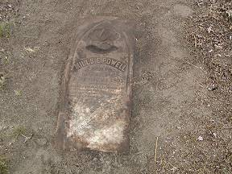 | 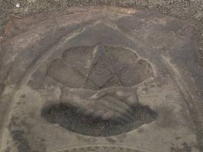
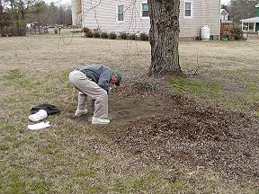 | 