Pulaski Church ~Carrsville Rd~ Cemetery
Transcribed by members of the
Grave Site Survey Task Force (GSSTF)
Under the Auspices of
Isle of Wight County Historical Society (IWCHS)
Visited August 28, 2005

Pulaski Baptist Church is located on Carrsville highway (Hwy # 58) just west of the Suffolk line. The main cemetery is located adjacent to the church while a smaller one is located just behind the church.

A selection of shaving foam, water, or talcum powder was used to improve the legibility of the inscriptions on the older tombstones. Afterwards, a clean water spray was used to remove any residue. GSSTF members were careful not to damage tombstones or artifacts during the transcription process.

Any text within the “[ ]” is a comment about the tombstone inscription, ex., [fs] indicates a footstone inscription. Throughout the transcribing process, an attempt was made to preserve the, ‘look and feel’ of the original inscriptions as regards word spacing, arrangement, and possible misspellings.

Please address your comments/corrections to: albert.b@charter.net or epowellsr@aol.com.

 | Inscription |  |  | Inscription
 | SETH E. MITCHELL  Sept 28, 1889  May 25, 1977 |  |  | CHARLIE W. PICCOTT  Nov 2, 1920  Aug 8, 1979
 | DOROTHY VINSON  July 9, 1921 – Sept 2, 2002  Crocker Funeral Home |  |  | LORINE D. WILLIAMS  July 28, 1910  April 6, 1975
 | JUNIOUS DUKE  Oct 10, 1913  Sept 17, 1973 |  |  | HARRY DUKE  March 6, 1923  March 15, 1975
 | MARTHA D. DARDEN  June 22, 1900  Dec. 22, 1989  Precious Memories |  |  | JAMES R. DARDEN, JR.  Nov. 3, 1906  July 6, 1987  Precious Memories
 | MAY ETTA DUKE  Born April 10, 1861  Died Sept. 3, 1956 |  |  | HERBERT DUKE  Born April 2, 1893  died Nov. 10, 1957
 | EDDIE W. DUKE  Born Aug 1908  Died Sept. 23, 1957  EDDIE DUKE SR  Virginia  Pvt. US Army  World War II  Aug. 12, 1906 Sept 23 1957 |  |  | ESSIE HAMLIN  May 16, 1895  Feb. 25, 1970
 | ABRAHAM DUKE  July 4, 1911  April 13, 1970  Serv by citizen |  |  | [4 concrete vaults, illegible inscriptions]
 | EVELANA BOONE  Born Feb. 17, 1868  Died Sept. 29, 1955 |  |  | LUTHER W. BOONE, JR  May 12, 1937  Aug 16, 1996  LUTHER W. BOONE  US Air Force  Viet Nam  May 12, 1937  Aug. 16 1996
 | CORRINE BOONE MAYFIELD  Dec. 31, 1933  Feb. 22, 1954  CORRINE B. MAYFIELD  Born Dec. 31 1933  Died Feb. 22 1954 |  |  | CHARLIE KNIGHT  Born Jan. 26, 1918  Died Sept. 18, 1960
 | WARREN M MITCHELL  SGT US Army  World War I  Jan 12 1892 May 28 1982 |  |  | OTELIA MITCHELL  Jan. 11, 1896  May 24, 1981
 | Mother  BEVERLY C. RAWLS  Apr. 8, 1950  July 10, 2000 |  |  | BEATRICE LAWRENCE  Aug. 123, 1924  Jan 14, 1968
 | BEVERLY  CAROL  RAWLS  Apr 8 1950  July 10 2000  -----  Crocker |  |  | Mother Father  CORA T. PICOTT HERBERT N. SR.  July 24, 1926 Mar. 16 1928  Oct. 5, 2003 Married Feb. 10, 1996  Aug. 1945  RAWLS
 | GILBERT RAWLS  Apr 1 1902  Dec 9 1975 |  |  | MARY L RAWLS  June 22, 1900  June 5, 1988
 | MILDRED BUTLER  Born Aug, 10, 1871  Died Aug, 14, 1965 |  |  | SUSIE KEEN  Died Aug, 18, 1972
 | MAUDE B. GRIFFIN  May 6, 1904  Nov. 26, 1973 |  |  | BOONE  Father Mother  ROGER EDSELL MARY VIRGINIA RAWLS  Apr. 13, 1931 Married Nov. 7, 1929  Dec. 19, 1954 Oct. 10, 1986
 | MARY L. GRANT  Died  Jan 22  1946 |  |  | SARAH A. ADKINS  1890 – 1934
 | LEROY B. ADKINS  1919 – 1933 |  |  | CATHERINE C. JONES  Sept 6, 1908  July 9, 1971
 | SALLIE FORD  Died Aug 28 1955 |  |  | ALLIE B. SCOTT  Born Dec 2, 1904  Died April 29, 1961
 | MCKINLEY DARDEN  Jan 1922  July 24, 1978 |  |  | ELSIE V. KEEN  Dec 17, 1921  June 1, 1982
 | RUBY B. ELEY  Jan 20 1904  May 30 1982 |  |  | LUTHER WARNER, SR  Sept. 19, 1896  Sept. 11, 1968
 | VIOLA RAWLINGS  Nov. 11, 1911  Aug. 10, 1990  VIOLA MAE  BOONE  Nov. 11 1911  Aug 10 1990  Community |  |  | LUTHER W. BOONE SR  Sept. 19, 1896  Sept 11, 1968
 | JOHN W. CHAPMAN  Died Aug 22, 1959 |  |  | CHARLES W. CHAPMAN  Born Jan. 8, 1879  Died Nov. 23, 1951
 | DELLA CHATMAN  March 25, 1880  April 1, 1967 |  |  | LILLIE M. EATON  Nov. 3, 1907  April 2, 1982

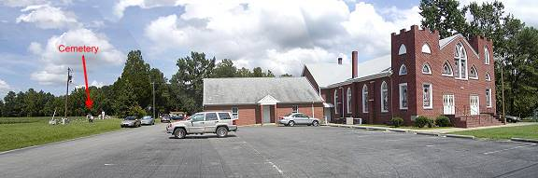

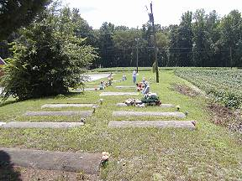 | 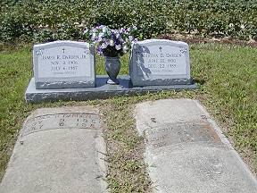
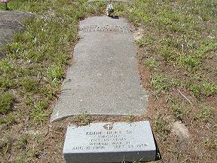 | 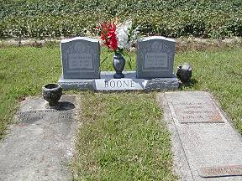
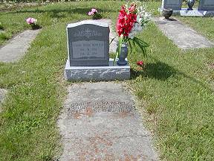 | 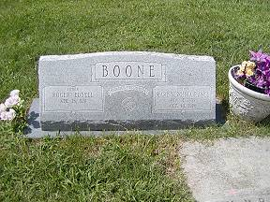
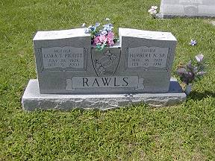 | 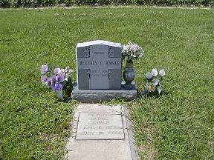
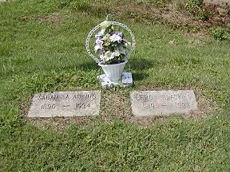 | 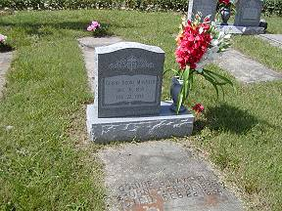
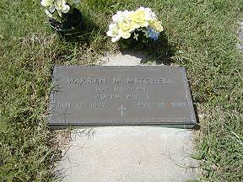 | 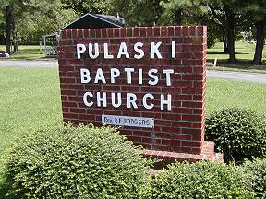
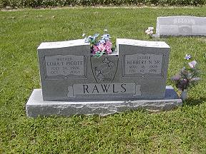 | 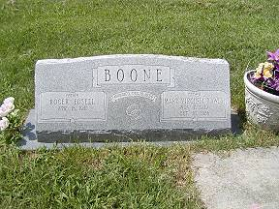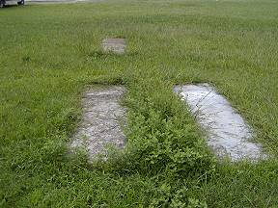
 | 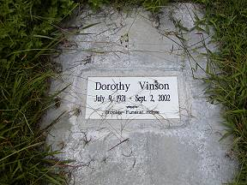
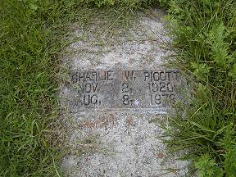 | 