Ricks ~Hunt Club Rd~ Cemetery
Transcribed by members of the
Grave Site Survey Task Force (GSSTF)
Under the Auspices of
Isle of Wight County Historical Society (IWCHS)
Visited April 7, 2013

Location: At the corner of Hunt Club Rd and Old Oak Ln … Off of Walters Hgwy

A selection of shaving foam, water, or talcum powder was used to improve the legibility of the inscriptions on the older tombstones. Afterwards, a clean water spray was used to remove any residue. GSSTF members were careful not to damage tombstones or artifacts during the transcription process.

Any text within the “[ ]” is a comment about the tombstone inscription, ex., [fs] indicates a footstone inscription. Throughout the transcribing process, an attempt was made to preserve the, ‘look and feel’ of the original inscriptions as regards word spacing, arrangement, and possible misspellings.

Please address your comments/corrections to: albert.b@charter.net or epowellsr@aol.com.

 |  | Inscription |  |  |  | Inscription
 |  | INELL R. GARRIS  Sept 27 1927  June 21 1992 |  |  |  | GERTRUDE RICKS  September 8 1919  October 20 1952
 |  | PERNELL RICKS  June 27 1914  July 6 1985 |  |  |  | MARTHA F. RICKS  Jan 6 1898  Feb 26 1972
 |  | WALTER RICKS  Jan 15 1921  June 14 1978 |  |  |  | DORIS O. FLYTHE  Jan. 16, 1923 – Sept 20 2009  Engram Funeral Home
 |  | PRETLOW C. FLYTHE  Apr 2 1918  Oct 11 1981 |  | Note (1) |  | NT RICKS  Pvt  US Army  World War II  Jul 28 1917  Jul 20 1986
 |  | (5 ea small child-size mounds, in a row, unmarked except w/ plastic flowers) |  |  |  | (3 ea adult-size mounds, no markers)
Notes:
- VA marker

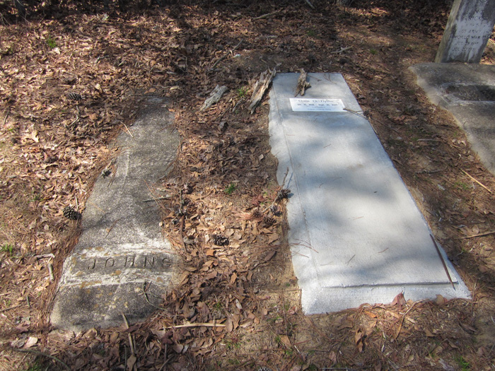 | 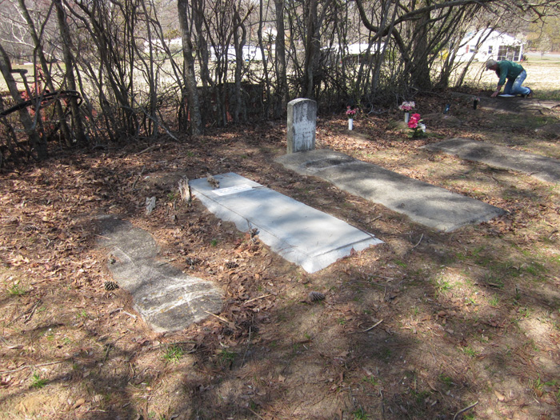
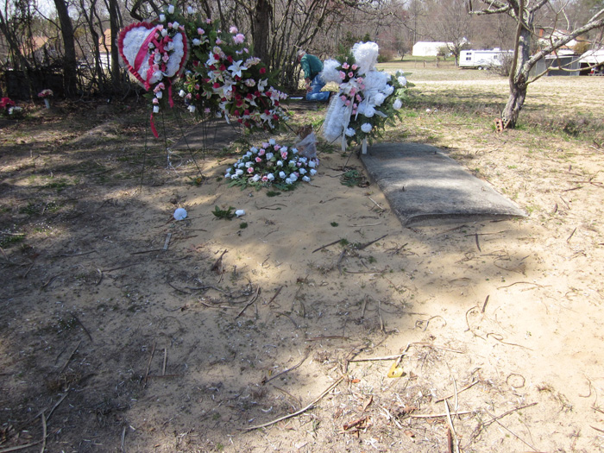 | 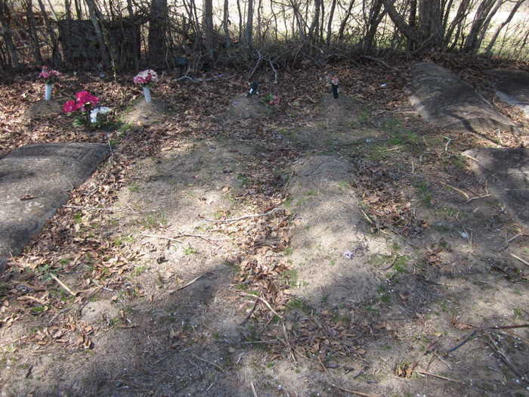
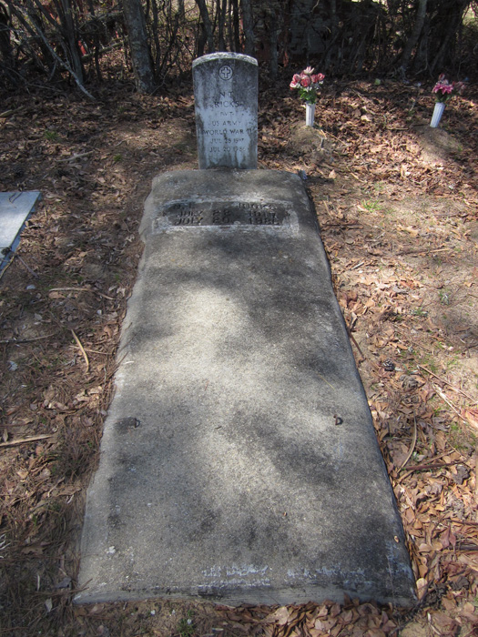 | 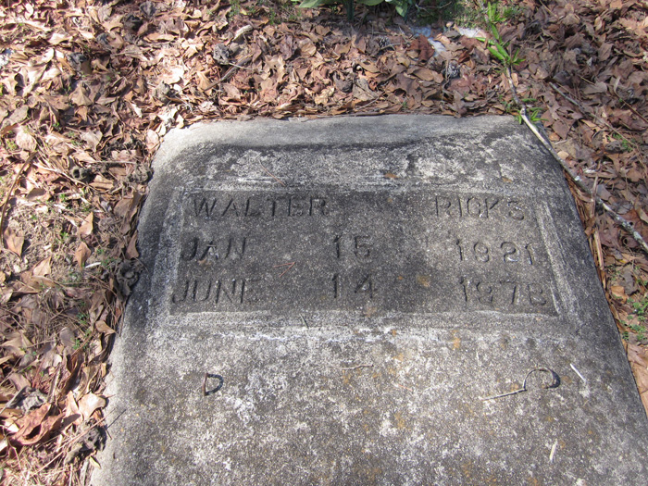
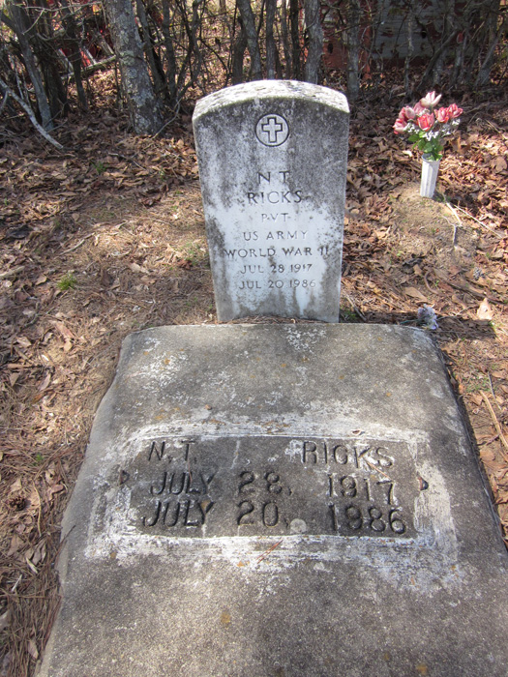 | 

