Rising Star ~Battery Park Rd~ Cemetery
Visited by Members of
Grave Site Survey Task Force (GSSTF)
Under the Auspices of
Isle of Wight County Historical Society (IWCHS)
July 25, 2004

This small cemetery is located in the rear of the Rising Star Baptist Church on Battery Park Road in Smithfield. Comments from members of the church indicated that there are several unmarked graves in the woods behind the church and no one seems to know who is buried within.

Any text within the “[ ]” is a comment about the tombstone inscription, ex., [fs] indicates a footstone inscription. Throughout the transcribing process, an attempt was made to preserve the, ‘look and feel’ of the original inscriptions as regards word spacing, arrangement, and possible misspellings.

Please address your comments/corrections to: albert.b@charter.net or epowellsr@aol.com.

 | Inscription |  |  | Inscription
 | Mother  VERA M. SIMMS  1910 1961 |  |  | Mother  And  Grandmother  EMMA EVERETTE  1892 1957
 | KELLIE MILTON  1977 Sept 1977  [infant grave] |  |  | ROBERT SIMMS  1912 1969
 | CALDONIA S. DENSON  May 24, 1914  Oct. 4, 1995 |  |  | WILLIAM L.  TILLMAN  Jan. 10, Jul. 20,  1952 1981  “In Loving Memory”

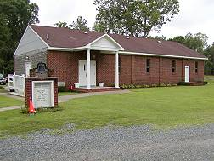 | 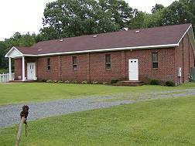

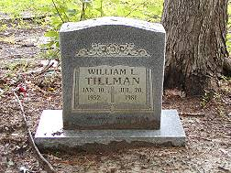 | 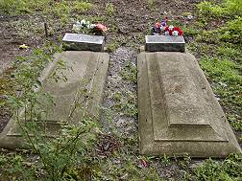
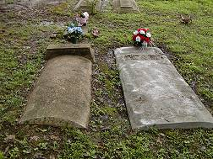 | 