Riverview Church Cemetery
Visited by Members of the
Grave Site Survey Task Force (GSSTF)
By direction of
Isle of Wight County Historical Society (IOWCHS)
March 2, 2004

This cemetery is located behind the Riverview United Methodist Church on Smith’s Neck Road (Rt. # 655) near the town of Rescue. The cemetery is being maintained and most of the tombstone inscriptions are legible. GSSTF members included Ms. Mischelle Canter, Ms. Jerianne Gardner, Mr. William Cook and Mr. Ernest Powell, Sr.

Please address comments and questions to: albert.b@charter.net or epowellsr@aol.com.

Note # | Inscription |  |  |  |  | Note # | Inscription
 | WILLIE BOY ROLLINS  1888 1951 |  |  |  |  |  | ROLLINS  WILLIE K. ARTENNIA B.  1865 1934 1862 1937
 | ALEXANDER F. BURNS  PVT US Army  World War II  Jul 25 1893 Jan 21 1977 |  |  |  |  |  | CORA P. PITTMAN  1878 1965
 | ALBERT W. PITTMAN  1876 1957 |  |  |  |  |  | ALBERT GARNER VIRGINIA MURPHY  May 8, 1904 Feb. 20, 1908  Aug. 25, 2000 Dec. 10, 1990  Married Sept. 30, 1923  PITTMAN
 | ROBERT L. ROLLINS  Virginia  PVT Co B 318 Infantry  Aug 11 1902 Jan 18 1966 |  |  |  |  |  | ROBERT J. MARION D.  Apr. 10, 1901 Oct. 9, 1907  May 14, 1961 Apr. 28, 1970  TENNIS
 | Father Mother  BENJAMIN F. MARY L.  Born 1875 Born 1877  Died 1926 Died 1945  TENNIS |  |  |  |  |  | Son  JAMES L. WILSON  March 1, 1929  June 1, 1930
 | Father Mother  WILEY J. NANNIE E.  Born 1904 Born 1906  Died 1974 Died 1993  WILSON |  |  |  |  |  | Father  WILEY J. WILSON, JR.  Born 1932
 | Mother  JANET P. WILSON  Born 1932  Died 1998 |  |  |  |  |  | MARION R. PEVETO  1925 1969  [funeral home marker]
 | JOHNSON  LILLIE F. HARRIET A.  1882 1967 1869 1941 |  |  |  |  |  | GEORGE W. WYATT  Sept. 3, 1872  May 4, 1936  “At Rest”
 | MARY E. WHITLEY  Feb. 25, 1894  June 28, 1920  “At Rest” |  |  |  |  |  | MAUDE L. WYATT  Feb. 25, 1874  March 16, 1917  “At Rest”
 | JOHNSON  WALTER M. MARY L.  Sept. 5, 1879 Sept. 10, 1892  Sept. 29, 1952 Oct. 23, 1979 |  |  |  |  |  | MAMIE A. BURNS  1898 1920
 | HILLYER  ANNA TAYLOR LEAROY J.  1882 1930 1879 1968 |  |  |  |  |  | JOHN ROBERT JOHNSON  April 26, 1892 Dec. 24, 1953
 | IDA REYNOLDS JOHNSON  May 6, 1898 May 30, 1956 |  |  |  |  |  | JOHN W. WATKINS  Virginia  Cook QM Corps  WWI  March 9, 1895  May 17, 1941
 | CLAUDE M. TENNIS  Born Sept 25, 1873  Died May 26, 1943 |  |  |  |  |  | ANNA T. TURLINGTON  Feb. 21, 1883  July 23, 1972
 | WILLIE L. JOHNSON  Jan. 17, 1898  Jan. 23, 1936 |  |  |  |  | Note (1) | F.V.G. [crypt cover]
 | HERMAN ALLAN WATKINS  Nov. 15, 1928  Dec. 17, 1937 |  |  |  |  |  | ADDIE WORSTER  (1868 – 1919)  FLORENCE V. GILLIAN  (1896 – 1918)
 | BENNIE BILLINGSLEY  1924 1932 |  |  |  |  |  | POWELL  WILLIAM JULIA S.  1859 1941 1855 1934
 | REYNOLDS |  |  |  |  |  | CLIFFORD REYNOLDS  Born 1886  Died 1975
 | CLARA  PARKER  Feb 18, 1889  Sept. 17, 1949 | WILLIAM  HENRY  April 3, 1863  Sept. 18, 1948 |  | REBECCA  TENNIS  1863 - 1903
 | Mr. BURNIS REYNOLDS  Born 1891  Died 1980 |  |  |  |  |  | AMOS REYNOLDS  March 4, 1916  July 7, 1916
 | S. H. MARSHALL  Aug. 8, 1818  Sept. 29, 1905  S.H.M. [fs] |  |  |  |  | Note (2) | I.L.S.
 | Son of  LEROY and ISABELL  SKEETER  Born  Sept. 7, 1918  Died  Sept 7, 1918  “Our darling one has  gone before to greet  us on the blissful shore.” |  |  |  |  |  | IRA LEON  Son of  LEROY AND ISABELL  SKEETER  Born Jan. 26, 1888  Died Oct. 2, 1918  “They loved him most  who knew him best”
 | Admiral SKEETER  Born 1847  Died 1910 |  |  |  |  |  | BROWN  EDITH L. LINWOOD P.  Born Jan. 1924 Born Oct. 1910  Died May 1942 Died July 1928  Sister [fs] Brother [fs]
 | WELLS  CHARLIE L. MARY B.  Born Oct. 12, 1906 Born Mar. 8, 1912  Died Sept. 18, 1954 |  |  |  |  |  | JULIAN L. GRIFFIN, SR.  Dec. 30, 1874  May 29, 1973
 | ANNA D. GRIFFIN  Sept. 6, 1882  Mar. 20, 1914 |  |  |  |  |  | GRIFFIN Infants  March 1914
 | NONA DEWS ANDREW J  May 23, 1895 Oct. 23, 1880  Aug. 3, 1970 July 14, 1966  TURNER |  |  |  |  |  | MARTIN
 |  |  |  |  |  |  | WILLIAM T.  Aug. 21, 1848  Sept 23, 1927 | SARAH A.  May 17, 1866  Nov. 10, 1928 | NOAH P.  Aug 29, 1824  May 30, 1936
 | MARTIN |  |  |  |  |  | Mother  NORA MAY MARTIN  May 6, 1881  Dec. 17, 1911
 | ANNIE E.  1861 – 1936 | EZEKIEL  1900 – 1943 |  | MARCELLOUS J.  1851 - 1916
 | ALEX A. MARTIN  1874 1953  “At Rest” |  |  |  |  |  | Brother  LESLIE A. MARTIN  Jan. 16, 1904  Dec.16, 1970
 | EMMIE MANNING MARTIN  Aug. 18, 1892  Aug. 28, 1986 |  |  |  |  |  | W. ROICE MARTIN  Sept. 22, 1909  Oct. 2, 1997
 | MARY M. SKEETER  Nov. 25, 1904  Sept. 15, 1925  M.M.S. [fs] |  |  |  |  |  | CRAIG DUNNING  Virginia  PVT Infantry  World War II  Oct. 24, 1917 July 28, 1959
 | HINES  SAMMUEL A. MARGARET J.  Sept. 8, 1860 June 1, 1856  Jan. 8, 1937 Apr. 21, 1919 |  |  |  |  |  | THURMAN HAMPTON GAY  “Skip”  Feb. 5, 1932  Apr. 4, 2002
 | WILLIAM R. GAY, SR.  June 18, 1906  Oct. 23, 1975 |  |  |  |  |  | LEIGH ANNA M. GAY  March 6, 1914  August 15, 2001
 | GEORGE T. GAY  Nov. 28, 1874  Feb. 12, 1956 |  |  |  |  |  | PEARL I. GAY  June 26, 1886  Dec. 10, 1953
 | FRANCIS P. GAY  Jan. 18, 1921  Mar. 6, 1945 |  |  |  |  |  | MADELENE M.  Daughter of  G. W. & SERENA J.  WATKINS  Oct. 28, 1914
 | MARTIN  ENOCH A. LULIE M.  May 15, 1886 Jan. 28, 1897  Oct. 29, 1964 Feb. 27, 1983 |  |  |  |  |  | ENOCH A. MARTIN  1886 1964  Colonial Funeral Home
 | Mrs. LULIE J. MARTIN  1897 1983  Colonial Funeral Home |  |  |  |  |  | ADELINE W. BURNS  July 2, 1888  Mar. 5, 1970
 | PETER D. BURNS  Dec. 17, 1872  Aug. 3, 1951 |  |  |  |  |  | CECIL SIMMS CROWDER  Nov. 29, 1903  July 20, 1984
 | LESLIE W.  WYATT  US Marine Corps  World War II  Aug. 3 1921  Mar. 11, 1995 |  |  |  |  |  | JOYCE MUNROE WYATT  May 18, 1929  “Loving wife of Leslie Wyatt”
 | PANSY  C. CROWDER  May 3, 1903  Feb. 20, 1984 |  |  |  |  |  | SANDRA  GALE HITCHINGS  June 15, 1943  June 26, 1952
 | E. LORRAINE CUTCHIN  1929 1992  [metal marker] |  |  |  |  |  | CECIL R. CROWDER  New Jersey  T SGT US Army  World War II  May 15 1926 June 2 1970
 | RALPH A. KING  Feb. 8, 1887  Oct. 3, 1961 |  |  |  |  |  | JOSIE B. KING  1887 1968
 | GENE E. KING  March 10, 1913 |  |  |  |  |  | Sister  AUDREY E. BROWN  1902 1920
 | Mother  BETTY E. BROWN  1861 1937 |  |  |  |  |  | Father  J. S. BROWN  1861 1936
 | In Memory of the Carter Children  Buried in the Carolyn Hines Cemetery  CARTER |  |  |  |  |  | WELLS  CHARLIE L. MARY B.  Oct. 12, 1906 Mar. 8, 1912  Sept. 18, 1954
 | THOMAS  Son of  W. T. & MARY J.  1886  D.B. 52 page 382 |  | Infants  sons of  P. H. & NANNIE M.  1896 1906
 | CARTER  FRANK PAUL ALICE STEVENS  May 27, 1898 Sept. 12, 1902  Jan. 5, 1989 April 29, 1990  “Together forever” |  |  |  |  |  | MALISSA C. DEWS  Mar. 6, 1875  Aug. 9, 1909
 | JOHN W. DEWS  Sept. 17, 1855  Died 1918 |  |  |  |  |  | BROWN  EDITH L. LINWOOD P.  Jan. 1924 Oct. 1910  May 1942 July 1928  Sister [fs] Brother [fs]
 | STOWE  NATHAN HALL RUTH CARTER  Jan. 9, 1889 Nov. 9, 1893  June 30, 1970 Feb. 25, 1966  “In Loving Memory” |  |  |  |  |  | JACQUELINE  CARTER  Aug. 5, 1934  Aug. 14, 1934  “Asleep in Jesus”  Baby [fs]
 | NATHAN HALL STOWE  Virginia  PFC Co K 165 Infantry  World War I  Jan 9 1889 June 30 1970 |  |  |  |  |  | CARTER  PATRICK H. NANNIE M.  Dec. 17, 1871 Dec. 26, 1872  May 3, 1961 July 1, 1968  Father [fs] Mother [fs]
 | NONA C. JORDAN  Feb. 14, 1877  May 19, 1966 |  |  |  |  |  | ALICE M. BARHAM  Wife of  RICHARD H. CARTER  Sept. 24, 1909  Dec. 9, 1938  A.B.C. [fs]
 | NANNIE T. CARTER  Sept. 30, 1878  Feb. 3, 1929  “At Rest” |  |  |  |  |  | WILLIAM T. CARTER  Oct. 25, 1870  May 23, 1928  “At Rest”
 | CARTER  IMLA E.  Dec. 18, 1916  June 19, 1952 |  |  |  |  |  | JOSIE HEARN CARTER  Feb. 25, 1890  Nov. 28, 1948
 | MAGGIE H. CARTER  1885 1955 |  |  |  |  |  | J. H. CARTER  Jan. 15, 1884  Nov. 16, 1938  J.H.C. [fs]
 | MARY SWAN  CARTER  Born  June 1852  Died  Oct. 1933 |  |  |  |  |  | Wm. T. CARTER  Born  June 14, 1833  died  Oct. 22, 1911  “The pains of death are past  labor and sorrow cease  and life’s long warfare  closed at last,  His soul is found in peace.”  Wm T.C. [fs]
Note (3) | JOSEPH HINES  Son of  NORMAN & CAROLINE UNDERWOOD  HINES  Born Nov. 24 – 1853  Died Nov. 17 - 1906 |  |  |  |  |  | VIRGINIA M. DUNNING  July 16 1934 Nov. 1, 1934  [metal plaque on stone]
Note (4) | S. T. [fs] |  |  |  |  |  | HORACE E. REYNOLDS  1910 1973
Note (5) | JOSEPH G. J. GEORGE  TENNIS TENNIS, JR.  Feb. 20, 1863 Apr. 15, 1894  Feb. 16, 1927 Apr. 18, 1906  J.G.T. [fs] J.G.T. Jr [fs]  TENNIS |  |  |  |  | Note (5) | SYPH TENNIS REBECCA B.  died TENNIS  Aug. 14, 1906 Oct. 27, 1869  TENNIS
 | J. C. DUNNING  1915 1969  [metal marker] |  |  |  |  |  | WILLIAM L. DUNNING  April 30, 1903 July 4, 1966  [copper plaque on stone]
 | ALPHA E. DUNNING  Aug. 17, 1879 Dec. 9, 1957  [copper plaque on stone] |  |  |  |  |  | EFFIE M. DUNNING  June 11, 1882 Oct. 26, 1955
 | AGNES BURNS GARNER  JORDAN  Feb. 6, 1908  Dec. 3, 1996 |  |  |  |  |  | RYLAND B. GARNER  April 15, 1904  Jan. 8, 1952
 | MAMIE A. BURNS  1898 1920 |  |  |  |  | Note (6) | OLLIE D.  BURNS  Virginia  Chauffeur  1 Mech Regt. AS  World War I  December 17, 1895  August 19, 1925

Notes:
- Initials are on a concrete crypt cover … no other inscriptions visible
- Initials are on a marble marker … no other inscriptions visible
- Inscription is handwritten on a concrete slab
- No headstone, this is possibly a footstone for the TENNIS family monument
- Each of these names is on one side of a 4-sided monument
- American Legion Marker is adjacent to grave

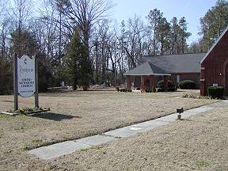 | 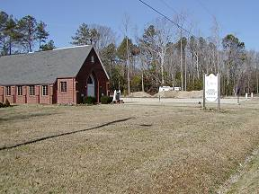
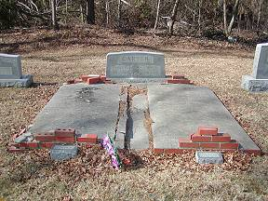 | 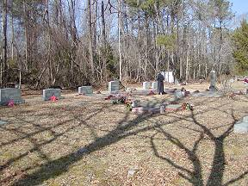
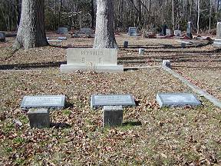 | 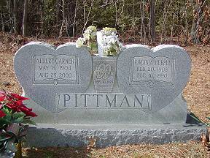
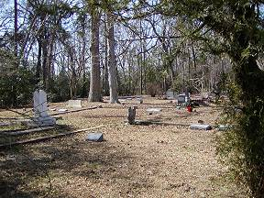
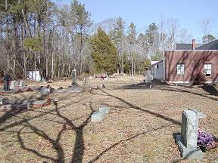
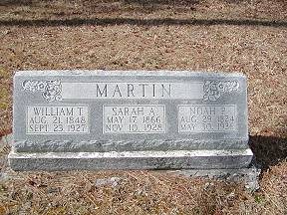 | 