Scott ~Mill Swamp Rd~ Cemetery
Transcribed by members of the
Grave Site Survey Task Force (GSSTF)
Under the Auspices of
Isle of Wight County Historical Society (IWCHS)
Visited September 17, 2005

A selection of shaving foam, water, or talcum powder was used to improve the legibility of the inscriptions on the older tombstones. Afterwards, a clean water spray was used to remove any residue. GSSTF members were careful not to damage tombstones or artifacts during the transcription process.

Any text within the “[ ]” is a comment about the tombstone inscription, ex., [fs] indicates a footstone inscription. Throughout the transcribing process, an attempt was made to preserve the, ‘look and feel’ of the original inscriptions as regards word spacing, arrangement, and possible misspellings.

Please address your comments/corrections to: albert.b@charter.net or epowellsr@aol.com.

 | Inscription |  |  | Inscription
 | RICHARD T. CARROLL  March 18, 1891  March 3, 1935 |  |  | SARAH A. CARROLL  Aug. 26, 1882  March 7, 1935
 | unmarked infant grave |  |  | unmarked infant grave
 | ALICE LEE SCOTT  Born  March 19, 1913  Died Apr. 18, 1913 |  |  | A. N. SCOTT  Born Oct. 18, 1850  Died Dec. 10, 1919  A.N.S. [fs]
 | MARTHA ELLA  Wife of  A. N. SCOTT  Born Jan. 22, 1859  Died  Ded. 15, 1909  _______  At Rest  M.E.S. [fs] |  |  | ALICE MAY  Wife of  J. T. BARHAM  Born  Aug. 30, 1884  Died  Oct. 21, 1909  _____  At Rest

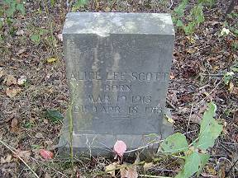 | 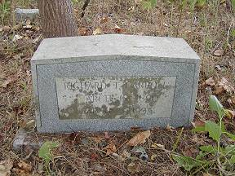
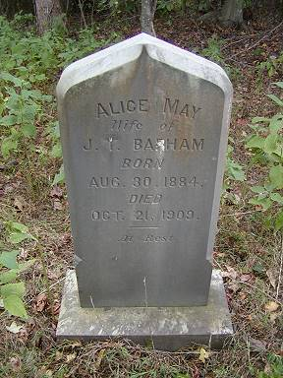 | 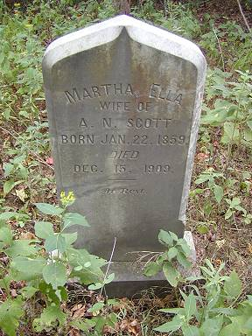
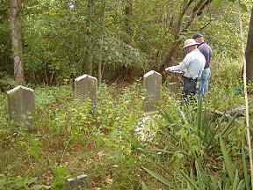 | 