Southall ~Lawson Creek Ln~ Cemetery
Transcribed by members of the
Grave Site Survey Task Force (GSSTF)
Under the Auspices of
Isle of Wight County Historical Society (IWCHS)
Visited May 29, 2006

A selection of shaving foam, water, or talcum powder was used to improve the legibility of the inscriptions on the older tombstones. Afterwards, a clean water spray was used to remove any residue. GSSTF members were careful not to damage tombstones or artifacts during the transcription process.

Any text within the “[ ]” is a comment about the tombstone inscription, ex., [fs] indicates a footstone inscription. Throughout the transcribing process, an attempt was made to preserve the, ‘look and feel’ of the original inscriptions as regards word spacing, arrangement, and possible misspellings.

Please address your comments/corrections to: albert.b@charter.net or epowellsr@aol.com.

 | Inscription |  |  | Inscription
Note (1) | In  Memory of  MARY SOUTHALL  Wife of  Dr. I. B. SOUTHALL  Who died Oct.^{r} 22nd 1812  In the 36th year of her  age  Regreted by all who knew her  J.B.S. [fs] |  | Note (2) | To +  D^{r}. JA.^{S}B  Who d in heav  d  is not to  a  in the

Notes:
- The word, “regretted” is actually engraved on the stone, not a typo.
- This tombstone is broken and fragmented.

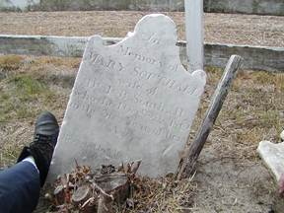 | 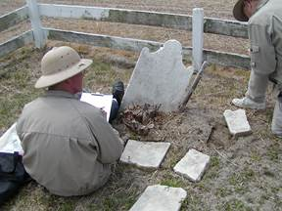
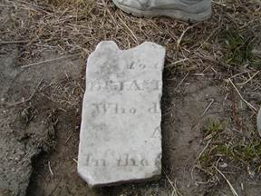 | 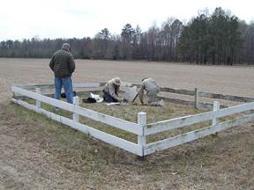
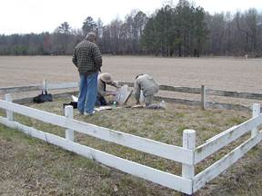 | 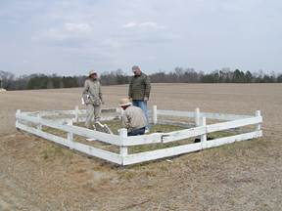
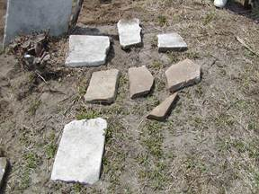 | 