Stringfield_Thomas Woods Tr_ Cemetery
Transcribed by members of the
Grave Site Survey Task Force (GSSTF)
Under the Auspices of
Isle of Wight County Historical Society (IWCHS)
Visited September 30, 2005

A selection of shaving foam, water, or talcum powder was used to improve the legibility of the inscriptions on the older tombstones. Afterwards, a clean water spray was used to remove any residue. GSSTF members were careful not to damage tombstones or artifacts during the transcription process.

Any text within the “[ ]” is a comment about the tombstone inscription, ex., [fs] indicates a footstone inscription. Throughout the transcribing process, an attempt was made to preserve the, ‘look and feel’ of the original inscriptions as regards word spacing, arrangement, and possible misspellings.

Please address your comments/corrections to: albert.b@charter.net or epowellsr@aol.com.

 | Inscription |  |  | Inscription
 | WILLIAM D. PATTERSON  1893 1970 |  |  | MARY BRITTLE  April 18, 1969
 | [unmarked footstone or headstone … no visible markings] |  |  | [Note # 1]

Notes: 1. There is visible evidence of at least 11 unmarked graves

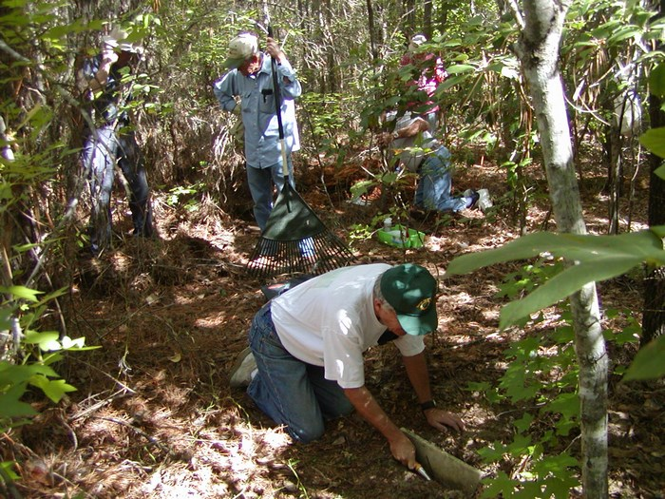 | 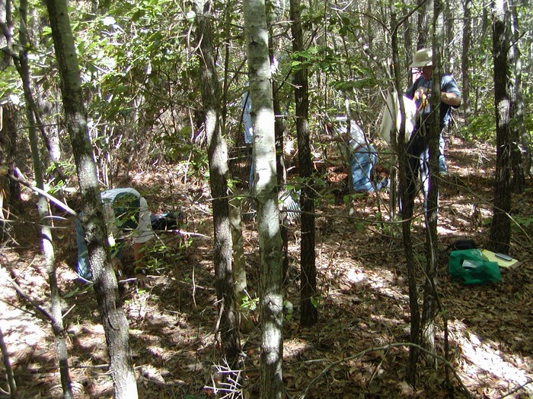
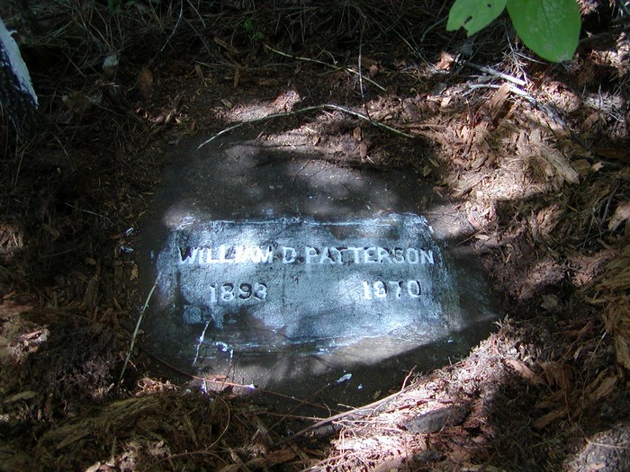 | 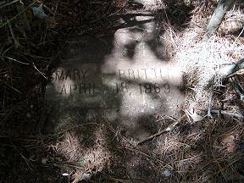
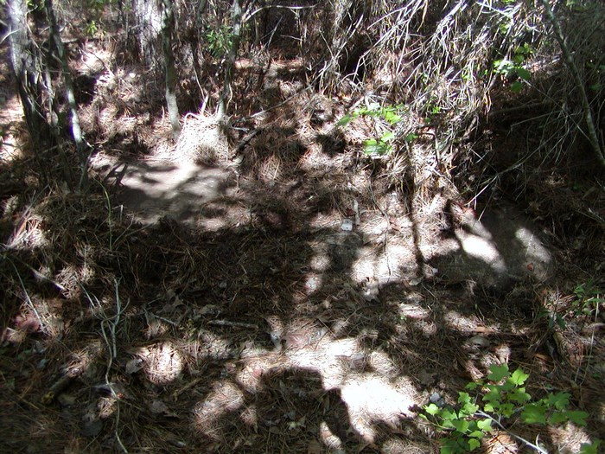 | 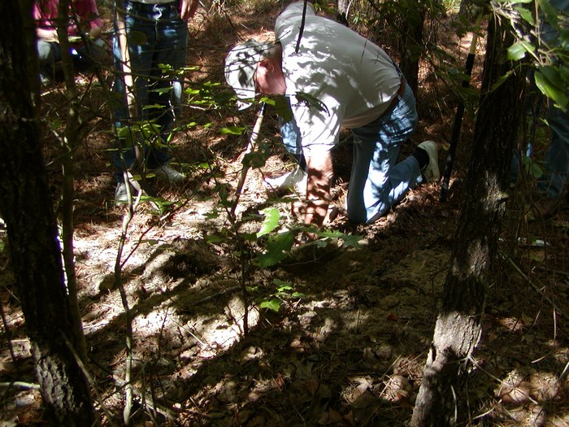
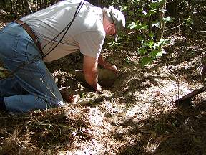 | 