Sweet Haven Church ~Brewers Neck Blvd~ Cemetery
Transcribed by members of the
Grave Site Survey Task Force (GSSTF)
Under the Auspices of
Isle of Wight County Historical Society (IWCHS)
Visited June 15, 2005

A selection of shaving foam, water, or talcum powder was used to improve the legibility of the inscriptions on the older tombstones. Afterwards, a clean water spray was used to remove any residue. GSSTF members were careful not to damage tombstones or artifacts during the transcription process.

Any text within the “[ ]” is a comment about the tombstone inscription, ex., [fs] indicates a footstone inscription. Throughout the transcribing process, an attempt was made to preserve the, ‘look and feel’ of the original inscriptions as regards word spacing, arrangement, and possible misspellings.

Please address your comments/corrections to: albert.b@charter.net or epowellsr@aol.com.

 | Inscription |  |  | Inscription
 | ADA B. BRINKLEY  Sunrise July 25, 1914  Sunset Jan 17, 2004  Beloved wife & mother |  |  | In Loving Memory  ELDER IDA L. BAILEY  July 10, 1918 – June 18, 2001
 | YVETTE D. HILL  June 20, 1968  Sept. 17, 1983 |  |  | ALICE T. GRAY  1910 – 2001  You will always be loved
 | ROSALEE B. LEWIS  Aug. 6, 1921  Dec. 4, 2002 |  |  | CATHERINE P. BATTEN  Sept. 17, 1940  Aug. 20, 1996
 | Mother  LILLIE C. GIBBS  July 7, 1907  Sept 27, 1995  If tears could build a stairway,  and memories a lane, I’d walk  right up to Heaven and bring  you home again |  |  | ASA A. BATTEN  March 30, 1938  June 26, 1995  Husband
 | ARTICE A. CRAWLEY  June 22, 1933  August 24, 1983 |  |  | ROBIN GARDNER  Aug. 20, 1958  Feb. 10, 1998
 | HELEN WHITE  1933 1986 |  |  | DORA G. TEE  Jan. 20 Jan. 22  1920 1989
BISHOP KING DAVID DORCAS E. GRAY
October 12, 1916 July 30, 1921
December 4, 1993 April 10, 1998
In loving memory
JOHNSON
Forever with the Lord

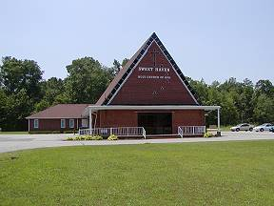 | 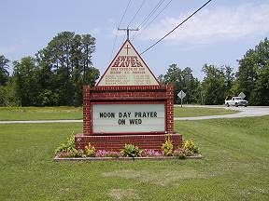
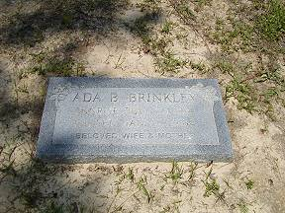 | 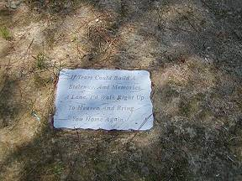
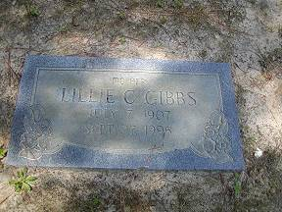 | 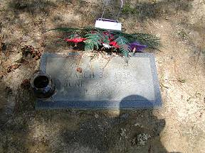
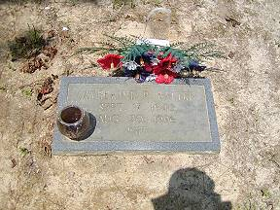 | 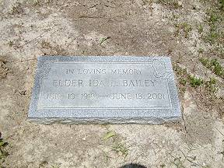
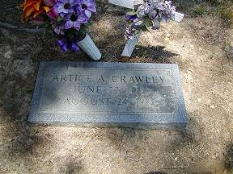 | 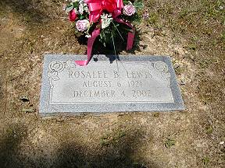
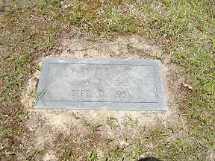 | 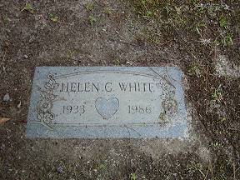
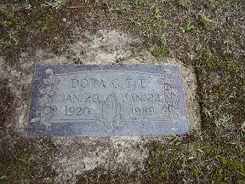 | 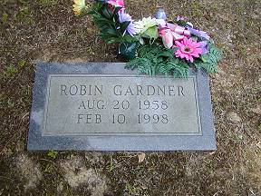
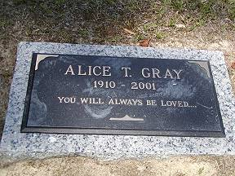 | 