Thomas ~Bayview Dr~ Cemetery
Visited by Members of
Grave Site Survey Task Force (GSSTF)
Under the Auspices of
Isle of Wight County Historical Society (IWCHS)
October 17, 2004

This small cemetery is located on private property and is surrounded by metal fencing. The area around the cemetery has been maintained but the area within the fencing is overgrown.

A selection of shaving foam, water, or talcum powder was used to improve the legibility of the inscriptions on the older tombstones. Afterwards, a clean water spray was used to remove any residue. GSSTF members were careful not to damage tombstones or artifacts during the transcription process.

Any text within the “[ ]” is a comment about the tombstone inscription, ex., [fs] indicates a footstone inscription. Throughout the transcribing process, an attempt was made to preserve the, ‘look and feel’ of the original inscriptions as regards word spacing, arrangement, and possible misspellings.

Please address your comments/corrections to: albert.b@charter.net or epowellsr@aol.com.

 | Inscription |  |  | Inscription
 | ELIZABETH  THOMAS  Born  Nov. 7, 1857  Died  Apr. 5, 1929  Mother  E.T. [fs] |  |  | NOAH  THOMAS  Died  Aug. 14, 1898  Age 65 yrs  Father  N.T. [fs]
THOMAS
M. H. THOMAS
Mar. 25, 1896
Apr. 10, 1922
“To Forget is vain
endeavor
Love’s remembrance
lasts forever”

M.H.T. [fs]

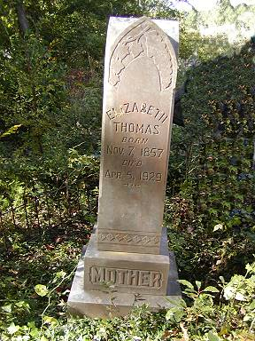 | 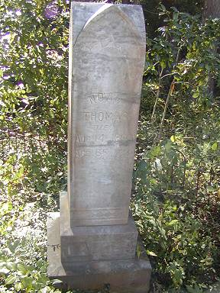
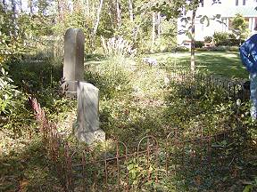 | 