Turner # 2 ~Trump Town Rd~ Cemetery
Transcribed by members of the
Grave Site Survey Task Force (GSSTF)
Under the Auspices of
Isle of Wight County Historical Society (IWCHS)
Visited November 16, 2005

This old family cemetery, where WILLIAM HENRY and ELLEN FRANCES TURNER are buried as well as several members of their family, is located on Va. Rt. 651 (Trump Town Rd). The farm was known as the HENRY TURNER Farm and later as the “NEALIE” TURNER farm. “NEALIE” (CORNELIOUS) married FANNIE ELLA TURNER, daughter of WILLIAM HENRY and ELLEN FRANCES TURNER. The cemetery on this farm has been well kept by their descendents. GURNEY NURNEY now occupies the farm.

Throughout the transcribing process, an attempt was made to preserve the, ‘look and feel’ of the original inscriptions as regards word spacing, arrangement, and possible misspellings. GSSTF members were careful not to damage tombstones or artifacts during the transcription process.

Please address your comments/corrections to: albert.b@charter.net or epowellsr@aol.com.

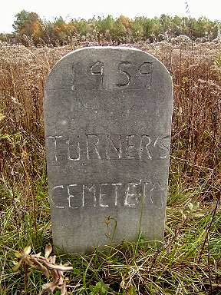
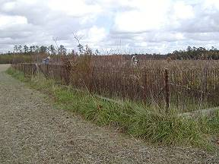 | 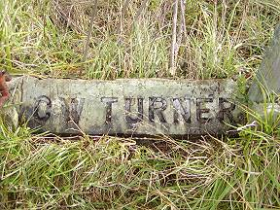
View of fenced-in cemetery | Stone at entrance to cemetery
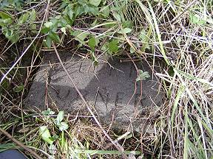 | 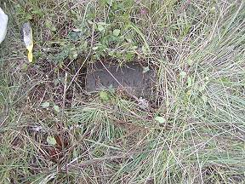
ELLEN TURNER tombstone | Another view of ELLEN TURNER tombstone

