TURNER ~Harry Wilson Rd.~ Cemetery
Visited by Members of
Grave Site Survey Task Force (GSSTF)
Under the Auspices of
Isle of Wight County Historical Society (IWCHS)
April 25, 2004

This small cemetery is located off of Harry Wilson Rd (gravel road) about one mile from Hwy. # 258. Access is through a rough path around the edge of a farmer’s field and through heavy underbrush at the end of that path. A somewhat elaborate fence, consisting of concrete posts and iron chain, surrounds the actual cemetery, which is about 67 feet x 34 feet. It was not possible to probe for additional tombstones due to the dense growth of vines, weeds, and fallen tree limbs. All visible names were on the large granite marker.

Any text within the “[ ]” is a comment about the tombstone inscription, ex., [fs] indicates a footstone inscription. Throughout the transcribing process, an attempt was made to preserve the, ‘look and feel’ of the original inscriptions as regards word spacing, arrangement, and possible misspellings.

Please address your comments/corrections to: albert.b@charter.net or epowellsr@aol.com.

In Loving Memory of

LEWIS TURNER
1756 1837
JAMES TURNER
1804 1840
ARMSTRONG TURNER
1799 1877
MARY ANN SEEDS TURNER
1811 1874
JAMES ARMSTRONG TURNER
1832 1877
JAMES H. BATTEN
1834 1869
MARTHA A. TURNER BATTEN
1836 1869
MARTHA STEPHENSON TURNER
1846 [blank]
ANDREW JACKSON TURNER
1849 1920
FANNIE RACHEL JONES TURNER
1854 1908
WILLIAM ARMSTRONG TURNER
1876 1937
FANNIE PEARL TURNER
1896 1913
ANDREW HUGH TURNER
1913 1913

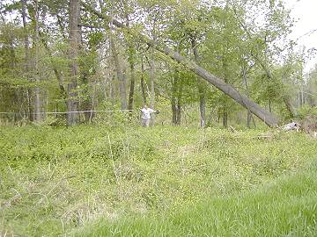 | 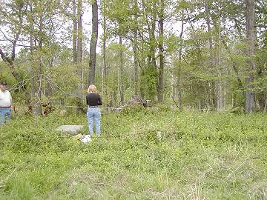
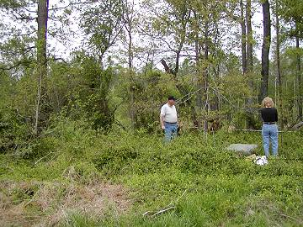 | 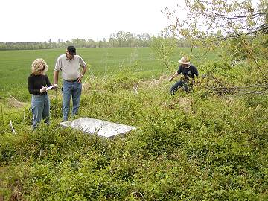
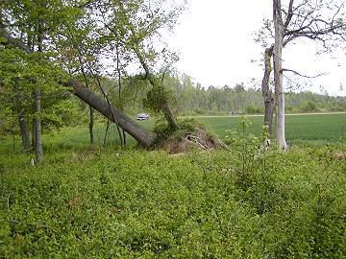
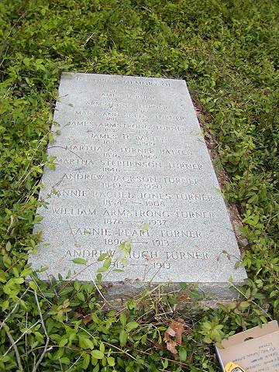 | 