TURNER ~Trump Town Rd~ Cemetery

Visited by a Volunteer of
The Isle of Wight County Historical Society
December 29, 2003

Observations
This small cemetery is located on Trump Town Road (# 651) about 2 miles south off of route # 620 (Foursquare Road). Figure 1 shows a view of the cemetery, unofficially called, “Turner Cemetery” for the purpose of this report. The “[“ and “]” marks contain elucidating comments and are not inscribed on the tombstone. The “[fs]” indicates a footstone inscription. The numbers in the, “Photo #” columns refer to the annotations in the photographs.

Please address your comments/corrections to: albert.b@charter.net or epowellsr@aol.com.

Photo # | Inscription |  |  | Photo # | Inscription
1 | GEORGE L. TURNER  July 10, 1872  April 1, 1938 |  |  | 2 | Father  JOHN T. TURNER  June 15, 1840  Mar. 18, 1917  “Asleep in Jesus  Blessed Sleep”  J.T.T. [fs]
3 | MARY E. TURNER  April 12, 1850  April 5, 1939 |  |  | 4 | TURNER
 |  |  |  |  | GEORGE L.  July 10, 1872  April 1, 1938 | LULA C.  Dec. 28, 1878  May 7, 1949
5 | VINCENT |  |  | 6  Note (1) | TURNER  MARY WHITLEY  April 12, 1850  Oct. 16, 1938
5 | S. ALICE  Aug. 29, 1869  Feb. 2, 1951  S.A.V. [fs] | JAMES H.  June 15, 1866  Nov. 28, 1932  J.H.V. [fs] |  | 6  Note (1)

Notes:
(1) This inscription, shown in Figure 4, is on the reverse side of the headstone in Figure 3.

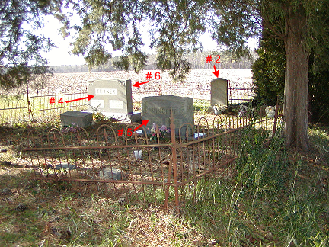
Figure 1

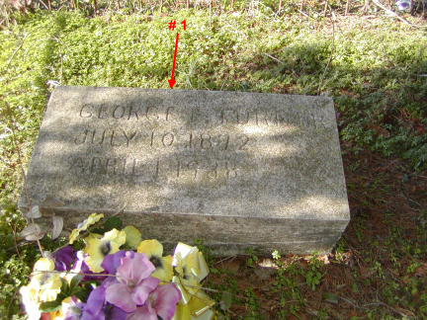
Figure 2
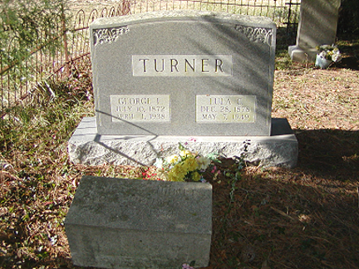
Figure 3

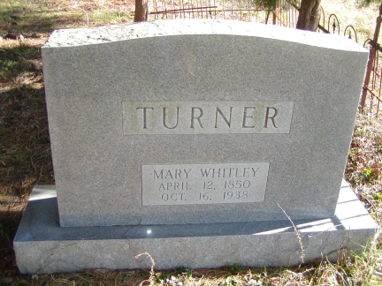
Figure 4
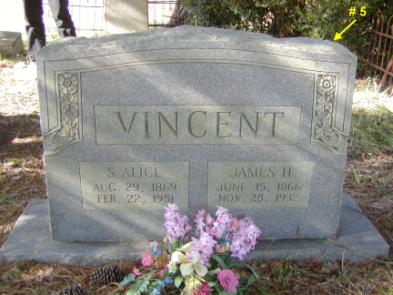
Figure 5

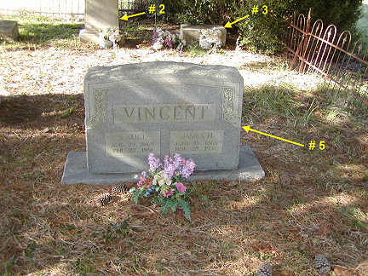
Figure 6

