Tynes ~Carroll Bridge Rd~ Cemetery
Transcribed by Members of
Grave Site Survey Task Force (GSSTF)
Under the Auspices of
Isle of Wight County Historical Society (IWCHS)
Visited May 1, 2005

Thanks to Tommie & “DeDe” Darden for their help in locating this cemetery.

The cemetery, with its lone occupant, is adjacent to the road, has been maintained and has a white paving stone border.

GEORGE TYNES
died Feb. 24, 1952

Please address your comments/corrections to: albert.b@charter.net or epowellsr@aol.com.

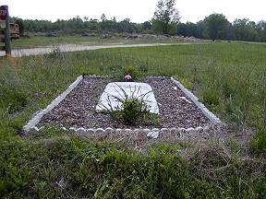 | 