Tynes ~Longview Dr~ Cemetery
Transcribed by members of the
Grave Site Survey Task Force (GSSTF)
Under the Auspices of
Isle of Wight County Historical Society (IWCHS)
Visited June 12, 2005

A selection of shaving foam, water, or talcum powder was used to improve the legibility of the inscriptions on the older tombstones. Afterwards, a clean water spray was used to remove any residue. GSSTF members were careful not to damage tombstones or artifacts during the transcription process.

Any text within the “[ ]” is a comment about the tombstone inscription, ex., [fs] indicates a footstone inscription. Throughout the transcribing process, an attempt was made to preserve the, ‘look and feel’ of the original inscriptions as regards word spacing, arrangement, and possible misspellings.

Please address your comments/corrections to: albert.b@charter.net or epowellsr@aol.com.

 | Inscription |  |  | Inscription
 | Mrs. ELNDRA LEE TYNES  d. Apr 13, 1960 |  |  | GLADYS M. TYNES  Born July 5, 1914  died May 22, 1952  G.M.T. [fs]
 | Sleepy  JESUS  HARREL  JOHNSON  W.B. Feb 27, 1849  died Dec. 15, 1912 |  |  | EVERTT JOHNSON  W.B. July 10, 1847  D. Nov 27, 1913
WILEY WILLIAMS
Oct. 15, 1854
Feb. 27, 1917

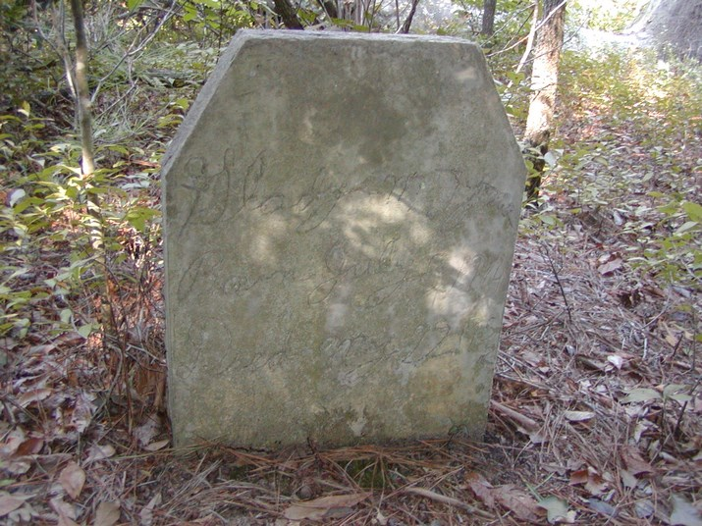 | 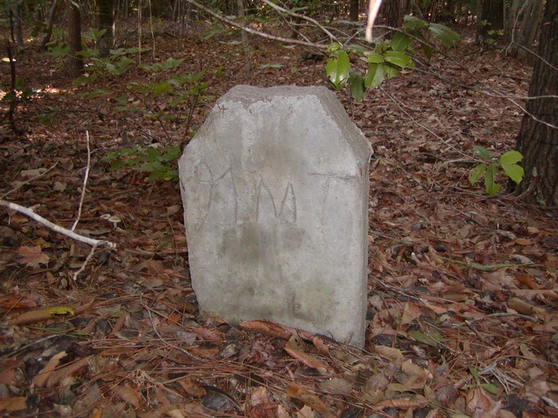
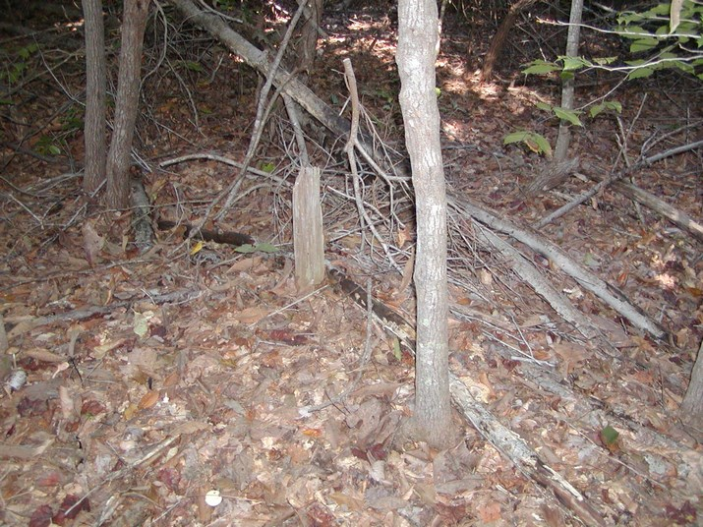 | 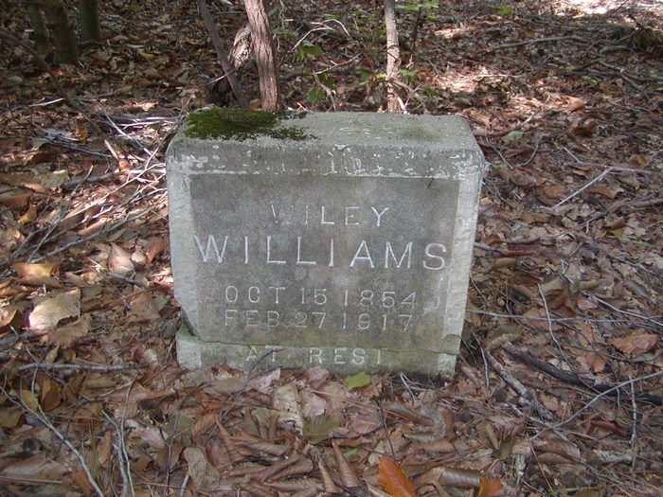
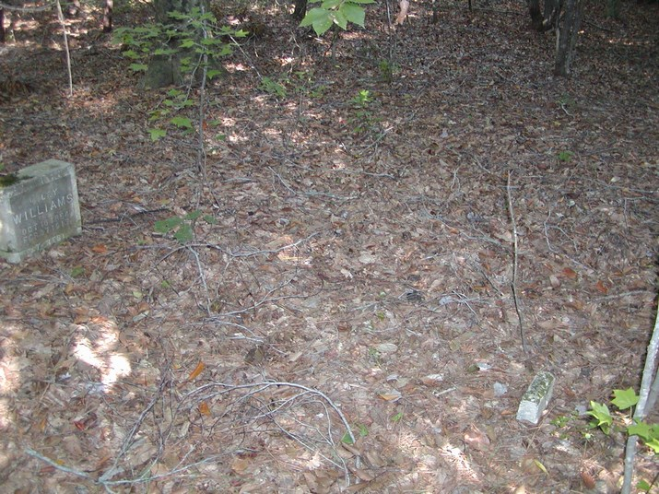 | 