Unidentified—Joyners Bridge Rd-- Cemetery
Transcribed by members of the
Grave Site Survey Task Force (GSSTF)
Under the Auspices of
Isle of Wight County Historical Society (IWCHS)
Visited May 4, 2014

This cemetery is located close to the woods in an adjacent field to Cemetery # 126 off of Joyners Bridge Rd. It is obviously a cemetery but there are no visible tombstones or other markings to indicate who is buried there … local neighbors are aware of the cemetery but could not identify any of the deceased. It could be that further probing would reveal the existence of gravesites, but the thick brush, weeds and briars would have to be cleared for any future probing.

Please address your comments/corrections to: albert.b@charter.net or epowellsr@aol.com.

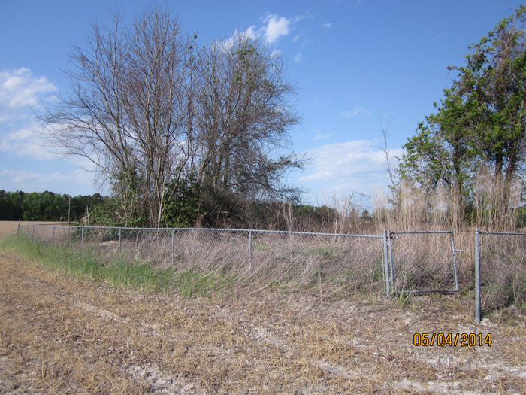 | 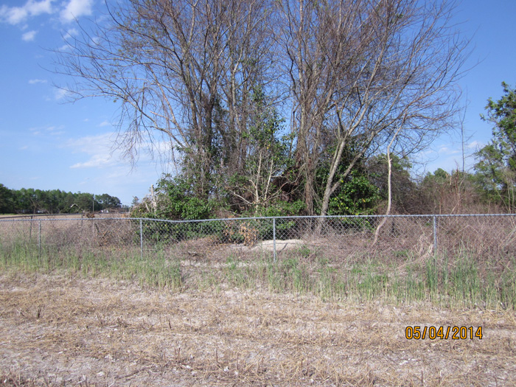
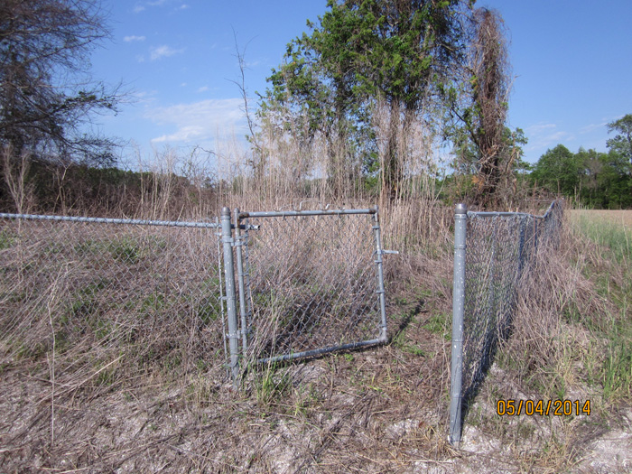 | 