Unidentified--Dardens Mill Rd--Cemetery
Transcribed by members of the
Grave Site Survey Task Force (GSSTF)
Under the Auspices of
Isle of Wight County Historical Society (IWCHS)
Visited Oct 20, 2013

This particular cemetery while of a size that would accommodate more burials, contained only one visible gravesite. This was a burial vault or crypt that had been broken with no visible human remains. Locals were aware of the cemetery but could not identify any person(s) buried there.

The cemetery is located a field some distance behind a private residence on Dardens Mill Rd and closely adjacent to an old railway track.

Please address your comments/corrections to: albert.b@charter.net or epowellsr@aol.com.

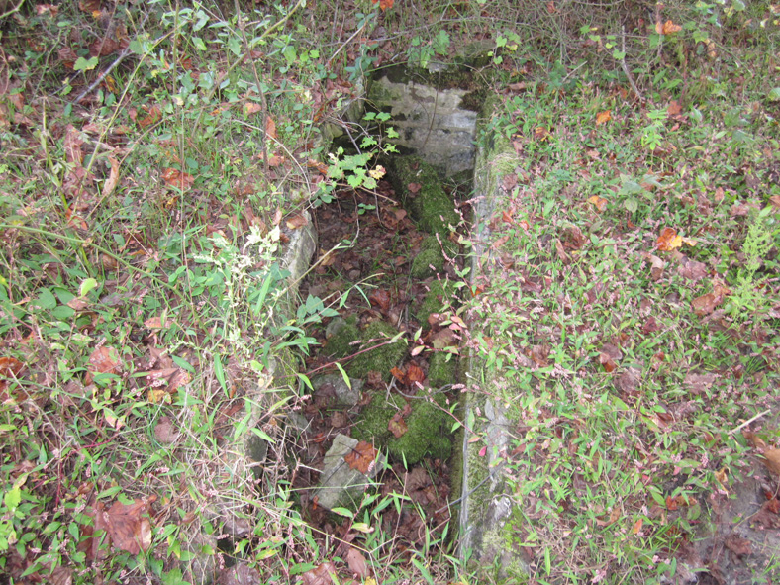 | 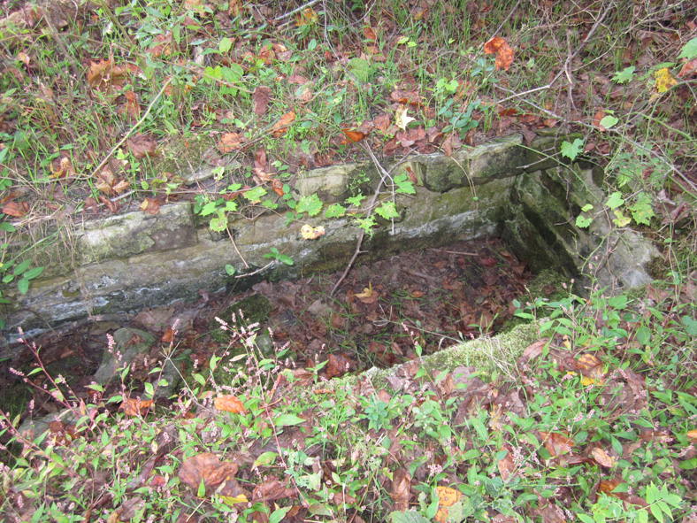
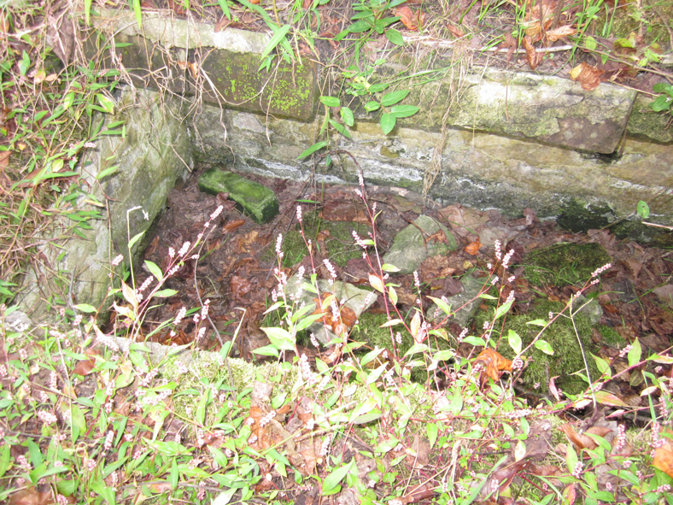 | 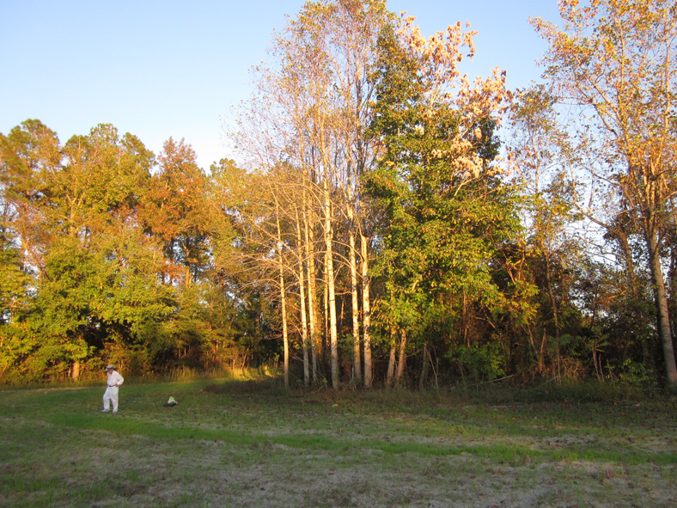
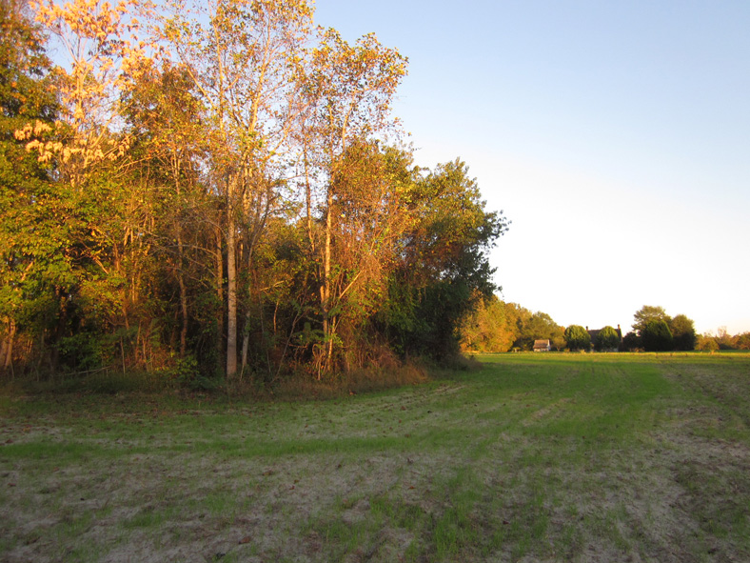 | 