Vellines ~Raynor Rd~ Cemetery
Transcribed by Members of
Grave Site Survey Task Force (GSSTF)
Under the Auspices of
Isle of Wight County Historical Society (IWCHS)
Visited Feb 27, 2005

This cemetery is reported to contain the remains of two members of the Vellines family although no tombstones were visible and the only visible marker was a small brick surround. Task force members were unable to obtain any names, other than the last names, of the deceased.

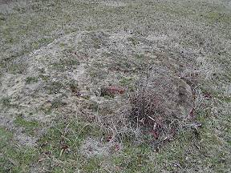 | 