WESTCOTT ~Goose Hill Creek~ Cemetery
Visited by Members of
Grave Site Survey Task Force (GSSTF)
Under the Auspices of
Isle of Wight County Historical Society (IWCHS)
May 5, 2004

This small cemetery is located on private property in the Goose Hill Creek community. The property owner intends to erect a fence around the 2 gravesites found including the tombstone which had been moved from its original location … due possibly to earthmoving equipment during home construction. It seems that the upright tombstone was initially a ledger or crypt stone as evidenced by the raised center shown in figure 2. Neither of the two graves discovered were in the near vicinity of the upright tombstone.

Throughout the transcribing process, an attempt was made to preserve the, ‘look and feel’ of the original inscriptions as regards word spacing, arrangement, and possible misspellings.

Please address your comments/corrections to: albert.b@charter.net or epowellsr@aol.com.

MARGARET WESTCOTT
died in august 1792
aged 18 years

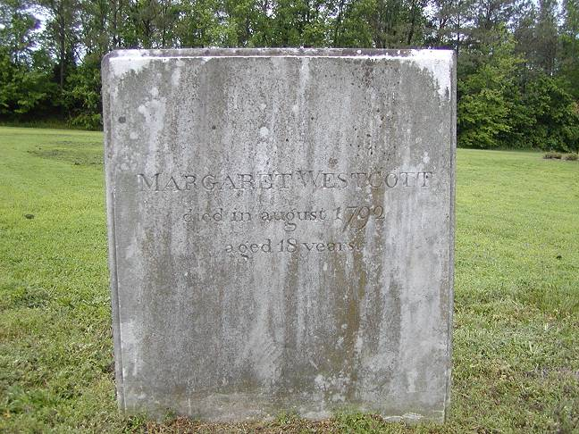
Figure 1 Tombstone in an upright position

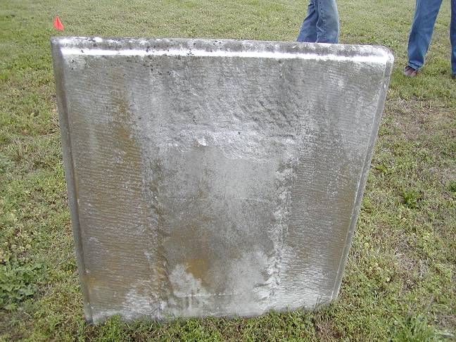
Figure 2 Rear of tombstone

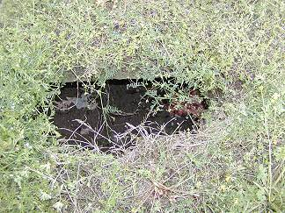  Figure 3 Deteriorated brick crypt | 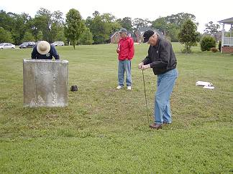  Figure 4 Probing for possible gravesites

