WHITE-HOLLOWAY CEMETERY
Visited by Members of
Grave Site Survey Task Force (GSSTF)
Under the Auspices of
Isle of Wight County Historical Society (IWCHS)
March 31, 2004

This is a small family cemetery located off of Old Stage Hwy just north of Smithfield, VA. It is accessed via a heavily rutted dirt road (Oak Tree Lane) about ¼ mile from the main road. There appears to be about 18 graves, although some of the graves are unmarked. The cemetery has been maintained, grass has been cut, and limbs and other debris has been removed.

GSSTF members were careful not to disturb tombstones or surrounding artifacts and in the few cases where inscriptions were not readily discernible, a combination of a water spray and shaving cream was used to highlight the letters and improve the legibility. Afterwards, a clean water spray was used to remove any residue. The pictures shown below are examples of the gravesites and surrounding area.

Any text within the “[ ]” is a comment about the tombstone inscription, ex., [fs] indicates a footstone inscription. Throughout the transcribing and report preparation process, an attempt was made to preserve the, ‘look and feel’ of the original inscriptions as regards word spacing, arrangement, and possible misspellings.

Please address your comments/corrections to: albert.b@charter.net or epowellsr@aol.com.

 | Inscription |  |  | Inscription
 | HERBERT LEE SKEETER, JR.  PFC US Army  July 25 1956 Jun 27 2001  HERBERT  LEE  SKEETER JR  July 25 1956  June 27 2001 [fs] |  |  | GEORGETTA  SPRATLEY  Sept 4 1911  Sept 3 1973
 | CHERRIE R. TUCKER  May 17, 1940  Oct 21, 1982 |  |  | PERRY L. EDWARDS  July 13, 1958  July 11, 1991
 | Our Beloved  Mother and  Grandmother  LAURA T. WHITE [hs] |  |  | LAURA T. WHITE  May 10 1913  Jan 9 1984  [on top of vault]
 | RICHARD WHITE, SR.  June 6, 1915  March 11, 1991 |  |  | RIP  KADEEM L. WHITE  9-30-92  With Love  your Granddaddy  -n-  Grandmother  -n-  Mother Sister  Brother
 | SEBELIA BRIGGS  Aug. 29, 1948 [note 1] |  |  | JOSEPH L. WHITE  Born Nov. 25, 1929  Died July 21, 1959
 | CHESTER E.  HOLLOWAY  July 30 1952  Sept 22 1975 |  |  | OLIVER J  HOLLOWAY  Aug 16, 1953  Sept 8 1976
 | W. VIRGINIA  HOLLOWAY  March 10 1925  Feb 26 1977 |  |  | BONNIE J  HOLLOWAY  Sept 11 1977 [note 1.]
CIVERES HOLLOWAY
Nov. 25, 1918 – Feb. 28, 1998

Notes:
(1) Only one date on the stone … unsure as to whether this was a ‘born’ date or a ‘died’ date.

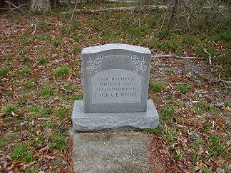 | 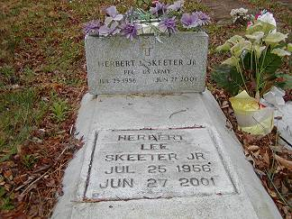
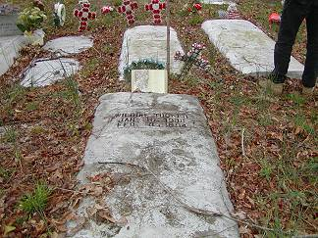 | 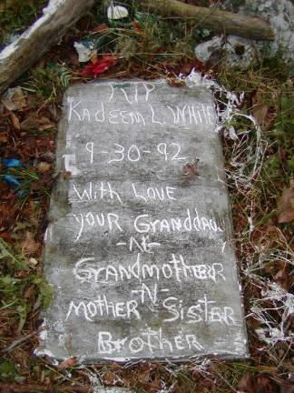
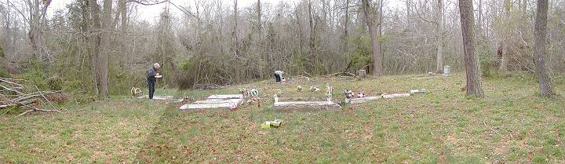
White-Holloway Cemetery Panoramic View

