White ~ Blue Ridge Tr ~ Cemetery
Transcribed by members of the
Grave Site Survey Task Force (GSSTF)
Under the Auspices of
Isle of Wight County Historical Society (IWCHS)
Visited May 25, 2005

A selection of shaving foam, water, or talcum powder was used to improve the legibility of the inscriptions on the older tombstones. Afterwards, a clean water spray was used to remove any residue. GSSTF members were careful not to damage tombstones or artifacts during the transcription process.

Any text within the “[ ]” is a comment about the tombstone inscription, ex., [fs] indicates a footstone inscription. Throughout the transcribing process, an attempt was made to preserve the, ‘look and feel’ of the original inscriptions as regards word spacing, arrangement, and possible misspellings.

Please address your comments/corrections to: albert.b@charter.net or epowellsr@aol.com.

 | Inscription |  |  | Inscription
 | LEWIS T. REBECCA B.  Dec. 25, 1873 Mar 5, 1871  June 8, 1940 Oct. 7, 1937  JACKSON |  |  | NELL O. WALKER  Apr. 27, 1905  Dec. 12, 1968
Note (1) | LEWRSTNNIS BRIGGS  Died Sept 15 1951 |  |  | MARY ALICE BRIGGS  19230 – 1993  Sleep My Love
 | ELLA M. HAWKS  Sept. 15, 1895  Jan. 19, 1941 |  |  | JEANETTE WHITE  Mar. 20, 1963  May 11, 2002
 | MITTIE R. WHITE  May 10, 1954  Jan. 20, 2002  Forever in our hearts |  |  | LENIOUS W. WHITE JR.  Aug. 7, 1947  Feb. 15, 1991
 | LENIOUS W. WHITE SR  Sept. 13, 1909  May 16, 1996  In Loving Memory |  |  | JANIE L. WHITE  Nov. 2, 1918  Oct. 19, 1982  Beloved Mother
 | SUSIE TYNES  Jan. 24, 1880  Jan. 20, 1969  [unmarked footstone] |  |  | [damaged – unmarked grave]
 | EDDIE WHITE  June 27, 1877  Dec. 14, 1964  Gone but not forgotten  EDDIE W WHITE  Born Jun – 27 – 1877  Died Dec – 14 – 1964 |  |  | WILLIAM A.  WHITE  1911 --- 1979  Beloved  WILLIAM A WHITE  July 14, 1911  June 13, 1979
Note (2) | Mother  MITTIE A. WHITE  May 24, 1880  Aug. 7, 1950  We never lose those whom  we never cease to love  MINNIE WHITE  Born – 1880  Died – 1951

Notes:
(1) This obvious misspelling, “LEWRSTNNIS” is actually engraved on the crypt stone.
(2) The two different spellings of, “MITTIE” and, “MINNIE” are actually engraved on the tombstone.

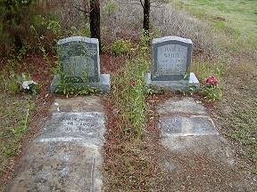 | 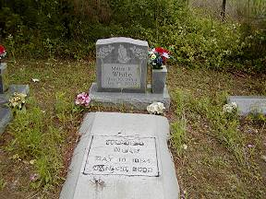
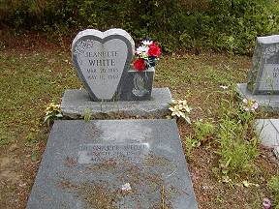 | 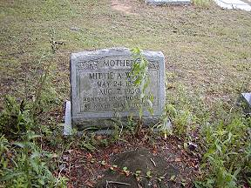
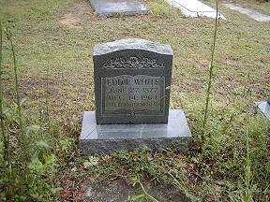 | 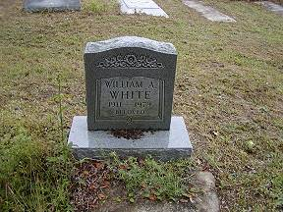
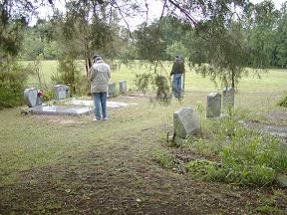 | 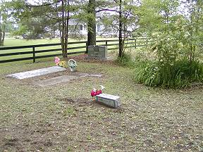
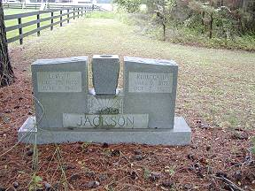 | 