White ~White Hill Trail~ Cemetery
Visited by Members of
Grave Site Survey Task Force (GSSTF)
Under the Auspices of
Isle of Wight County Historical Society (IWCHS)
November 7, 2004

This small cemetery is located on private property (Myers Farm) on White Hill Trail (# 623) near Mill Swamp Baptist Church. It has not been maintained and is heavily overgrown. The surrounding metal fence has fallen in places with some sections missing. Most of the tombstone inscriptions were legible although some stones had sunk into the soil so that dirt had to be removed in order to read the inscription. A selection of shaving foam, water, or talcum powder was used to improve the legibility of the inscriptions on the older tombstones. Afterwards, a clean water spray was used to remove any residue.

GSSTF members were careful not to damage tombstones or artifacts during the transcription process.

Any text within the “[ ]” is a comment about the tombstone inscription, ex., [fs] indicates a footstone inscription. Throughout the transcribing process, an attempt was made to preserve the, ‘look and feel’ of the original inscriptions as regards word spacing, arrangement, and possible misspellings.

Please address your comments/corrections to: albert.b@charter.net or epowellsr@aol.com.

 | Inscription |  |  | Inscription
 | My Husband  WM. A. BINFORD  Born  May 21, 1856  Died Oct. 16, 1883  “His dying words,  Jesus over of my soul  Let me to thy bosom”  W.A.B. [fs] |  |  | CHARLIE B. MYERS  Died Oct. 7, 1880  Age 6 yrs.  “Go bright boy ‘tis  Jesus calls thee”  C.B.M. [fs]
 | [dressed stone approximately  36” X 24” but no inscription,  located in SE corner of cemetery  next to corner of fence.] |  |  | MARY  Born 1987  Died 1888  DENNIS  Born & Died 1902  D.F.W. [fs]
 | SAMMIE WATTIE  WHITE  Born Dec. 15, 1824  Died Sept. 20 1881  Age 6 y’rs 9 mo & 5 da  “Sleep Wattie dear, and take thy rest  God called you home he thought it best  ‘Twas hard, indeed, to part with thee  But Christ’s strong arm supported me” |  |  | ROXANNA E.  Wife of  A. H. WHITE  Born  Oct. 26, 1835  Died  Oct. 16, 1906  WHITE  R.E.W. [fs]
 | AUGUSTUS H.  WHITE  Born  Dec. 15, 1828  Died  Jun. 30, 1908  A.H.W. [fs] |  |  | GEORGE W. WHITE  Born  Aug. 12, 1865  died  Jan. 1, 1915  “He is not dead but sleepeth.”  G.W.W. [fs]
 | IDA C. GWALTNEY  Wife of  G. W. WHITE  Born  Dec. 12, 1865  Died  May 2, 1899  “Asleep in Jesus  blessed thought” |  |  | Baby  Infant son of  GEO. & IDA C.  WHITE  Born Apr 25, 1899  died Apr 26, 1899
 | MARY E.  Wife of  T. A. COFER  Born Jan. 4, 1854  M.E.C. [fs] |  |  | THOMAS A. COFER  Born June 3, 1851  died Nov. 22, 1896  T.A.C. [fs]

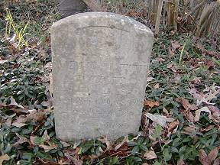 | 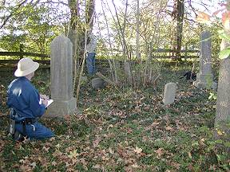
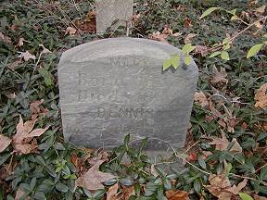 | 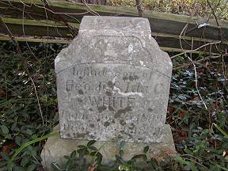
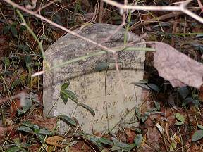 | 