Whitehead ~Old Carrsville Hwy~ Cemetery
Transcribed by members of the
Grave Site Survey Task Force (GSSTF)
Under the Auspices of
Isle of Wight County Historical Society (IWCHS)
Visited August 30, 2005

This small family cemetery is located in a farm field in the town of Carrsville. Thanks to Mr. Phillip Bradshaw for identifying this cemetery to the GSSTF members.

A selection of shaving foam, water, or talcum powder was used to improve the legibility of the inscriptions on the older tombstones. Afterwards, a clean water spray was used to remove any residue. GSSTF members were careful not to damage tombstones or artifacts during the transcription process.

Any text within the “[ ]” is a comment about the tombstone inscription, ex., [fs] indicates a footstone inscription. Throughout the transcribing process, an attempt was made to preserve the, ‘look and feel’ of the original inscriptions as regards word spacing, arrangement, and possible misspellings.

Please address your comments/corrections to: albert.b@charter.net or epowellsr@aol.com.

 | Inscription |  |  | Inscription
 | Another Angel in Heaven  JESSE T. WHITEHEAD  Died Aug. 9, 1857  Aged 3 years & 6 mos |  |  | ELIZA A. WHITEHEAD  Born  Oct. 29, 1821  Died  Nov. 12, 1899
Note (1) | [headstone missing .. no visible identification]  J.W. [fs]  J. MULHOLLAND  Ports. Va

Notes:
(1) The deteriorated condition of the cemetery markers make it difficult to identify all of its occupants … the footstone inscription, “J.W.” appears to be intended for a person other than for the infant Jesse T. Whitehead.

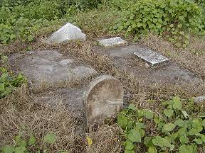 | 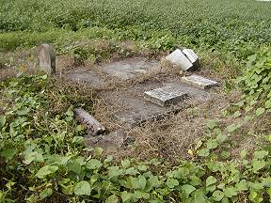
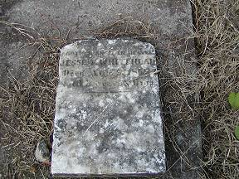 | 