Whiteheads Grove ~Benns Church Rd~ Cemetery
Visited by Members of
Grave Site Survey Task Force (GSSTF)
Under the Auspices of
Isle of Wight County Historical Society (IWCHS)
Visited April 17, 20, 2005

A selection of shaving foam, water, or talcum powder was used to improve the legibility of the inscriptions on the older tombstones. Afterwards, a clean water spray was used to remove any residue. GSSTF members were careful not to damage tombstones or artifacts during the transcription process.

Any text within the “[ ]” is a comment about the tombstone inscription, ex., [fs] indicates a footstone inscription. Throughout the transcribing process, an attempt was made to preserve the, ‘look and feel’ of the original inscriptions as regards word spacing, arrangement, and possible misspellings.

Please address your comments/corrections to: albert.b@charter.net or epowellsr@aol.com.

 | Inscription |  |  | Inscription
 | MARGARET BUCHANAN  GILLIAM  Dec. 12, 1923  Oct. 18, 1974 |  |  | Husband  HARRY V. DIXON  March 25, 1885  July 27, 1954
 | OTELIA  DIXON  Apr. 17, 1888  Apr. 12, 1944  At Rest |  |  | CARROLL B. RILEY  1932 – 1968
 | H. RAY LOWE  Nov. 15, 1912  Sept 21, 1999 |  |  | WALTER PLEASANTS  Oct. 3, 1882  May 9, 1964
 | MARY FRANCES  LOWE JOYNER  Apr. 6, 1947  Aug. 15, 1983 |  |  | MARY E. LOWE  Jan. 20, 1909  Mar. 10, 1972
 | ROBERT WAYNE  LANKFORD  Oct. 21, 1944  Aug. 4, 1946 |  |  | GEORGE LEE  LANKFORD  Dec. 31, 1940  Mar. 15, 1941
 | LANKFORD  OTIS J., SR MARY WILKINS  May 2, 1916 Jan. 13, 1919  Jan. 10, 2001 Dec. 28, 1995 |  |  | GILMER  MARY LANKFORD JOHN THOMAS  Aug. 16, 1942 Jan. 21, 1939  Oct. 28, 2001
 | RAYMOND E. TURNER  Feb. 19, 1938  Jan. 18, 1995 |  |  | GRACE N. TURNER  Nov. 6, 1904  Apr. 10, 1987
 | VERNON L. TURNER  Mar. 17, 1899  Dec. 21, 1959 |  |  | RAYMOND EARL OUTLAW  US Navy  World War II  Mar 29 1920 Sep 24 2000  Purple Heart
 | MURPHY  EULICE RIDDICK ETHEL TURNER  Dec. 13, 1888 Aug. 25, 1901  Nov. 2, 1979 Feb. 10, 1998 |  |  | CAROL WESLEY SAWYER  Aug. 17, 1900  May 14, 1940
 | WILLIAM EVERETT SAWYER  1868 – 1932 |  |  | FRANCES R. KENNELL  1949 2005
 | HILDA MYERS RICHARDS  Jan. 1, 1918  Feb. 1, 1998 |  |  | JOHN CRAFFORD RICHARDS  Nov. 12, 1914  Mar. 16, 2001
 | Mother  SALLIE L. RICHARDS  Jan. 30, 1894  April 21, 1967 |  |  | Father  JOHN R. RICHARDS  May 2, 1894  April 27, 1977
 | CUTCHIN  PAUL S. SR. MARY R.  Nov. 19, 1896 June 28, 1897  Sept. 25, 1980 Sept. 27, 1975  Married April 25, 1916 |  |  | PAUL S. CUTCHIN JR  US Army  US Navy  Korea  Nov 15 1928 May 22 2002
 | MARY ANN MATTHEWS  February 11, 1859  February 18, 1937 |  |  | JOHN FRANCIS MATTHEWS  October 20, 1863  January 9, 1929
 | CLYDE L. JR MARY CUTCHIN  1916 – 1998 Married Sept 25, 1937 1919 – 2000  BROCK |  |  | BOBBY DEAR BAYNARD  SFC US Army  Dec 23 1955 May 16 1986
 | LANKFORD  THOMAS MARTHA MOORE  Oct. 20, 1857 Sept. 12, 1871  Aug 25, 1914 May 18, 1921 |  |  | CHAPMAN  SAMUEL G EVELYN G  May 30, 1904 Dec. 22, 1908  June 29, 1972 Aug 7, 2000
 | LILLIAN V. LAWRENCE  Sept. 19, 1883  Feb. 21, 1956 |  |  | WALTER LAWRENCE  Aug. 23, 1876  Nov. 3, 1947
 | ROBERT M. LAWRENCE  Aug. 4, 1907  died 1946 |  |  | In Memory of  Deacon  CRITTENDEN C. CHANNEL  Born Aug. 26, 1845  Baptized Oct. 25, 1868  into the fellowship of this church  Elected Deacon June 22, 1872  and filled this office until his death Jan. 4, 1902  “Mark the perfect man and behold  the upright; for the end of that man is peace”  PsXXX Vh; 37  Erected by Whitehead Grove Baptist Church  At Rest  C. C. CHANNELL  Born Aug 26, 1846  died the death of the righteous  Jan. 4, 1902  Dearest Husband we have laid thee  in the peaceful graves embrace  but thy memory will be cheriset  till we see thy Heavenly face [fs]
 | PURDIE  JAMES L. GRACE C.  Apr. 20, 1980 Mar. 7, 1891  Aug. 30, 1951 Apr 20, 1979 |  |  | JACQUELINE Y. CARLSON  Mar. 25, 1936  Sept. 5, 1970
 | CHAPMAN  EDGAR W. JOSEPHINE  June 28, 1867 Aug. 14, 1870  Aug. 16, 1935 Mar. 13, 1962 |  |  | NOVELLA E.  WHITE  daughter of  H. L. & MATTIE  PARR  Nov. 28, 1880  Jan 25, 1914  “How desolate our  home, bereft of thee”  M.E.P. [fs] H.L.P. [fs]
 | J. WAVERLY HORNE JR  U.S. Army Air Forces  World War II  Feb 7 1920 Dec 14 1997 |  |  | JAMES WAVERLY HORNE  Sept. 2, 1895  Jan. 2, 1950
 | DORIS PURDIE HORNE  June 25, 1898  Sept. 23, 1976 |  |  | BENJAMIN F. DARNELL  TEC 5 US Army  World War II  Dec 8 1919 Feb 4 1992
 | DAVID WAYNE GRIFFIN  Sept. 18, 1956  July 13, 1998  At Rest |  |  | VIRGINIA VELLINES PAYNE  December 6, 1916  March 11, 1996
 | H. L. PARR  Son of  JAMES & ADELINE  PARR  May 30, 1855  Mar 8, 1895  My darling one  has gone before  to greet us on  the blissful shore |  |  | MATTIE PARR  Daughter of  W^{M} T. & PAULINE  VELLINES  May 10, 1878  June 9, 1889  Lord she was thine  and not our own  thou has not  done us wrong
 | EUNICE F. STEPHENS  Mar. 8, 1937  May 10, 1994  In God’s loving care |  |  | “Dick”  ALEXANDER GIBSON  Jun. 13, 1906  Apr. 9, 1989
 | Son  R. BLANE BURRIS  Jan. 10, 1965  Jan. 24, 1993 |  |  | WIGGS  HARRY JOHN POLLY PYLE  Feb. 17, 1927 Aug. 28, 1926  July 7, 2003 Feb. 18, 1999  HARRY JOHN WIGGS  CRM US Navy  WWII Korea Vietnam  Feb 17 1927 Jul 7 2003
 | MARY V. BUTLER MURPHY  1862 – 1930 |  |  | DANIEL JACKSON MURPHY  1857 – 1932
 | HARRIET MURPHY RITTER  1893 – 1988 |  |  | EMMA J. GODWIN  wife of J. G. KNIGHT  Born Sept 20, 1873  died Apr. 2, 1917  “Lord she was thine and not our own  thou hast not done us wrong”
 | SARAH A.  wife of J. E. JOHNSON  Born Mar. 31, 1877  died Oct. 2, 1906  “She was a kind and affectionate wife,  a fond mother,  and a friend to all.” |  |  | NELLIE C. NELMS  Dec. 1874  Feb. 1938
 | NELMS  “CASEY”  LINWOOD L. RUBY T.  June 6, 1904 Aug. 31, 1910  May 14, 1980 Oct. 24, 1996 |  |  | DELFENTHAL  JOSEPH MCKINLEY  Aug. 13, 1928  Dec. 19, 2001  JOSEPH M DELFENTHAL  CPL US Army  Korea  Aug 13, 1928 Dec 19 2001 [fs]
 | LYDIA WATKINS MURPHY  1896 – 1979 |  |  | WILLIAM HOLMES WATKINS  PFC US Army  Korea  1924 1979
 | LUTHER M. MURPHY  1884 – 1959 |  |  | BIRTLEY R. HINES  Mar 19, 1881
 | GEORGE E. PITT  Dec. 29, 1877 |  |  | JAMES W. THOMPSON  “Bill”  Aug. 15, 1929  Oct. 26, 1987
 | LELIA ELLEN CHAPMAN GRIFFIN  Nov. 18, 1898  Feb. 12, 1990 |  |  | JAMES R. GRIFFIN  1893 - 1953
 | WILMA JEAN BARBREY  Born 2-15-1939 died 1-11-2005 |  |  | GARY WAYNE GILMER  Sept. 30, 1961 – Aug. 9, 1984  “Greater love hath no man than this,  that a man lay down his life for  his friends”  John 15:13
 | GRIFFIN  JAMES THOMAS EMMA ALLMOND  1849 – 1920 1854 – 1918 |  |  | IDA PITT  1872 – 1894
 | THOMAS PITT JR  1874 – 1895 |  |  | THOMAS H. PITT  1840 – 1900
 | VICTORIA PITT  [no dates] |  |  | JAMES RICHARD [indecipherable]  1866 1897  RW BAKER & CO
 | CRUMPLER  BESSIE LEE LEE J. LULA L.  1894 –1995 1863 – 1945 1866 – 1949  B.L.C. [fs] L.J.C. [fs] L.L.C. [fs] |  |  | In Memory of  ELIZABETH WHITEHEAD  who died Feb. 28th 1894  Aged 80 years  At Rest  also  JACK WHITEHEAD  Husband of the aforesaid  who died July 13, 1899  Aged 77 years  “Mark the perfect man  and behold the upright  for the end of that man is peace”  Psalms 37 chap. 37 verse
 | At Rest  M. TEXANNA COFIELD  wife of  C. C. CHANNELL  July 1851  Aug 1932  A friend to all  M.T.C. [fs] |  |  | JOHN ROBERT BROCK  Born July 16, 1851  died Dec. 30, 1890  “Blessed are the dead who die in the Lord”  A good man, useful citizen. A zealous  Christian. A deacon in Whitehead Grove Baptist  church. A gentle and affectionate husband  and father  Erected by his widow and sons  BROCK
 | FANNIE E. LATIMER  nee BROCK  nee CHANNELL  Mar. 4, 1853  Feb. 22, 1905  Our sad loss, her gain Prov. 31 10 to 28  erected by Husband & sons |  |  | JAMES J. CRUMPLER  Sept. 7, 1820  July 27, 1884  At Rest  CRUMPLER  J.J.C. [fs]
 | JULIE A.  his wife  May 30, 1834  Jan 24, 1905  Rest in Peace  CRUMPLER  J.A.C. [fs] |  |  | CRUMPLER  GEORGE MADISON FANNIE SCOTT  Nov. 26, 1867 Aug. 21, 1892  Dec. 29, 1948 Oct. 1, 1976  G.M.C. [fs] F.S.C. [fs]
 | Father  SIDNEY M. CRUMPLER  1871 - 1910 |  |  | Mother  MARGARET U. CRUMPLER  1870 - 1959
 | “Tina”  GERALDA C. GRIFFIN  wife [fs] |  |  | GEORGE L. GRIFFIN  Dec. 3, 1908  Dec. 26, 1970  son [fs]
 | JAMES C. GRIFFIN  1910 – 1956  son [fs] |  |  | GRIFFIN  MARY C. THOMAS C.  1878 – 1921 1876 – 1941  mother [fs] father [fs]
 | MAYO  Mother Father Sister Sister  [no names or dates] |  |  | FLORENCE MAYO NAW  1873 - 1957
 | EDNA D. LANKFORD  July 2, 1896  Dec. 20, 1963 |  |  | SETH LANKFORD  Feb. 18, 1892  July 8, 1965
 | JASPER L. LANKFORD  Dec. 30, 1913  Aug. 22, 1983 |  |  | BROCK  LYNETIE M. ALEXANDER W. MARTHA C.  1895 – 1953 1853 – 1930 1874 - 1904
 | FRANK S. GRIFFIN  Apr. 29, 1915  Nov. 6, 1985 |  |  | MAGGIE  Wife of BENJAMIN CHAPMAN  Born June 1, 1860  died April 2, 1899  “Asleep in Jesus – Blessed sleep.”
 | BENJAMIN CHAPMAN  Born Sept. 28, 1862  died Jan. 3, 1908  “God have called our dear one to dwell with  Jesus for ever more” |  |  |   GLADYS CHAPMAN STUMP  Dec. 19, 1904  Aug. 25, 1905
 | JOHN C. BATTEN  June 27, 1904  Oct. 5, 1905 |  |  | TURNER  FRANK L. MABEL L.  1907 – 1979 1913 – 1972
 | EDITH GRACIE PRUDEN  FOWLER  Oct. 16, 1887  Apr. 18, 1932 |  |  | TURNER  GEORGE F. FANNIE L.  1857 – 1929 1886 – 1972
 | MARY E. HOLLAND  Sept. 8, 1847  Sept. 13, 1926  “Thy trials ended, thy rest is won.” |  |  | GEORGE F. TURNER JR  1927 – 1998
 | [illegible .. hand carved on concrete slab] |  |  | ROXANNA PRUDEN  Born May 20, 1854  died Dec 10, 1916
 | JOSEPHINE PURDIA  1862 – 1933 |  |  | FLETCHER GLOVER EDWARDS  Sept. 2, 1887  Mar. 6, 1959
 | GEORGIE WHITLEY EDWARDS  MAR. 3, 1891  Oct. 1, 1978 |  |  | REYNOLDS  CHARLES W. GOULIA E.  Nov. 21, 1897 July 25, 1896  June 14, 1969 May 25, 1957
 | ROBERT F.  son of G.F. & EMMA  TURNER  Aug. 10, 1888  Sept. 4, 1918  “Gone but not forgotten” |  |  | DIXON  JOHN HENRY  1842 – 1914  Co. F. 9 Inf. C.S.A.  CATHERINE  Beloved wife of JOHN HENRY DIXON  1851 – 1936  “Peacefully sleeping”  Mother [fs] Father [fs]
 | Benj. K. CHAPMAN  Born Jan. 13, 1892  died Feb. 5, 1910  “Blessed is he that liveth in the Lord” |  |  | Benj. CHAPMAN JR.  Born Feb. 1908  Died Sept. 12, 1910  “Only asleep but not forever”
 | Infant Son of  B. & M. A.  CHAPMAN |  |  | [small marker … not legible]
 | HENRY PRUDEN  Born Jan. 22, 1855  Died Oct. 24, 1902  “Gone but not forgotten”  H.P. [fs] |  |  | Lead kindly light  ANNIE J. VAUGHN  wife of HENRY PRUDEN  Born May 17, 1863  died Dec. 26, 1915
 | GRACE GALE NORRIS  July 3, 1898  Jan. 1, 1976 |  |  | CLARENCE W. GALE  Jan. 29, 1885  Oct. 17, 1950
 | THOMAS WALTON GALE  Born Mar. 22, 1859 – died Jan. 8, 1916 |  |  | ROBERT C. PITTMAN  1923 – 1944
 | NATHANIEL GALE  Born June 18, 1886  died Sept. 5, 1889 |  |  | THOMAS G. PITTMAN  Virginia  SGT. 116 Inf. 29 Div.  Feb. 12, 1942
 | NELLIE GALE PITTMAN  Jan. 6, 1889  Apr. 16, 1954 |  |  | MOLLIE  wife of JOSIAH CHAPMAN  Born Nov. 15, 1871  died Nov. 13, 1894  “Gone but not forgotten”
 | MADISON EDWARDS  died Oct. 9, 1901  Age 29 years  “Gone but not forgotten” |  |  | GEORGIANNA EVANS POWELL  mother of  MERRITT S. POWELL
 | WILLIAM E.  son J. O. & M.  CHAPMAN  Born Sept. 5, 1889  died Oct. 22, 1892 |  |  | JOSIAH O. CHAPMAN  June 24, 1864  Dec. 12, 1918  “They loved him most  who knew him best”
 | LUCIE E.  CHAPMAN  Jan. 16, 1878  Oct. 27, 1945  “A tender mother, and  a faithful friend” |  |  | JESSIE LAWLESS CHAPMAN  May 10, 1907  Mar. 2, 1925  “Dying is but going home”
 | WESLEY EDWARDS  1873 – 1915 |  |  | IDA EDWARDS WARREN  1879 –1959
 | JAMES WESLEY  son of  T. L. & M. F. EDWARDS  Born June 22, 1919  died Oct. 22, 1923  Darling we miss thee  J.W.E. [fs] |  |  | MINNIE BELL PRESSON  wife of C. T. PRUDEN  July 12, 1895  Feb. 1, 1919  The fairest flower, we fondly love, how soon it fades
 | In memory of my  Darling son  GEORGE J. CHAPMAN  Born Mar 7, 1869  died Dec. 22, 1890  Age 21 yrs 9 mo. 15 d’ys  “Asleep in Jesus, sweet Jesus”  erected by his mother |  |  | SUSIE L.  Daughter of  C. H. & SARAH  EDWARDS  June 13, 1904  Feb. 14, 1909  Sweet be thy rest
 | LIZZIE LEE  Daughter of  C. H. & SARAH  EDWARDS  Nov. 14, 1889  Mar. 2, 1900  Crossed the river of life |  |  | CHARLES OBIE  Son of  C. H. & SARAH  EDWARDS  Born Aug. 10, 1891  Died in France  Oct. 10 1918  Not lost to love – not lost to  memory: but gone to our  Heavenly home above  EDWARDS
 | Infant of  C. H. & SARAH  EDWARDS  Gods gift recalled |  |  | BENNIE A. CARLSON III  US Navy  Sep 21 1955 Feb 25 1991
 | JAMES E. PURDIE  1915 - 1943 |  |  | MERRITT S POWELL  Virginia  Pvt Co G 4 Regt VA Inf  Spanish American War  April 13 1882 March 31 1966
 | POWELL  Wife Husband  JOSEPHINE B. MERRITT S.  Dec. 12, 1892 April 13, 1880  Sept. 6, 1965 March 31, 1966 |  |  | LOUISE CROCKER  Aug. 21, 1896  Oct. 15, 1944  At Rest
 | BATTEN  JAMES W. ALICE D.  Feb. 8, 1869 Aug. 5, 1876  Oct. 1, 1924 Dec. 5, 1935  In loving memory |  |  | PAULINE B. WILLIAMS  June 13, 1899  March 9, 1984
 | RUTH BATTEN STREMEL  Oct. 22, 1894  Nov. 12, 1976  R.B.S. [fs] |  |  | SARAH T. EDWARDS  Mar. 10, 1865  May 1943
 | C. H. EDWARDS  Aug. 3, 1858  Dec. 13, 1933 |  |  | SALLY E. SCOTT  June 20, 1894  Feb. 2, 1962
 | GEORGE ANDREW KEMP  May 7, 1906  April 22, 1989 |  |  | ANNIE LAURA KEMP  Oct. 14, 1903  Dec. 12, 1989
 | WILLIAM D. KEMP, JR.  Sept. 30, 1894  Mar. 8, 1971 |  |  | LINDA K. WILLIAMS  Sept. 7, 1897  Nov. 5, 1953
 | OLELIA W. KEMP  Dec. 10, 1866  Nov. 27, 1948 |  |  | WILLIAM D. KEMP, SR.  Oct. 13, 1850  June 25, 1934
 | THOMAS E. KEMP  Dec. 28, 1901  July 28, 1980 |  |  | SAMANTHA E. BRADSHAW  1990 1990  Colonial Funeral Home
 | TUPER W BRADSHAW  Virginia  Cox USNR  World War II  March 1 1926 June 28 1964 |  |  | GEORGE W. PINNER  1853 1936
 | JO ANN BRADSHAW  1960 1993  Hill Funeral Home |  |  | GAYLE  Husband Wife  E. PHONZER GERTRUDE THOMAS  1901 – 1996 1904 – 1992
 | TODIE W. LIZZIE P.  June 12, 1887 Aug. 19, 1894  Sept. 6, 1961 Nov. 1, 1968  BRADSHAW |  | Note (1) | GR[..]VER LEE BRADSHAW  1910 1992  Hill Funeral Home
 | COLLIN C ODEY  Virginia  Pvt Co E 116 Infantry  World War I  April 12 1892 April 30 1945 |  |  | NEALIE ODEY BRADSHAW  Feb. 21, 1911  June 20, 1977
 | WILLIE C ODEY  1917 1943  I.O. Hill Company |  |  | Father  EDWARD WOODSEY DIXON  Aug. 9, - Feb. 7,  1911 1999
 | Mother  HILDA RUTH DIXON  Sept. 10, - Apr. 27,  1930 1991 |  |  | EDWARD WOODSEY DIXON  Mar. 14, 1881  Oct. 28, 1966
 | TERRY E. JONES  1975 1978 |  |  | JOHN WESLEY DIXON  Dec. 17, 1878  Feb. 6, 1953  At Rest
 | ROSA TURNER DIXON  Nov. 8, 1880  Aug. 31, 1954  At Rest |  |  | ELLIS ROY THOMAS  Oct. 10, 1930  Apr. 12, 1953  E.R.T. [fs]
 | NOAH F. THOMAS  Jan. 4, 1872  Jan. 3, 1947  N.F.T. [fs] |  |  | LUBY H. THOMAS  Dec. 29, 1882  April 3, 1968
 | ALGIE JULIOUS  MURPHY, SR.  Aug. 14, 1916  Dec. 2, 1984 |  |  | MURPHY  In Loving Memory  OCIE H. REAVES B.  Oct. 20, 1884 April 23, 1894  Nov. 10, 1972 June 20, 1970
 | SARAH BUTLER  MURPHY  1855 – 1924  S.B.M. [fs] |  |  | In Loving Remembrance  of our father  J. H. MURPHY  Born  Mar. 28, 1851  Died  May 7, 1916  J.H.M. [fs]
 | EUNICE JAMES  MURPHY  June 26, 1910  Dec. 18, 2000  In loving memory |  |  | LAURA E. MURPHY  1890 --- 1965  At Rest
 | HUDSON L. MURPHY  1880 – 1952  At Rest |  |  | SAMUEL LOYED HORNE  Aug. 22, 1864  Dec. 22, 1932  S.L.H. [fs]
 | GEORGETTE H. HORNE  Jan. 10, 1871  Aug. 20, 1947  G.H.H. [fs] |  |  | ELTON LLOYD HORNE SR.  July 17 1894  July 20 1956
 | NANNIE JOHNSON SPIVEY SIMMONS  Widow of ROBERT L. SIMMONS  July 4, 1875  Jan, 26, 1954 |  |  | NATHAN KINDRED SPIVEY  March 10, 1857  Jan 8, 1929
 | ISIAH THOMAS JOHNSON  Aug. 3, 1859  Sept. 11, 1910 |  |  | WILLIAM RICHARD JOHNSON  Oct. 14, 1866  April 8, 1912
 | JOHN CALVIN JOHNSON  Feb. 2, 1861  Oct. 22, 1934 |  |  | JOHN ALLEN  GOSS  Jan. 29, 1936  Feb. 21, 1893
 | JOHN ALLEN GOSS  PFC US Army  Jan 39 1936 Feb 21 1983 |  |  | CHAPMAN  REA PATSY  WILLIAM R. PATRICIA F.  1937 – 1973 1942 – [blank]
 | WILLIAM R. CHAPMAN  Virginia  AIC US Air Force  Feb 23 1937 Aug 23 1973 |  |  | CHAPMAN  WILLIAM O. JOAN J.  Oct. 29, 1909 Oct. 6, 1914  Oct. 12, 1975 May 19, 1997  Daddy [fs]
 | MATTHEWS  CLAUDIUS WILBUR NANCY FAIRCLOTH  Aug. 24, 1866 Jan. 12, 1875  Oct. 14, 1924 Jan. 16, 1926 |  |  | HORNE  ALBERT W. RUBY P.  1893 – 1962 1901 – 1997
 | ALBERT W HORNE  Virginia  Pvt Co L 102 Infantry  World War I PH  April 25 1893 Feb 27 1962 |  |  | RUBY PURDIE HORNE  Sept. 24, 1901  Mar. 17, 1997
 | CHAPMAN  MARION W.  Jan. 19, 1902  Oct. 19, 1976 |  |  | LEON F., SR.  Dec. 14, 1900  May 1, 1988
 | LEON F CHAPMAN JR  SGT US Army  World War II  Feb 17 1921 Nov 23 1981 |  |  | PRUDEN  FREDERICK A. CARRIE BELL  Dec. 9, 1872 Nov. 27, 1873  July 26, 1949 Dec. 11, 1953
 | AGNES PARR BELL  Apr. 1, 1848  Feb. 9, 1926 |  |  | GEORGE THOMAS BELL  Feb. 1, 1847  July 19, 1914
 | JAMES M.  DAILEY  Born  Nov. 2, 1877  Died  Jan. 8, 1906  Asleep in Jesus  DAILEY |  |  | JOHN W.  BROCK  Mar. 18, 1868  Jan. 10, 1947  Father
 | OZELLA V.  BROCK  Sept. 9, 1872  Apr. 5, 1911  Mother |  |  | CROCKER  MILTON L. MARTIN F.  1920 – 2000 1896 – 1958  M.L.C. [fs] M.F.C. [fs]
 | J.T.B. [fs] [BROCK ?] |  |  | E.W.B. [fs] [BROCK ?]
 | B.O.B. [fs] [BROCK ?] |  |  | J.C.B. [fs] [BROCK ?]
 | E.O.B. [fs] [BROCK ?] |  |  | R.V.B. [fs] [BROCK ?]
 | CROCKER  JORDAN W. GEORGE D. MOLLIE T.  Dec. 21, 1900 Jan. 17, 1854 Dec. 30, 1858  Dec. 30, 1921 Dec. 15, 1910 May 5, 1930 |  |  | Our Brother  BERNIS R. BROCK  Born  May 24, 1883  Died  in Norfolk, Va.  March 8, 1903  Asleep in Jesus
 | Our Mother  ANNIE J. BROCK  Born  Nov. 6, 1849  Died  in Norfolk, Va.  May 29, 1903  Rest, sweet rest  A.J.B. [fs] |  |  | PARR  RICHARD J. PARR  May 21, 1860  Dec. 23, 1931  Asleep in Jesus
 | SETH  LANKFORD  May 25, 1853  Apr. 5, 1929  His wife  LUCY J.  LANKFORD  Sept. 4, 1852  May 5, 1943  LANKFORD |  |  | Father  FRANCIS E.  SPAIN  July 31, 1827  Feb. 24, 1901
 | Husband  JOHN W.  LOWRIE  Oct. 10, 1852  Apr. 10, 1898 |  |  | BUTLER  Father Mother  DAVID P. MARY B.  1861 – 1946 1860 - 1957
 | MARTHA P. VAUGHAN  July 31, 1833  Oct. 30, 1922 |  |  | WILLIAM H. VAUGHAN  June 2, 1830  May 1, 1906
 | Father Mother  JOHN W. BELL LUCY J. BELL  Oct. 6, 1870 June 22, 1874  May 6, 1920 Mar. 18, 1950  BELL  J.W.B. [fs] |  |  | EARLE F. PLEASANTS  1888 – 1976
 | MARY L. PLEASANTS  1888 – 1970 |  |  | HENRY E. BAILEY  PFC US Army  Korea    Oct 22 1932 Apr 19 1975
 | NANCY HARRELL OLIVER  March 26, 1908  September 4, 1997 |  |  | JOHNNIE L. OLIVER  May 17, 1903  May 18, 1968
 | ELOISE P. LUTER  September 2 1925  December 22 1987 |  |  | GEORGE HARVEY LUTER. JR  SGT US Army  World War II  Oct 5, 1923 Jul 19 1985
 | RUBY TEMPLE OLIVER  Aug. 28, 1913 |  |  | JESSIE V. OLIVER, SR.  July 6, 1904  Aug. 13, 1988
 | THELMA S. OLIVER  October 13, 1919  August 6, 1994 |  |  | LOTTIE OLIVER HORNE  June 3, 1913  May 15, 1998
 | JUNIE F. OLIVER, SR.  July 13, 1910  April 17, 1980 |  |  | PAUL R. HORNE  Virginia  PFC US Army  World War II BSM-PH  Jan 23 1915 Feb 9 1958
 | PURDIE  THOMAS K. PURDIE MARY J. PURDIE  1849 – 1934 1861 – 1939  “I know that my redeemer liveth” |  |  | GEORGE T. DAILEY  Aug. 15, 1879  July 23, 1899
 | HOLLAND  Father Mother  JAMES LEE MARY GODWIN  Oct. 10, 1863 Aug. 22, 1870  Oct. 26, 1950 Feb. 26, 1949 |  |  | Mother  MURRAY H. JOHNSON  Dec. 5, 1894  Jan. 25, 1937
 | Daughter  HAZEL M. JOHNSON  Dec. 123, 1913  June 14, 1914 |  |  | Son  BURTRON HOLLAND  Jan. 2, 1912  June 7, 1912
 | Grandmother  MARTHA H. PRUDEN  Nov. 20, 1829  Dec. 10, 1903 |  |  | EMMETT SCOTT  Born  Oct. 22, 1879  Died  April 19, 1911  “My precious husband from  us has gone,  a voice I loved is stilled,  a place is vacant in our home,  which never can be filled.”
 | JANE R. BUTLER  Feb. 15, 1849  Feb. 15, 1932 |  |  | STEPHEN T. BUTLER  June 22, 1865  April 5, 1954
 | EMMA J. BUTLER  Nov. 3, 1873  Oct. 10, 1933 |  |  | LOTTIE H. BUTLER  Mar. 5, 1907  Mar. 11, 1965
 | OLIVER  RALPH W., SR. MARTHA B.  June 8, 1918 May 14, 1918  Mar. 5, 1996 Nov. 10, 1990  Together forever |  |  | JORDAN  M^{C}IHRIE GLENWOOD MARIE CHAPPELL  Nov. 17, 1910 Jan. 4, 1913  Dec. 9, 1994 Jan. 1, 1986  Together forever
 | VERNON LILBON RHODES  Oct. 29, 1897  Sept. 1, 1978 |  |  | MARY BUTLER RHODES  Aug. 30, 1901  April 16, 1994
 | PRICE  SAMUEL N. MOLLIE B.  Oct. 14, 1911 Dec. 12, 1920  May 5, 1983 |  | Note (2) | - Son –  DONALD RAY PRICE  Oct. 5, 1943  June 24, 1972  Some we will meet again  ________________________  DONALD RAYE PRICE  North Carolina  A1C US Air Force  Vietnam  Oct 5 1943 June 24, 1972
 | JAMES HOWELL HILL  M SGT US Marine Corps  World War II Korea  Nov 25 1915 May 19 1992 |  |  | EVA C. HILL  Sept. 16, 1918

Notes:
(1) The letter(s) within the brackets is/are missing.
(2) The name, “RAYE” is actually engraved on the tombstone ... not a misspelling.

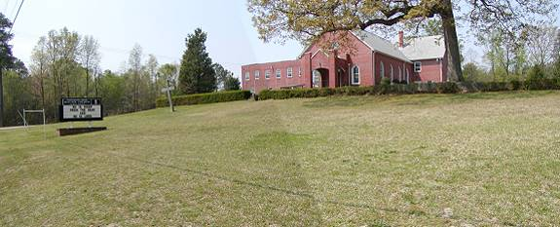
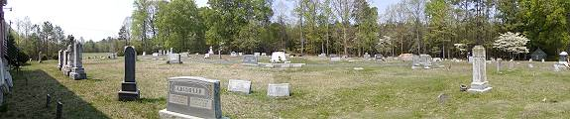
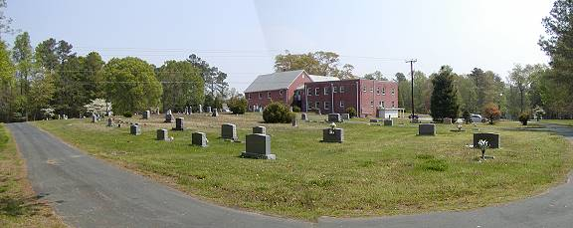
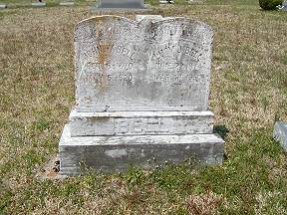 | 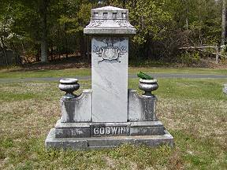
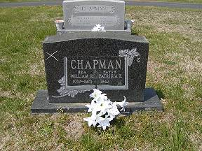 | 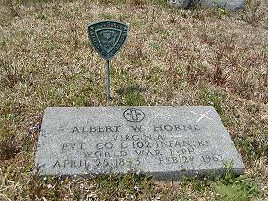
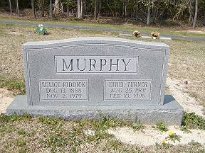 | 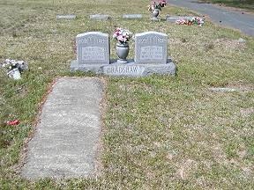
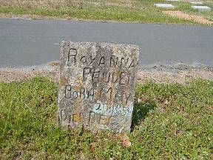 | 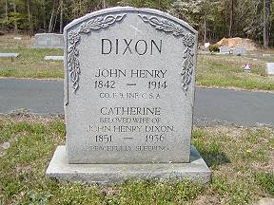
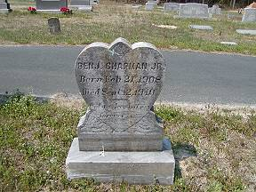 | 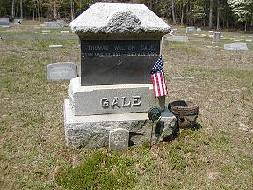
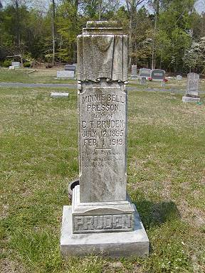 | 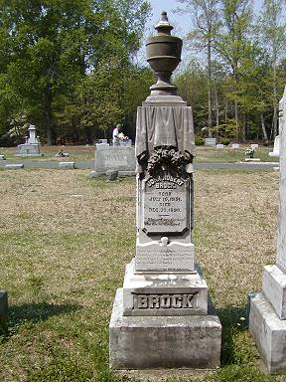
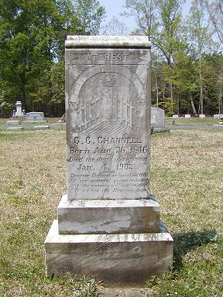 | 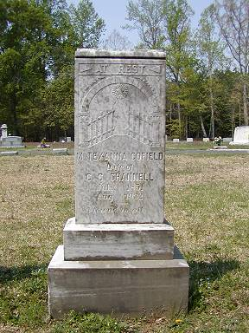
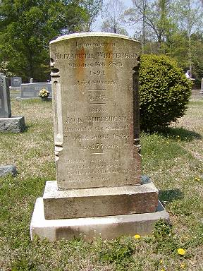 | 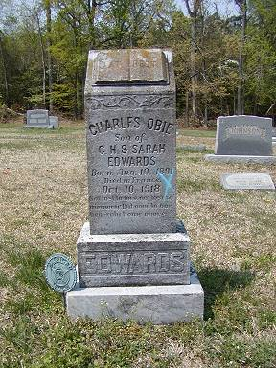
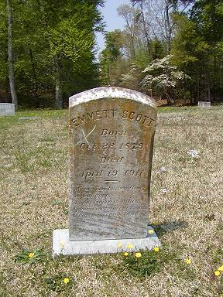 | 