WHITLEY ~Redhouse Rd.~ Cemetery
Visited by Members of
Grave Site Survey Task Force (GSSTF)
Under the Auspices of
Isle of Wight County Historical Society (IWCHS)

April 25, 2004

This cemetery is located in a small patch of woods off of Redhouse Rd. (# 644) about ½ mile east of hwy # 258. There is only one tombstone visible … an ironwork fence surrounds the cemetery, as depicted in the pictures below.

Any text within the “[ ]” is a comment about the tombstone inscription, ex., [fs] indicates a footstone inscription. Throughout the transcribing process, an attempt was made to preserve the, ‘look and feel’ of the original inscriptions as regards word spacing, arrangement, and possible misspellings.

Please address your comments/corrections to: albert.b@charter.net or epowellsr@aol.com.

JESSE WHITLEY
Born
April 24, 1810
Died
July 6, 1865
“Love, mercy, deal justly
And walk humbly before God.”

Erected by his son
L. H. WHITLEY

J.W. [fs]

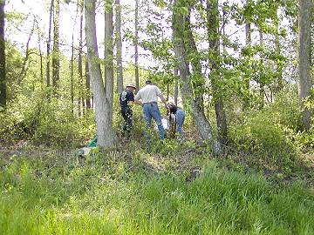 | 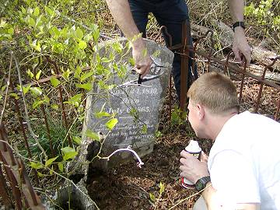
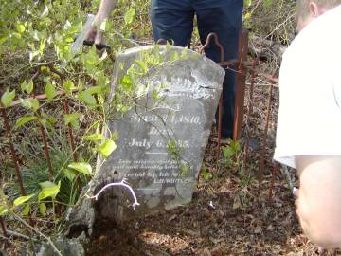 | 